2010 CPR guidelines

Adapted from:

European Resuscitation Council Guidelines for Resuscitation 2010 Section 4. Adult advanced life support

European Resuscitation Council Guidelines for Resuscitation 2010 Section 6. Paediatric life support

European Resuscitation Council Guidelines for Resuscitation 2010 Section 2. Adult basic life support and use of automated external defibrillators

Read the articles and answer the questions below:
The European Resuscitation Council (ERC) have published new CPR guidelines, which determine how we will teach and perform CPR during the next five years.
We are bringing you the most important changes from the ERC compared to the old guidelines from 2005 for basic life support, electrical therapies, advance life support, and paediatric life support.

The European Resuscitation Council Guidelines for Resuscitation 2010

Basic life support
- The importance of gasping as sign of cardiac arrest is emphasized.
- All rescuers, trained or not, should provide chest compressions to victims of cardiac arrest. A strong emphasis on delivering high quality chest compressions remains essential. The aim should be to push to a depth of at least 5 cm at a rate of at least 100 compressions/ min, to allow full chest recoil, and to minimize interruptions in chest compressions. Trained rescuers should also provide ventilations with a compression–ventilation (CV) ratio of 30:2.
- Telephone-guided chest compression-only CPR is encouraged for untrained rescuers.
- The use of prompt/feedback devices during CPR will enable immediate feedback to rescuers and is encouraged.

Electrical therapies: defibrillation, cardioversion and pacing
- Early, uninterrupted chest compressions are extremely important.
- The continuation of compressions during charging of the defibrillator is recommended.
- Immediate resumption of chest compressions following defibrillation is also emphasized. The interruption in the chest compressions should not be longer than 5 seconds
- The focus is now on a rapid safety check to minimize the pre-shock pause.
- Routine delivery of a pre-specified period of CPR (e.g., two or three minutes) before rhythm analysis and a shock is delivered is no longer recommended.
- The use of up to three successive (stacked) shocks may be considered if ventricular fibrillation/pulseless ventricular tachycardia: VF/VT occurs during cardiac catheterization or in the early post-operative period following cardiac surgery. This three shock strategy may also be considered for an initial, witnessed VF/VT cardiac arrest when the patient is already connected to a manual defibrillator.

Adult advanced life support
- Increased emphasis on the use of ‘track and trigger systems’ to detect the deteriorating patient and enable treatment to prevent in-hospital cardiac arrest.
- Increased awareness of the warning signs associated with the potential risk of sudden cardiac death out of hospital.
- The role of the precordial thump is de-emphasised.
- Delivery of drugs via a tracheal tube is no longer recommended – if intravenous access cannot be achieved, drugs should be given by the intraosseous (IO) route.
- When treating VF/VT cardiac arrest, adrenaline 1 mg is given after the third shock once chest compressions have restarted and then every 3-5 minutes (during alternate cycles of CPR). Amiodarone 300 mg is also given after the third shock.
- Atropine is no longer recommended for routine use in asystole or pulseless electrical activity (PEA).
- Reduced emphasis on early tracheal intubation unless achieved by highly skilled individuals with minimal interruption to chest compressions.
- Increased emphasis on the use of capnography to confirm and continually monitor tracheal tube placement, quality of CPR and to provide an early indication of return of spontaneous circulation (ROSC).
- The potential role of ultrasound imaging during ALS is recognised.
- Recognition of the potential harm caused by hyperoxemia after ROSC is achieved: once ROSC has been established and the oxygen saturation of arterial blood (SaO2) can be monitored reliably (by pulse oximetry and/or arterial blood gas analysis), inspired oxygen is titrated to achieve a SaO2 of 94 – 98%.
- Much greater detail and emphasis on the treatment of the post-cardiac arrest syndrome.
- Recognition that implementation of a comprehensive, structured post resuscitation treatment protocol may improve survival in cardiac arrest victims after ROSC.
- Increased emphasis on the use of primary percutaneous coronary intervention in appropriate (including comatose) patients with sustained ROSC after cardiac arrest.
- Revision of the recommendation for glucose control: in adults with sustained ROSC after cardiac arrest, blood glucose values >10 mmol l⁻¹ (>180 mg dl⁻¹) should be treated but hypoglycaemia must be avoided.

Paediatric life support
- Recognition of cardiac arrest –The decision to begin CPR must be taken in less than 10 seconds. According to the child’s age, carotid (children), brachial (infants) or femoral pulse (children and infants) checks may be used.
- The compression ventilation (CV) ratio used for children should be based on whether one, or more than one rescuer is present.
- Rescuers with a duty to respond should learn and use a 15:2 CV ratio; however, they can use the 30:2 ratio if they are alone, particularly if they are not achieving an adequate number of compressions. Ventilation remains a very important component of CPR in asphyxial arrests.
- The emphasis is on achieving quality compressions of an adequate depth with minimal interruptions to minimize no-flow time. Compress the chest to at least 1/3 of the anterior- posterior chest diameter in all children (i.e., approximately 4 cm in infants and approximately 5 cm in children). Subsequent complete release is emphasized. For both infants and children, the compression rate should be at least 100 but not greater than 120 min. The compression technique for infants includes two-finger compression for single rescuers and the two thumb technique for two or more rescuers. For older children, a one- or two-hand technique can be used, according to rescuer preference.
- Automated external defibrillators (AEDs) are safe and successful when used in children older than one year of age. Purpose-made paediatric pads or software attenuate the output of the machine to 50–75 J and these are recommended for children aged 1-8 years. If an attenuated shock or a manually adjustable machine is not available, an unmodified adult AED may be used in children older than 1 year.
- To reduce the no-flow time, when using a manual defibrillator, chest compressions are continued while applying and charging the paddles or self-adhesive pads (if the size of the child’s chest allows this). Chest compressions are paused briefly once the defibrillator is charged to deliver the shock. For simplicity and consistency with adult BLS and ALS guidance, a single-shock strategy using a nonescalating dose of 4 J kg (preferably biphasic, but monophasic is acceptable) is recommended for defibrillation in children.
- Cuffed tracheal tubes can be used safely in infants and young children. The size should be selected by applying a validated formula.
- The safety and value of using cricoid pressure during tracheal intubation is not clear. Therefore, the application of cricoid pressure should be modified or discontinued if it impedes ventilation or the speed or ease of intubation.
- Monitoring exhaled carbon dioxide (CO2), ideally by capnography, is helpful to confirm correct tracheal tube position and recommended during CPR to help assess and optimise its quality.
- Once spontaneous circulation is restored, inspired oxygen should be titrated to limit the risk of hyperoxemia.
EXERCISE 1: Answer the following questions:

- What is the important sign of cardiac arrest?
- Why should rescuers push to a depth of at least 5cm at a rate of at least 100 compressions per minute? .
- What is the compression-ventilation ratio provided by trained rescuers?
- Should the compressions continue during charging of the defibrillator?
- Under which conditions may the use of three successive shocks be considered?
- What is the name of an early warning system which alerts staff of a patient´s deteriorating condition?
- How are drugs to be administered if intravenous access cannot be achieved?
- When are adrenaline and amiodarone administered?
- Why is emphasis put on the use of capnography?
- What are the recommendations for glucose control?
- How can the pulse be checked in children, infants, or both?
- Which compression/ventilation ratio should be used when one rescuer is involved and when two rescuers are involved?
- What should the depth of compressions be in infants and in children?
- How can the no-flow time be reduced?
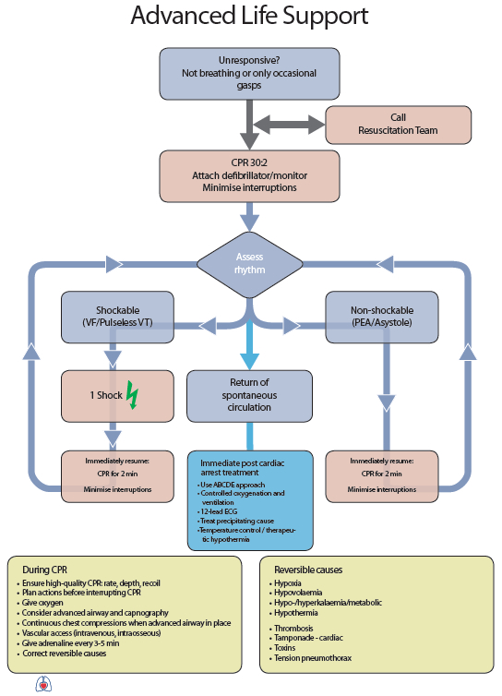

EXERCISE 2: look at the algorithm with advanced life support and match the English version with the following instructions in Czech:

Example: bezvědomí, zástrava dechu nebo jen občasné lapavé nadechnutí = unresponsive, not breathing or occasional gasps

zhodnoťte (srdeční) rytmus:

připojte defibrilátor/ monitor, minimalizujte přerušování masáže:

(defibrilační) výboj:

nedefibrilovatelný rytmus (bezpulzová elektrická aktivita/asystolie)

okamžitě pokračujte 2 minuty v KPR, minimalizujte přerušování (masáže)

obnovení spontánního oběhu:

okamžitá léčba po srdeční zástavě:

EXERCISE 3: Translate the part “During CPR” into Czech.

http://www.resuscitace.cz/wp-content/uploads/2010/09/Algoritmus-ALS_2010.jpg
http://ivormedical.com/2010/10/new-2010-cpr-guidelines/

EXERCISE 4: explain the meaning of the following acronyms:
Example: DLS dispatch life support

- ROSC
- ALS
- AED
- CV
- BLS
- VF
- VT
- PEA
- IO

LISTENING AND DISCUSSION:

The ethics of resuscitation and end-of-life decisions
Sudden unexpected cardiac arrest is an event with often devastating consequences to the individual victim, family and friends.
Healthcare professionals are obliged to do what is necessary to protect and save lives.
Several considerations are necessary to ensure that decisions to perform or stop resuscitation are appropriate, and that patients are treated with dignity. These decisions are complex and may be influenced by individual, international and local cultural, legal, traditional, religious, social and economic factors.
EXERCISE 5: Listen to Fredy Lippert and note down which main considerations have to be made during a resuscitation process. Access the recording through
http://resuscitation-guidelines.articleinmotion.com/article/S0300-9572(10)00439-9/aim
considerations have to be made during a resuscitation process:
when to______________ when to ______________
when not to____________ when to_______________

EX 6: Listen again and make notes about the main points of the chapters dealing with the key principles of ethics of resuscitation.

DISCUSS your attitude towards these issues with your colleagues.

For more information you can read:

http://resuscitation-guidelines.articleinmotion.com/article/S0300-9572(10)00439-9/pdf/european-resuscitation-council-guidelines-for-resuscitation-2010-section-10-the-ethics-of-resuscitation-and-end-of-life-decisions
http://ivormedical.com/2010/10/new-2010-cpr-guidelines/

EXERCISE: Describe your own experience with giving basic and /or advanced life support.
You can make notes on your case when you provided or assisten in provision of life support.



