**LANGUAGE PRACTICE FOR PRESENTATIONS**

**TRANSITIONS / „SIGNALLING WHERE WE ARE GOING“**

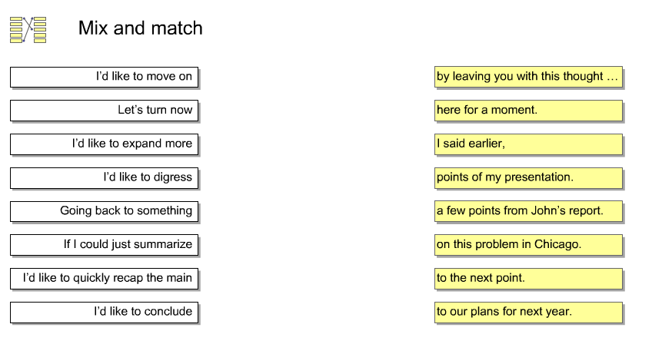

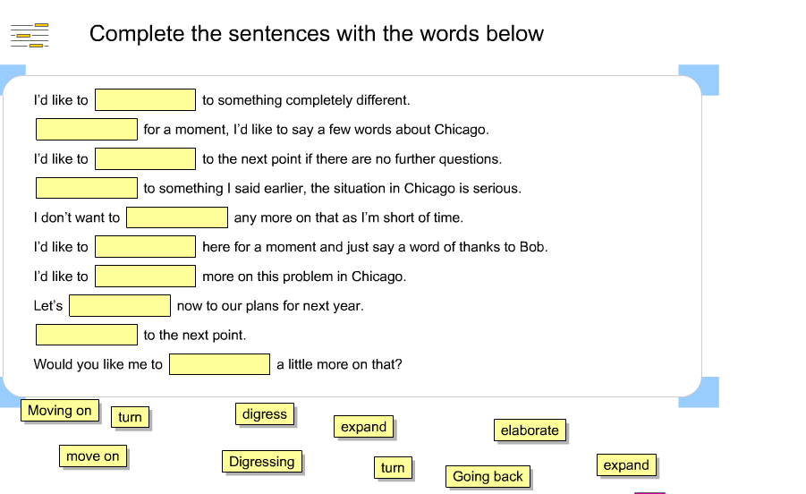

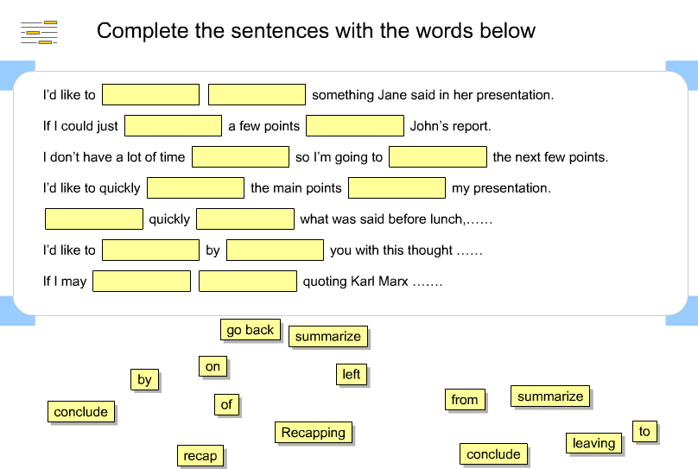

# **PRESENTATIONS - EXERCISES**

# ***Task 1* INTRODUCTION:** *Complete the following introduction with words from the list.*

questions act as talk about look at points of view

go along hear brief finally

*Good afternoon and thank you for making the effort to be here with us today. My name’s Rachel Rawlins and I’m responsible for teaching methodology. What I’d like to do today is _________ teaching methods at Czech universities. This ___________ talk will hopefully _____________ a springboard for discussion. I’m going to ____________ the methods from three _________ : firstly, the students; secondly, the teachers; and ___________, the materials. If you have any ___________, just interrupt me as I ___________. Your point of view may well be different, and we’d like to ___________ from you.*

# ***Task 2:*** As introductions can become repetitive, it is important to have a choice of words and expressions ready.

*Use one of the following expressions to replace the synonyms in bold.*

don’t hesitate a chance I take care I’m delighted sections

go through in more depth my purpose is finally divide

*Good morning, ladies and gentlemen.* ***It’s a pleasure*** *to be with you today. My name is Gordon Mathews and* ***I’m in charge*** *of the University Research Programme at the Rector’s Office.* ***We are here today*** *to* ***review*** *some key figures and to outline our strategy over the next five years. So what I intend to do is to* ***break down*** *this presentation into three* ***parts****: first, the current situation; second, the options facing us, and* ***third****, the strategy I propose. If you have any questions, please,* ***feel free*** *to interrupt me, but I should also say that there’ll be* ***an opportunity*** *to discuss issues* ***at greater length*** *after my talk.*

# ***Task 3* ENDING:** *Complete the following ending with words from the list.*

questions that’s all second discussion formed by

conclude issues briefly finally begin

*So, ____________I have planned to say about the topic. Let me summarize the main ____________. Very ____________, they are four. First, nation states, ___________, confederations, then, multinational empires, and ____________ multinational democracies. I’d like to ____________ by emphasizing the fact that the majority of today’s countries are ____________ multicultural societies. Well, I suggest we start the ____________ now. But before we ____________, let me thank you for your attention. OK, I’d be glad to answer any ____________ now.*

# ***Task 4***

Endings can become repetitive, so it is important to have a choice of words and expressions ready. *Use one of the following expressions to replace the synonyms in bold.*

Presence I’d be glad talk As you can see then lastly reliable now idea covers everything in It seems to me that listening sum up is based main

*That* ***brings me to the end******of*** *my* ***presentation****. Let me just* ***run over*** *the* ***key*** *points again. Very briefly, there are three. First, socio-biology in contrast to ecology,* ***second*** *to economy, and* ***third*** *to political science.* ***From what you have heard****, there are some* ***very good*** *reasons to see socio-biology as any treatment of social phenomena that basically* ***draws*** *on neo-Darwinist theory.* ***At this point****, I’d like to leave you with the following* ***thought****: remember that politics, ecology, as well as economy are part of life, and biology is the study of life.* ***In my opinion****, the only possibility is to accept the* ***existence*** *of socio-biology as an equal to other social sciences. Thank you for* ***your attention*** *and now, if you have any questions,* ***I’d be pleased*** *to answer them.*