Urinary System
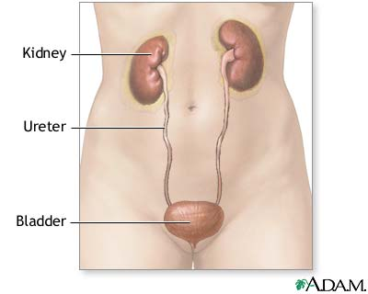
After the body oxidizes nutrient substances, it must deal with excretion (the elimination of metabolic waste products) to prevent their accumulation and potential poisoning. The kidneys are essential to the body's excretory needs. They constantly filter the blood, and selectively reabsorb vital constituents for conservation. Concentrated waste products and some remaining water form urine. The kidneys are also key to the homeostatic regulation of blood volume and pressure, ion concentration, pH, and red blood cell production.
Kidneys: location and structure
The kidney is a reddish bean-shaped organ in the lower back near the twelfth rib. It sits within perirenal fat and renal fascia (connective tissue) that protect it against injury. The lighter-colored outer part of the kidney is the renal cortex. The darker inner part is the renal medulla. Blood is filtered in the renal cortex and medulla to form urine.
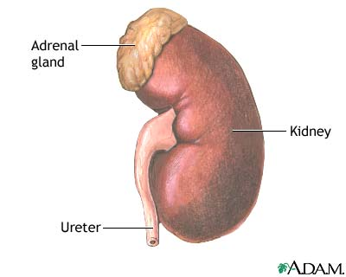
Within the kidney, urine travels through many structures before it reaches the ureter. The renal medulla contains dark triangular areas of tissue called the renal pyramids. Urine flows through a renal pyramid and exits at the renal papilla, the tip. The renal papilla has collecting ducts, small openings that allow urine to pass through. From the collecting ducts, the urine progresses to the renal pelvis, a widened area of the kidney, and exits through the ureter. The urine passes through the ureters to the urinary bladder. When the urinary bladder is full, the body releases urine through the urethra during urination, or micturition.
Kidneys: function
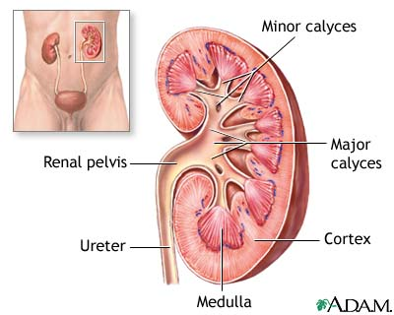
The functional unit of the kidney is the nephron. It contains a glomerular (Bowman's) capsule, a cup-shaped structure that surrounds a glomerulus (group of capillaries). Together, the glomerular capsule and glomerulus form a unit called the renal corpuscle. Attached to the Bowman's capsule is a long, twisting renal tubule that has four parts: the proximal convoluted tubule, the loop of Henle, the distal convoluted tubule, and a collecting duct.
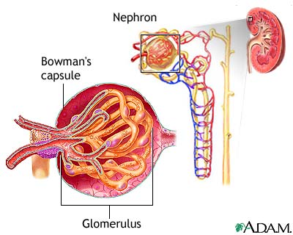
Filtration of the blood occurs in the renal corpuscle between the Bowman's capsule and glomerulus. In this nonselective process, fluid and tiny particles in the glomerulus pass from the blood into the Bowman's capsule and renal tubules. The liquid substance within the renal tubules is filtrate.
Blood reaches the kidney through the renal arteries, a branch of the aorta. The path from the renal artery to the glomerulus runs as follows: lobar artery, interlobar artery, arcuate artery, interlobular artery, and afferent arterioles. "Afferent" means that the arteriole is carrying blood toward the glomerulus.
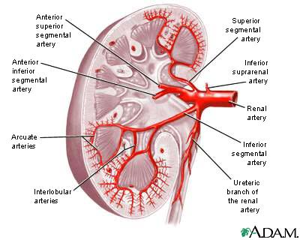
Small openings called fenestrations fill the capillaries that make up the glomerulus. Fenestrations allow tiny particles and water to pass into the filtrate. Surrounding the glomerulus are cells called podocytes. The interlocking pedicels (foot processes) of these cells surround the capillaries to form the filtration barrier. This barrier prevents the passage of blood cells, platelets, and protein molecules into the filtrate. Seven types of matter are small enough to pass through the filtration barrier: blood plasma (the liquid part of blood), glucose, amino acids, potassium, sodium, chloride, and urea (nitrogenous waste).
Some materials in filtrate are needed to maintain homeostasis (a stable internal environment); the reabsorption process returns these materials to the bloodstream. Reabsorption begins after blood leaves the glomerulus through the efferent arteriole. "Efferent" means that the arteriole is carrying blood away from the glomerulus. The efferent arteriole forms a peritubular capillary bed that envelops the renal tubule. As the peritubular capillaries pass near the renal tubule, useful substances in the filtrate such as glucose, vitamins, amino acids, water, and ions are reabsorbed into the bloodstream.
Urine production
Urine, the fluid that enters the collecting duct, passes to the urinary bladder through the ureters. Antidiuretic hormone (ADH) and aldosterone control how much urine the body produces. If the body becomes dehydrated, the pituitary gland releases ADH. This hormone reduces urine volume by causing the collecting tubules to allow more water to be reabsorbed into the bloodstream. If too much fluid is in the body, the pituitary gland stops releasing ADH and the excess water passes out of the body as dilute urine.
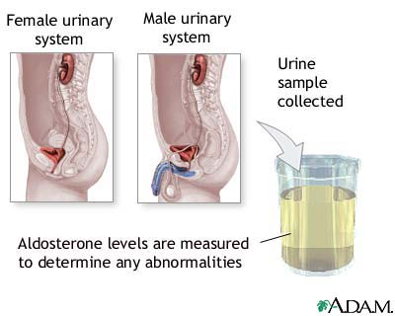
Aldosterone enhances sodium reabsorption, which increases water reabsorption into the blood from the collecting tubules. Because of the effect of aldosterone on the collecting tubules, the amount of water excreted in the urine decreases and blood volume and blood pressure increase.
Endocrine cells in the kidneys produce the hormone erythropoietin, which controls erythrocyte production.

The Reproductive System
The human reproductive system is a system by which humans reproduce and bear live offspring. Provided all organs are present, normally constructed, and functioning properly, the essential features of human reproduction are (1) liberation of an ovum, or egg, at a specific time in the reproductive cycle, (2) internal fertilization of the ovum by spermatozoa, or sperm cells, (3) transport of the fertilized ovum to the uterus, or womb, (4) implantation of the blastocyst, the early embryo developed from the fertilized egg, in the wall of the uterus, (5) formation of a placenta and maintenance of the unborn child during the entire period of gestation, or pregnancy (6) birth of the child and expulsion of the placenta, and (7) suckling (breast-feeding) and care of the child, with an eventual return of the maternal organs to virtually their original state.
For this biological process to be carried out, certain organs and structures are required in both the male and the female. The source of the ova (the female germ cells) is the female ovary; that of spermatozoa (the male germ cells) is the testis. In females, the two ovaries are situated in the pelvic cavity; in males, the two testes are enveloped in a sac of skin, the scrotum, lying below and outside the abdomen. Besides producing the germ cells, or gametes, the ovaries and testes are the source of hormones that cause full development of secondary sexual characteristics and also the proper functioning of the reproductive tracts. These tracts comprise the fallopian tubes, the uterus, the vagina, and associated structures in females and the penis, the sperm channels (epididymis, ductus deferens, and ejaculatory ducts), and other related structures and glands in males. The function of the fallopian tube is to convey an ovum, which is fertilized in the tube, to the uterus, where gestation (development before birth) takes place. The function of the male ducts is to convey spermatozoa from the testis, to store them, and, when ejaculation occurs, to eject them with secretions from the male glands through the penis.
At copulation, or sexual intercourse, the erect penis is inserted into the vagina, and spermatozoa contained in the seminal fluid (semen) are ejaculated into the female genital tract. Spermatozoa then pass from the vagina through the uterus to the fallopian tube to fertilize the ovum in the outer part of the tube. Females exhibit a periodicity in the activity of their ovaries and uterus, which starts at puberty and ends at the menopause. The periodicity is manifested by menstruation at intervals of about 28 days; important changes occur in the ovaries and uterus during each reproductive, or menstrual, cycle. Periodicity, and subsequently menstruation, is suppressed during pregnancy and lactation.
For a detailed discussion of the series of changes that occur in a woman’s body as her foetus develops, see pregnancy. For a description of the stages of labour and delivery, see parturition. For the development of the unborn child during gestation, see human embryology. For coverage of the many diseases and disorders that can affect the reproductive organs, see reproductive system disease.

Development of the reproductive organs
The sex of a child is determined at the time of fertilization of the ovum by the spermatozoon. The differences between a male and a female are genetically determined by the chromosomes that each possesses in the nuclei of the cells. Once the genetic sex has been determined, there normally follows a succession of changes that will result, finally, in the development of an adult male or female. There is, however, no external indication of the sex of an embryo during the first eight weeks of its life within the uterus. This is a neutral or indifferent stage during which the sex of an embryo can be ascertained only by examination of the chromosomes in its cells.
The next phase, one of differentiation, begins first in gonads that are to become testes and a week or so later in those destined to be ovaries. Embryos of the two sexes are initially alike in possessing similar duct systems linking the undifferentiated gonads with the exterior and in having similar external genitalia, represented by three simple protuberances. The embryos each have four ducts, the subsequent fate of which is of great significance in the eventual anatomical differences between men and women. Two ducts closely related to the developing urinary system are called mesonephric, or wolffian, ducts. In males each mesonephric duct becomes differentiated into four related structures: a duct of the epididymis, a ductus deferens, an ejaculatory duct, and a seminal vesicle. In females the mesonephric ducts are largely suppressed. The other two ducts, called the paramesonephric or müllerian ducts, persist, in females, to develop into the fallopian tubes, the uterus, and part of the vagina; in males they are largely suppressed. Differentiation also occurs in the primitive external genitalia, which in males become the penis and scrotum and in females the vulva (the clitoris, labia, and vestibule of the vagina).
At birth the organs appropriate to each sex have developed and are in their adult positions but are not functioning. Various abnormalities can occur during development of sex organs in embryos, leading to hermaphroditism, pseudohermaphroditism, and other chromosomally induced conditions. During childhood until puberty there is steady growth in all reproductive organs and a gradual development of activity. Puberty marks the onset of increased activity in the sex glands and the steady development of secondary sexual characteristics.
In males at puberty the testes enlarge and become active, the external genitalia enlarge, and the capacity to ejaculate develops. Marked changes in height and weight occur as hormonal secretion from the testes increases. The larynx, or voice box, enlarges, with resultant deepening of the voice. Certain features in the skeleton, as seen in the pelvic bones and skull, become accentuated. The hair in the armpits and the pubic hair become abundant and thicker. Facial hair (beard) develops, as well as hair on the chest, abdomen, and limbs. Hair at the temples recedes. Skin glands become more active, especially apocrine glands (a type of sweat gland that is found in the armpits and groin and around the anus).
In females at puberty, the external genitalia enlarge and the uterus commences its periodic activity with menstruation. There is a deposition of body fat in accordance with the usual contours of the mature female. Growth of axillary (armpit) and pubic hair is more abundant, and the hair becomes thicker.

