**Key**

**Complete the verb “be”.**

Nina ___was____ a nurse. (be) Was Nina a nurse? No, she wasn’t /was not.

The patient ___was___ unconscious. Was the patient unconscious? Yes, he was.

Doctors ___were___ in children’s ward. Were the doctors in children’s ward? No, they weren’t/were not.

Our nurses ___were_____ very competent. Were our nurses very competent? Yes, they were

The surgeon __was____ in the operating theatre. Was the surgeon in the operating theatre? No, he wasn’t

This __was____ Mr Hen’s first x-ray. Was this Mr Hen’s first x-ray? No, it wasn’t.

The toilets ___were___ on the ground floor. Were the toilets on the ground floor? Yes, they were.

**First aid**

She sterilized a clean, sharp needle with alcohol.

She made sure there was no glass or other foreign body in the wound.

She used the needle to puncture the blister.

She did not remove burnt clothing.

She squeezed a main artery.

She kept the injured person lying down.

She immobilized the injured body part once the bleeding had stopped.

She treated the person for shock.

She did not immerse severe large burns in cold water.

She checked for signs of circulation.

She swabbed with Iodine or rubbing alcohol.

She applied antibiotic ointment and covered with a bandage.

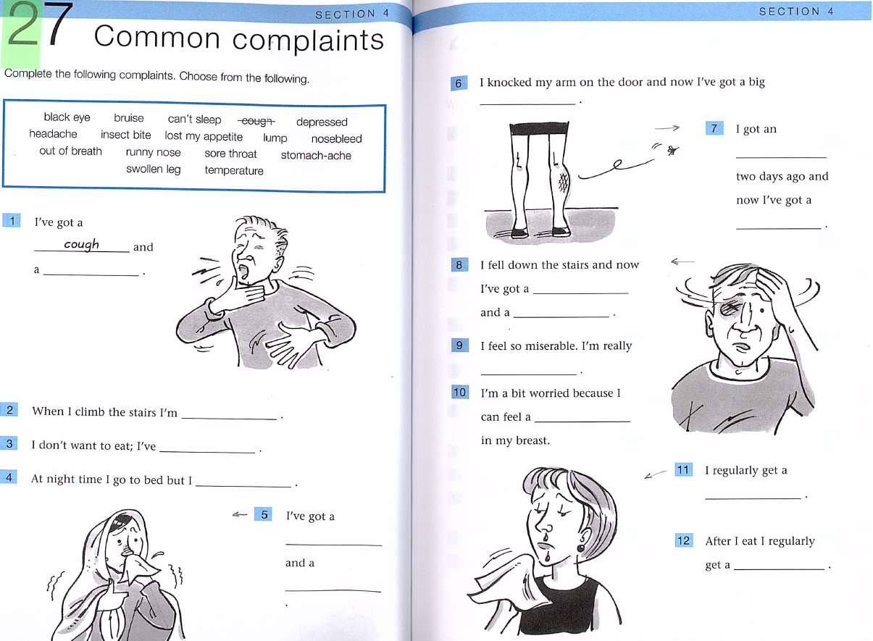

1. sore throat

2. out of breath (look up the difference between “breath” and “breathe”)

3. lost my appetite (look up present tense of “lost”)

4. can’t sleep.

5. I’ve got a runny nose and a temperature (look up words “fever”, “chills” and “to shiver”)

6. bruise

7. insect bite (mosquito bite, bee sting, wasp sting), swollen leg (swell, swelling, swollen)

8. headache, black eye (concussion, consciousness, unconsciousness - I was unconscious)

9. depressed

10. lump

11. nosebleed

12. stomach-ache [eɪk]

**A job interview**

1. fully-qualified, 2. part-time, 3. night shift, lectures, 4. rewarding, 5. applying for

**E-mail:**

I am writing, I am getting on, I am enjoying, have, I am working, want, make, check, I am learning, go out, I am going, I am making

**Describing pain**

1-f, 2-h, 3-g,4-e,5b, 6c, 7a, 8d

cramp=spasm

not bad, slight/mild, moderate/quite bad, severe, agonizing/unbearable