**1. Work with your partner and match the diseases with their definition**

|  |  |
| --- | --- |
| **1. Acromegaly** | a) Disorder in which an underactive thyroid produces too little thyroxine. |
| **2. Addison's disease** | b) Disorder in children in which the anterior pituitary overproduces growth hormone, resulting in abnormal enlargement of the extremities (nose, jaw, fingers, and toes) and the long bones, causing unusual height. |
| **3. Cushing's syndrome** | c) Disorder caused by an overproduction of steroids (mostly cortisol) by the adrenal cortex, resulting in obesity and muscular weakness. |
| **4. Diabetes mellitus** | d) Disorder in which an overactive thyroid produces too much thyroxine. |
| **5. Gigantism** | e) Disorder in which the anterior pituitary overproduces growth hormone, resulting in abnormal enlargement of the extremities—nose, jaw, fingers, and toes; in children, the disorder produces gigantism. |
| **6. Hyperthyroidism** | f) Disorder in which the adrenal cortex underproduces cortisol and aldosterone, resulting in the disruption of numerous bodily functions. |
| **7. Hypothyroidism** | g) Disorder in which the body's cells cannot absorb glucose, either because the pancreas does not produce enough insulin or the cells do not respond to the effects of insulin that is produced. |

**2. Acromegaly - Complete one word into each gap**

Acromegaly is a disorder in ________ (1) the anterior pituitary produces too much growth hormone (GH). This causes an increased growth in bone and soft tissue, especially in the extremities—nose, jaw, fingers, and toes. If the disorder occurs _____ (2) children who have not yet fully developed the increased levels of GH also result _____(3) the exceptional growth of the long bones. This condition, a variation of acromegaly, is known as _______.(4)

Acromegaly is a rare disorder, occurring in approximately 50 _____(5) of every 1 million people. _______ (6) men and women are affected. Because the symptoms come on gradually, the disorder is often not identified until the patient is middle aged.

In 90 percent of _____(7) cases, acromegaly is caused by a noncancerous tumour that develops within the pituitary. The tumour causes the anterior pituitary _____(8) ignore growth hormone inhibiting hormone (GHIH), a regulating hormone secreted by the hypothalamus that stops the pituitary from producing GH. GH _____(9) thus secreted without a stopping mechanism.

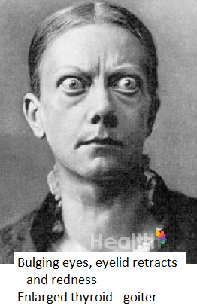The first step in treating acromegaly is the surgical _________(10) of the tumour. Afterward, some patients require medications that help to reduce the secretion of GH. With treatment, an individual suffering from acromegaly may be able to live a normal _______ (11) span. Without treatment, an individual will most ______ (12) die early because of the disorder's adverse effects on the heart, lungs, and brain.

**3. Graves’ disease -** Listen and answer the following questions:

What is Graves’ disease?

How is it diagnosed?

What treatment is available?

**4. Listening: Cushing’s disease**

Watch the video and discuss the following questions with your partner:

1. Is there a difference between Cushing’s disease and Cushing’s syndrome? If so explain what.
2. How do we find out that a person is suffering from Cushing’s disease?
3. Who is susceptible to this disease?
4. What treatment options are at our disposal?
5. What are the adverse effects of bilateral adrenalectomy?

**5. Addison's disease**

Addison's disease is a disorder in which the adrenal cortex produces too little cortisol and aldosterone, resulting in the _____________ (DISRUPT) of ___________ (NUMBER) bodily functions. About 4 in every 100,000 people suffer from this disorder. It strikes men and women of all ages.

The most common cause of Addison's disease is the ________ (DESTRUCT) or shrinking of the adrenal cortex. In about 70 percent of the cases, this is caused by an autoimmune disorder: a condition in which the body produces antibodies that attack and destroy the body's own tissues instead of foreign ____________ (INVADE) such as viruses and bacteria. In the case of Addison's disease, antibodies attack and destroy cells of the adrenal cortex.

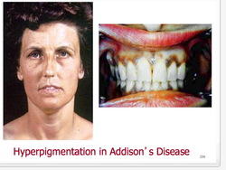Addison's disease tends to be a gradual, _______ (SLOW) developing disease. By the time symptoms are noted, about 90 percent of the adrenal cortex has been destroyed. The most common symptoms include fatigue and ________ (LOSE) of energy, decreased appetite, nausea, vomiting, diarrhoea, abdominal pain, muscle _________ (WEAK), _________ (DIZZY) when standing, and dehydration. Unusual areas of darkened skin and dark freckling also appear. Women suffering from the disease may stop having normal menstrual periods. As the disease progresses, the symptoms become more severe: abnormal heart rhythms, ____________ (CONTROL) nausea and vomiting, a drastic drop in blood pressure, kidney ____________ (FAIL), and ______________ (CONSCIOUS).

Individuals suffering from Addison's disease are treated with steroid medications that replace cortisol and aldosterone in the body. Taking these medications for the rest of their lives, those individuals can expect to live a normal life span.

**6. Hypothyroidism**

**a) Read the text and find out what happens if the thyroid gland is underactive in children.**

**b) Complete the missing sentences. There is one which you do not need.**

Hypothyroidism is a disorder in which an underactive thyroid gland fails to produce or secrete as much thyroxine as the body needs. ____ (1) Thereby organs and tissues in every part of the body can be damaged.

The disorder is one of the most common chronic (long-term) diseases in the United States. ____ (2) Women are twice as likely as men to suffer from the disorder.

Hypothyroidism is most often the result of Hashimoto's disease. In this disease, the body's defence system fails to recognize that the thyroid gland is part of the body's own tissues and attacks it as if it were a foreign body. _____(3) Infections caused by viruses and bacteria and a diet lacking iodine can also bring about hypothyroidism.

Symptoms commonly include fatigue, decreased heart rate, weight gain, depression, muscle pain or weakness, dry skin, extreme sensitivity to pain, and puffiness of the face. _____(4) Such a state may be very dangerous for the patient.

If hypothyroidism occurs in early childhood, the condition is known as cretinism. This condition results in dwarfism. ____ (5) Cretins (those suffering from cretinism) have scanty hair and very dry skin. They are often mentally retarded. However, if the condition is discovered early enough and medications to replace thyroxin are given, mental retardation and other symptoms can be prevented.

Synthetic or man-made thyroid hormone medications are also given to adults to treat hypothyroidism. ____ (6)

1. However, we have to point out that these may not appear until years after the thyroid has stopped functioning.
2. This treatment generally maintains normal thyroid hormone levels, allowing an individual to lead a normal lifestyle.
3. Silent thyroiditis is found less often than the other two.
4. Since this hormone is essential to physical growth and body metabolism, a low supply of this hormone can slow life-sustaining processes.
5. Sometimes the gland is destroyed in the process.
6. As many as 11 million adults and children may be affected by hypothyroidism.
7. That means that the head and trunk, which should be about the same length as the legs, grow about one-and-a-half times larger.

**7. Look at the text once more and find words which mean:**

1. To have an influence on or effect on something _______
2. Performing necessary functions which keep the body alive _________
3. The body of a human or animal excluding the head and limbs _______
4. To cause ________
5. Vital ________
6. Swelling ________
7. Limited, not much, and less than is needed _______
8. To give permission or opportunity ________

**Blood drawing**

**Best practices in phlebotomy**

1. Why are blood test performed and what do they show? Do you know what a CBC is?

2. Have you ever had a blood test? How did you feel about it? Do you have any bad/good experience with it?

3. Have you ever drawn blood? What was it like?

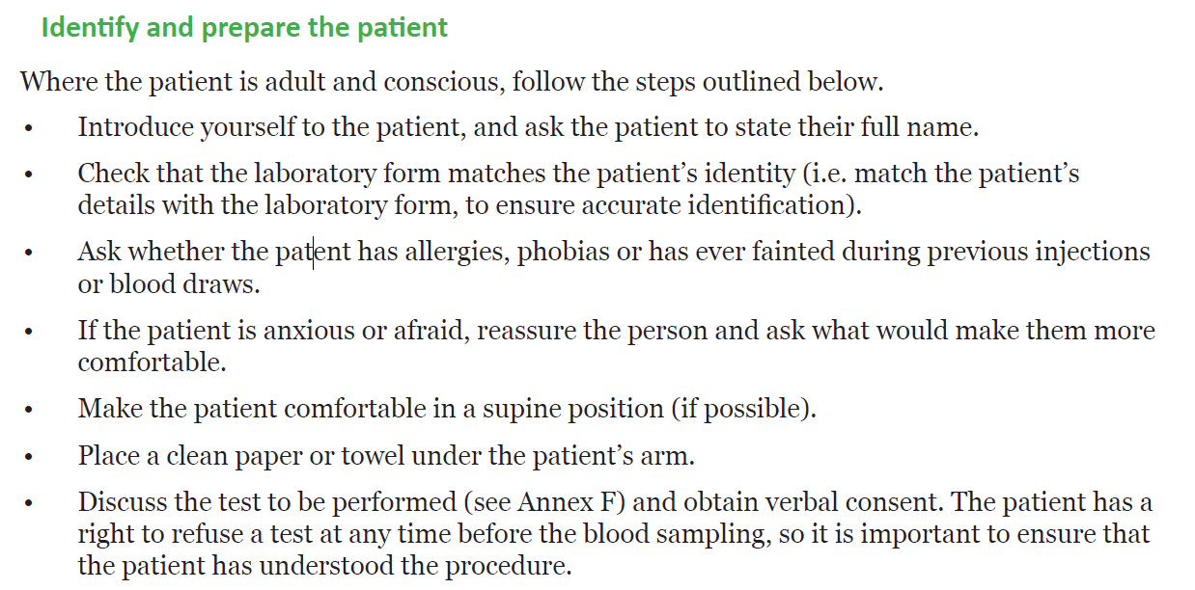

You may also look at:

<https://www.youtube.com/watch?v=RKuUPO6NNcU>

<http://whqlibdoc.who.int/publications/2010/9789241599221_eng.pdf>