**1. Glasses or lenses - that is the question…**

***Read the text and complete the correct form of the words in brackets.***

While more people prefer to wear glasses exclusively, wearing contacts has been growing in ______________ (POPULAR) ever since scientific ______________ (ADVANCE) made contacts ______________ (AFFORD) and practical for people in the late 70’s and 80’s. Whether you choose to wear eyeglasses or contact lenses for vision ______________ (CORRECT) mostly depends on personal ______________ (PREFER). Lifestyle, comfort, ______________ (CONVENIENT), budget and aesthetics should all factor into your decision-making process.

Before deciding between contacts and glasses, keep in mind that one is not ______________ (NECESSARY) better than the other; each has its pros and cons in terms of vision, ______________ (EASY) of use and eye health.

Eyeglasses offer many benefits over contact lenses. They require very little cleaning and ______________ (MAINTAIN), you don't need to touch your eyes to wear them (decreasing your risk for eye infections), and glasses are cheaper than contact lenses in the long run since they don't require frequent _____________ (REPLACE). There are some drawbacks as well, you will have to deal with lens _____________ (REFLECT) and glare. Glasses fog up with changes in temperature and they may be a ____________ (DISTRACT) during sport activities.

That being said, contact lenses have many advantages over glasses. Contacts sit directly on your eye, so vision, particularly peripheral vision, is ______________ (OBSTRUCT). You can participate in sports and outdoor activities without fear of eyeglasses getting in the way, falling off or breaking. You can even change the colour of your eyes with colour contact lenses.

**2. Reading**

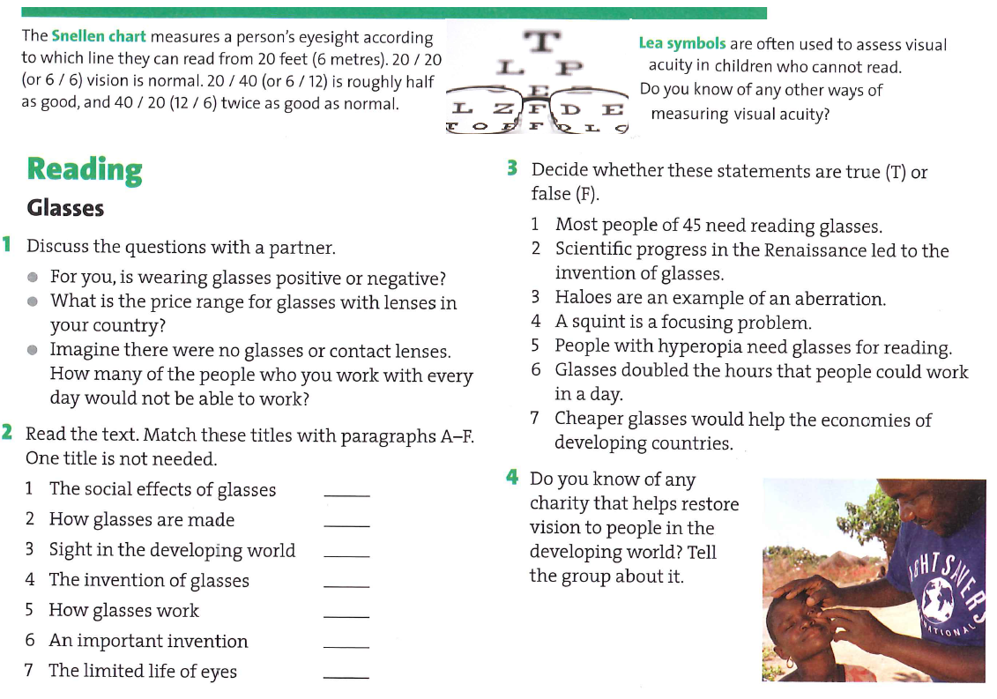

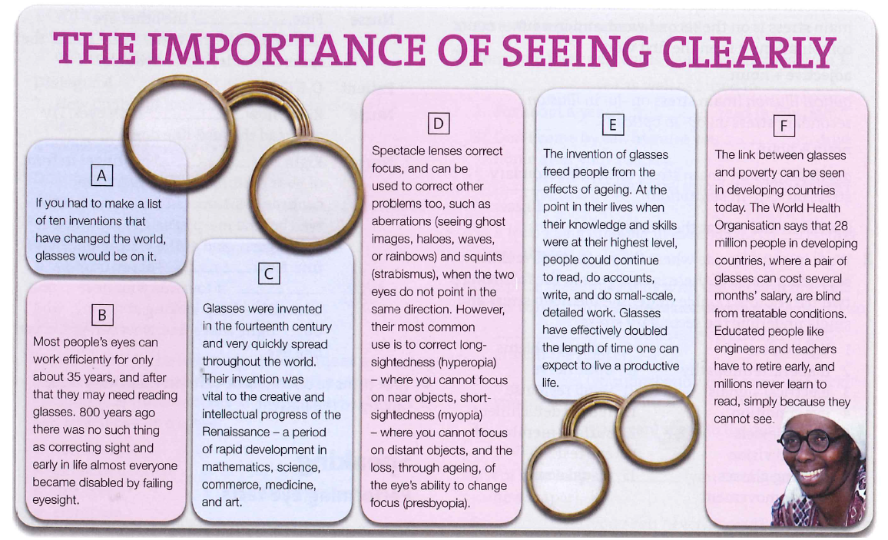

***5. Find a word in the text which means:***

A machine, tool, or system that someone has made for the first time - ____________

Useful and effective and working correctly - ____________

To gradually affect a larger area/amount of people - ____________

Another word for glasses - ____________

Something that is not normal or not what you would usually expect - ____________

A luminous or coloured circle, as seen around a light in glaucoma - ____________

A disorder in which the eyes point in different directions - ____________

To adjust a lens or instrument to produce a clear image - ___________

**6. The Ear: *Read the text and complete one word into each gap.***

The ear enables us to hear as well as maintain balance. The external part of the ear **_________** of the auricle (also called the ___________), the external auditory ­­­­___________ (meatus) and the ear ­­­­___________ (tympanum). The auricle is an immobile cartilaginous framework covered with skin and provides for the perception of sound, its bottom part is called the **earlobe**. The auditory canal is an S-shaped tube **________** ends with the tympanum separating the ­­­­___________ and ­­­­___________ ear. The skin of the canal is furnished with hairs and special glands which produce yellow ___________ secretion for protection against insects and dust.

The middle part embodies a small cavity in the temporal bone. The cavity is connected with the nasopharynx by means of the auditory tube, known as ­­­­___________ tube. Both are lined with mucous membrane which enables infection to permeate from the throat to the middle ear.

The cavity of the middle ear contains three tiny bones ­­­­___________, ­­­­___________and ­­­­___________, which serve for the transmission of sound vibrations. These can be reduced **________** means of two miniature muscles.

The ­­­­___________ ear is formed by irregularly shaped cavities containing fluid and complex membranous structures (___________ canal, ___________ and ___________which are filled with a fluid termed ___________and are surrounded by ___________) initiating nerve impulses. It functions as the actual receptor of sound. Sound __________ received by the external ear hit the ­­­­___________ membrane causing it to vibrate. The vibration is transmitted to the small bones in the middle ear called ____________. The stapes, which is attached to the oval __________ of the inner ear, causes the membrane of the inner ear to move with the sound which is thus carried forward to the canals of the inner ear and recognized by its volume.