Senses Worksheet
A Complete the gaps with a word made from the word in brackets.
1 The ear has two very important functions – it __________ us to hear and it functions as… (ABLE)
2 The middle ear contains three tiny bones __________ as the auditory ossicles. (KNOW)
3 The _________ structures of the inner ear are the vestibule, cochlea and semicircular canals. (BONE)
4 The eyes are housed in orbits located within the ___________ bones at the front of the skull. (FACE)
5 The sclera is the white portion of the eye which serves as a __________ covering for the eye. (PROTECTION)
6 The conjunctiva is _____________, but appears white because it covers the sclera. (COLOUR)

B Is university damaging eyesight?
Students experience a marked decline ___(1) eyesight while at university, with too much "intensive" reading ___(2) blame, a study suggests. Researchers at Spain's Complutense University found 31.3% of first-years ___(3) short-sighted. Among those four to six years older, in their final year, the rate was 49%. Research author Dr Rafaela Garrido said many ___(4) the 270 students tested spent ___(5) to 10 hours at a time reading ___(6) poor light. She told BBC News Online: "Some students are spending ___(7) long in intensive near work with their eyes. It is also a problem with people __(8) spend too long on a computer or using a microscope. It's difficult to ask students to do less reading, ___(9) it is essential to passing courses, but we have to find ways to deal with the stress on the eyes." Research is ____(10) carried out into lenses to prevent myopia among those involved in intensive reading or screen-viewing.
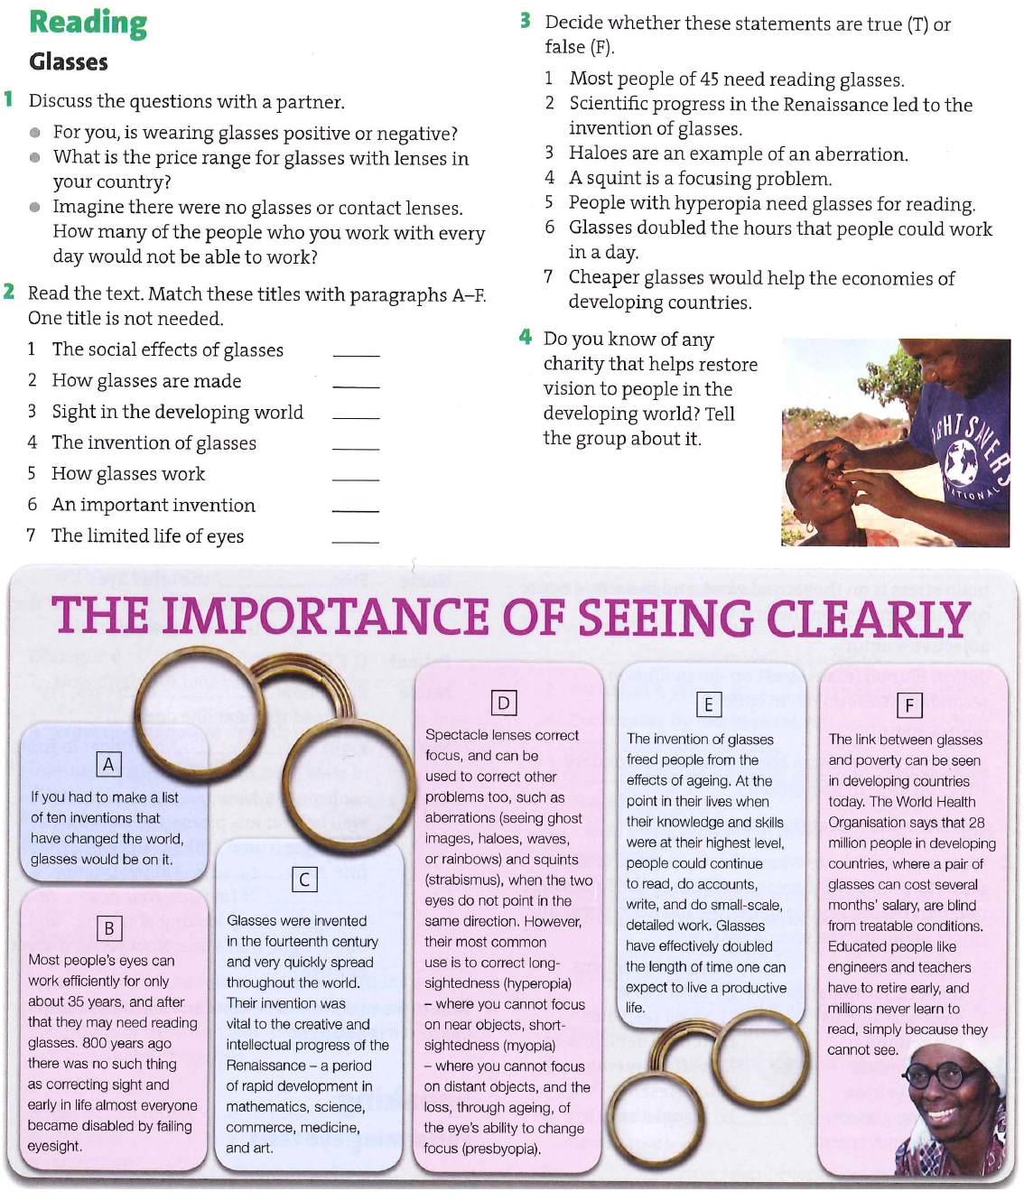
D Video – Ear
1 The ___________, the visible part of the ear, collects sound waves and directs them to the _________ canal, which is lined with ____________ and ceruminous ______________
2 The outer ear is separated from the middle ear by __________________.
3 The three tiny bones of the middle ear are the _________ or malleus, ________ or incus, and stapes or _________.
4 The Eustachian tube of the middle ear opens into the ____________ and permits ________________to equalize between the ear and the outside air.
5 The inner ear is ___________-like, consisting of bony and membranous structures surrounded by fluid. The semi-circular canals are fluid-filled bony ____________ that help maintain our body’s balance.
6 The organ of Corti is situated in the cochlea which is a fluid-filled, ___________-shaped structure. The organ of Corti changes the vibrations into nerve ______________ that are picked up by the ______________ nerve.
7 The auditory or ______________nerve sends these to the temporal lobe of the brain for interpretation.
E Grammar point – Indirect speech
