Urinary System
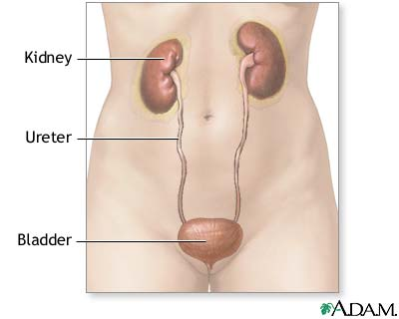
After the body oxidizes nutrient substances, it must deal with excretion (the elimination of metabolic waste products) to prevent their accumulation and potential poisoning. The kidneys are essential to the body's excretory needs. They constantly filter the blood, and selectively reabsorb vital constituents for conservation. Concentrated waste products and some remaining water form urine. The kidneys are also key to the homeostatic regulation of blood volume and pressure, ion concentration, pH, and red blood cell production.
Kidneys: location and structure
The kidney is a reddish bean-shaped organ in the lower back near the twelfth rib. It sits within perirenal fat and renal fascia (connective tissue) that protect it against injury. The lighter-colored outer part of the kidney is the renal cortex. The darker inner part is the renal medulla. Blood is filtered in the renal cortex and medulla to form urine.
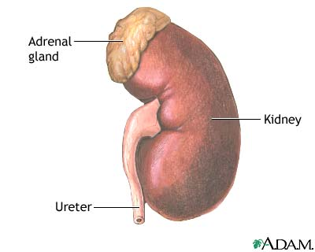
Within the kidney, urine travels through many structures before it reaches the ureter. The renal medulla contains dark triangular areas of tissue called the renal pyramids. Urine flows through a renal pyramid and exits at the renal papilla, the tip. The renal papilla has collecting ducts, small openings that allow urine to pass through. From the collecting ducts, the urine progresses to the renal pelvis, a widened area of the kidney, and exits through the ureter. The urine passes through the ureters to the urinary bladder. When the urinary bladder is full, the body releases urine through the urethra during urination, or micturition.
Kidneys: function
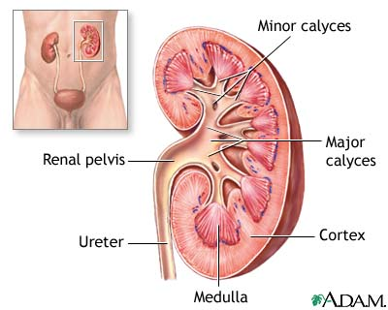
The functional unit of the kidney is the nephron. It contains a glomerular (Bowman's) capsule, a cup-shaped structure that surrounds a glomerulus (group of capillaries). Together, the glomerular capsule and glomerulus form a unit called the renal corpuscle. Attached to the Bowman's capsule is a long, twisting renal tubule that has four parts: the proximal convoluted tubule, the loop of Henle, the distal convoluted tubule, and a collecting duct.
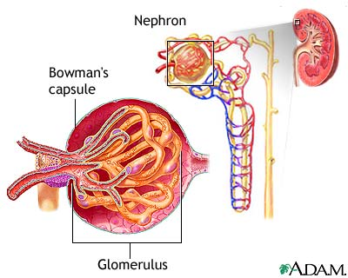
Filtration of the blood occurs in the renal corpuscle between the Bowman's capsule and glomerulus. In this nonselective process, fluid and tiny particles in the glomerulus pass from the blood into the Bowman's capsule and renal tubules. The liquid substance within the renal tubules is filtrate.
Blood reaches the kidney through the renal arteries, a branch of the aorta. The path from the renal artery to the glomerulus runs as follows: lobar artery, interlobar artery, arcuate artery, interlobular artery, and afferent arterioles. "Afferent" means that the arteriole is carrying blood toward the glomerulus.
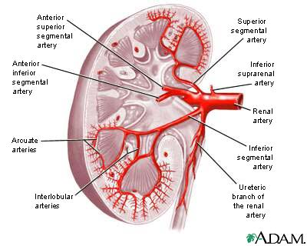
Small openings called fenestrations fill the capillaries that make up the glomerulus. Fenestrations allow tiny particles and water to pass into the filtrate. Surrounding the glomerulus are cells called podocytes. The interlocking pedicels (foot processes) of these cells surround the capillaries to form the filtration barrier. This barrier prevents the passage of blood cells, platelets, and protein molecules into the filtrate. Seven types of matter are small enough to pass through the filtration barrier: blood plasma (the liquid part of blood), glucose, amino acids, potassium, sodium, chloride, and urea (nitrogenous waste).
Some materials in filtrate are needed to maintain homeostasis (a stable internal environment); the reabsorption process returns these materials to the bloodstream. Reabsorption begins after blood leaves the glomerulus through the efferent arteriole. "Efferent" means that the arteriole is carrying blood away from the glomerulus. The efferent arteriole forms a peritubular capillary bed that envelops the renal tubule. As the peritubular capillaries pass near the renal tubule, useful substances in the filtrate such as glucose, vitamins, amino acids, water, and ions are reabsorbed into the bloodstream.
Urine production
Urine, the fluid that enters the collecting duct, passes to the urinary bladder through the ureters. Antidiuretic hormone (ADH) and aldosterone control how much urine the body produces. If the body becomes dehydrated, the pituitary gland releases ADH. This hormone reduces urine volume by causing the collecting tubules to allow more water to be reabsorbed into the bloodstream. If too much fluid is in the body, the pituitary gland stops releasing ADH and the excess water passes out of the body as dilute urine.
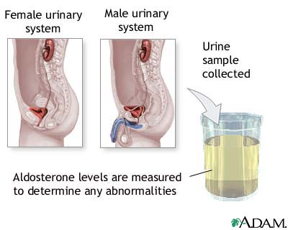
Aldosterone enhances sodium reabsorption, which increases water reabsorption into the blood from the collecting tubules. Because of the effect of aldosterone on the collecting tubules, the amount of water excreted in the urine decreases and blood volume and blood pressure increase.
Endocrine cells in the kidneys produce the hormone erythropoietin, which controls erythrocyte production.

