Genitourinary System Worksheet

Anatomy
A Word formation
1 The urinary system plays a major role in the _________ (eliminate) of waste from the body.
2 The __________ (out) layer, or cortex, of the kidney contains millions of microscopic units called…
3 From the renal tubules, the urine is __________ (empty) into the renal pelvis.
4 The release of urine is called ___________ (urine) or micturition.
5 Urinary retention means _____________ (able) to empty the bladder.

B Multiple choice
1 The urinary system ……… of two kidneys, two ureters, the urinary bladder and a urethra.
A consists B comprises C contains D composes
2 Kidneys are of critical importance .......... maintaining the state of internal balance known as homeostasis.
A by B at C on D in
3 The ……….. of urine, called micturition or urination, is regulated by two sphincters.
A lacking B voiding C avoiding D wanting
4 The upper sphincter functions involuntarily; the lower sphincter is under ……… control.
A unconscious B subconscious C conscious D underconscious
5 A nephron is a microscopic ……… unit of the kidney.
A function B functionary C functional D functioning

Pathologies
A Listen and decide if these statements are true or false.
1 Kidney stones occur more commonly in men than women.
2 There are three main reasons why kidney stones develop.
3 Large stones usually do not get stuck in the kidney, but can cause infection.
4 When there’s an infection, drinking a lot of water and taking medicine is the basic treatment.
5 In some cases, traditional surgery is still used.
6 Once got rid of, kidney stones never occur again.

B Describe briefly the three therapy methods:
1 Shockwave therapy:
2 Percutaneous nephrolithotomy:
3 Ureteroscopy:

C What do you think is the best prevention against kidney stones?

D Kidney failure
Acute kidney failure occurs when your kidneys suddenly _____ (1) unable to filter waste products _____(2) your blood. When your kidneys lose their filtering ability, dangerous levels of wastes ____ (3) accumulate and your blood's chemical makeup may get ____ (4) of balance.
Acute kidney failure — also called acute renal failure or acute kidney injury — develops rapidly ____(5) a few hours or a few days. Acute kidney failure is _____ (6) common in people who ____(7) already hospitalized, particularly in critically ill people _____(8) need intensive care.
Acute kidney failure can be fatal and requires intensive treatment. _____(9), acute kidney failure may be reversible. If you're otherwise ____(10) good health, you may recover normal kidney function.

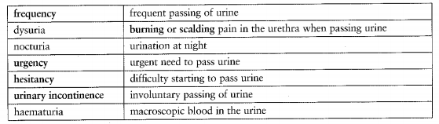
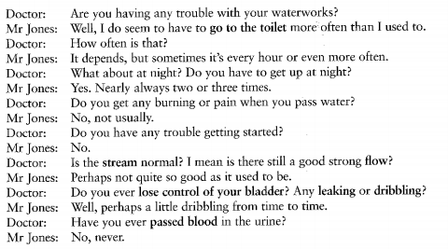
Now complete these notes about Mr Jones:
c/o (1) ………………………….. and (2)………………………………. for 1 yr. No (3) ………………………….. or (4) ……………………….
(5) ……………………………………. a little weaker. No incontinence apart from occasional (6) …………………………………….
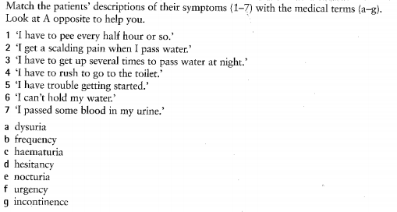
Write the doctor’s questions for each of the symptoms above.
1
2
3
4
5
6
7

