Senses Worksheet
A Complete the gaps with a word made from the word in brackets.
1 The ear has two very important functions – it __________ us to hear and it functions as… (ABLE)
2 The middle ear contains three tiny bones __________ as the auditory ossicles. (KNOW)
3 The _________ structures of the inner ear are the vestibule, cochlea and semicircular canals. (BONE)
4 The eyes are housed in orbits located within the ___________ bones at the front of the skull. (FACE)
5 The sclera is the white portion of the eye which serves as a __________ covering for the eye. (PROTECTION)
6 The conjunctiva is _____________, but appears white because it covers the sclera. (COLOUR)

B Is university damaging eyesight?
Students experience a marked decline ___(1) eyesight while at university, with too much "intensive" reading ___(2) blame, a study suggests. Researchers at Spain's Complutense University found 31.3% of first-years ___(3) short-sighted. Among those four to six years older, in their final year, the rate was 49%. Research author Dr Rafaela Garrido said many ___(4) the 270 students tested spent ___(5) to 10 hours at a time reading ___(6) poor light. She told BBC News Online: "Some students are spending ___(7) long in intensive near work with their eyes. It is also a problem with people __(8) spend too long on a computer or using a microscope. It's difficult to ask students to do less reading, ___(9) it is essential to passing courses, but we have to find ways to deal with the stress on the eyes." Research is ____(10) carried out into lenses to prevent myopia among those involved in intensive reading or screen-viewing.
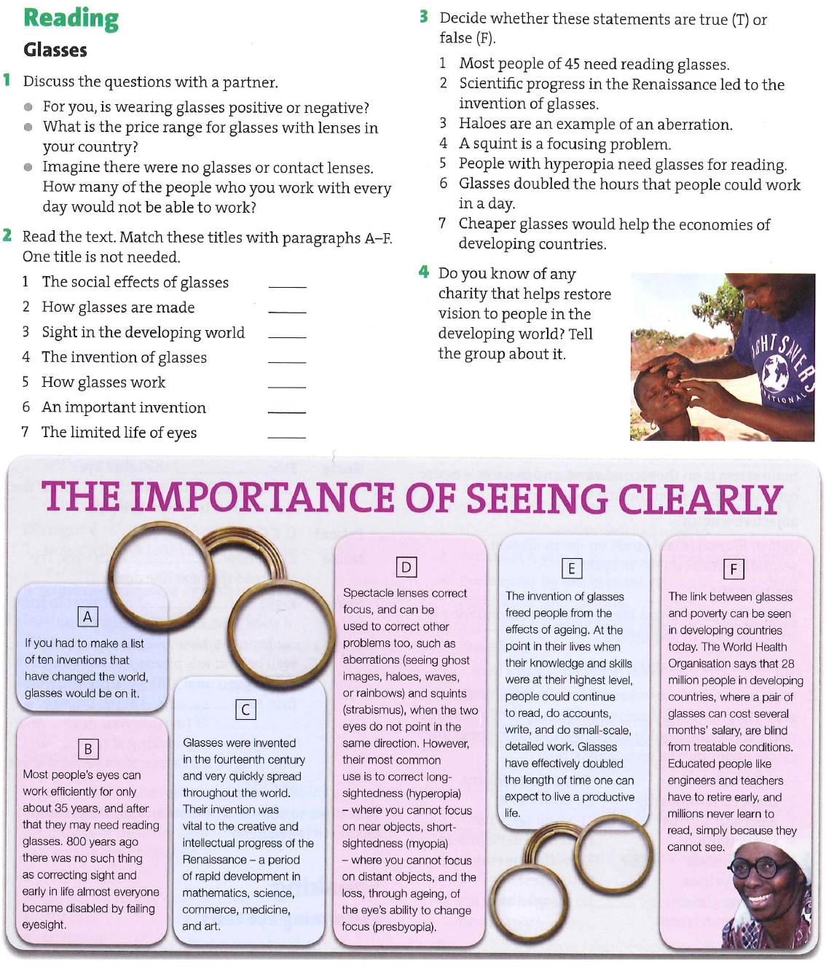
D Video – Ear
The ear has three parts: the outer ear or _____(1), the middle ear and the inner ear. The auricle, the visible part of the ear, collects sound waves and directs them to the _____(2) canal. The auditory, or ear canal is lined with ____(3) and ceruminous glands. The ear ____(4) from the ceruminous glands and the cilia protect the ear from entry by foreign matter. The thin tympanic membrane separates the outer ear from the middle ear. Sound waves cause it to vibrate. The three tiny bones of the middle ear are the hammer or malleus, ____(5) or incus, and stapes or stirrup. These bones pick up the vibrations from the tympanic membrane and transmit them to the inner ear. The Eustachian tube of the middle ear opens into the ____(6) and permits air pressure to equalize between the ear and the outside air.
The inner ear is maze-like, consisting of bony and membranous structures surrounded by fluid. The semi-circular canals are fluid-filled bony ____ (7) that help maintain our body’s balance.
The cochlea is a fluid-filled, _____(8) structure that houses the organ of Corti, the true organ of hearing. The fluid aids in the _____(9) of vibrations. The organ of Corti changes the vibrations into nerve impulses that are picked up by the auditory nerve.
Sound waves are collected by the auricle or outer ear and sent to the auditory canal, tympanic membrane, ear bones and then to the cochlea where the vibrations are changed by the organ of Corti to nerve impulses and transmitted by the auditory or _____(10) nerve to the temporal lobe of the brain for interpretation.
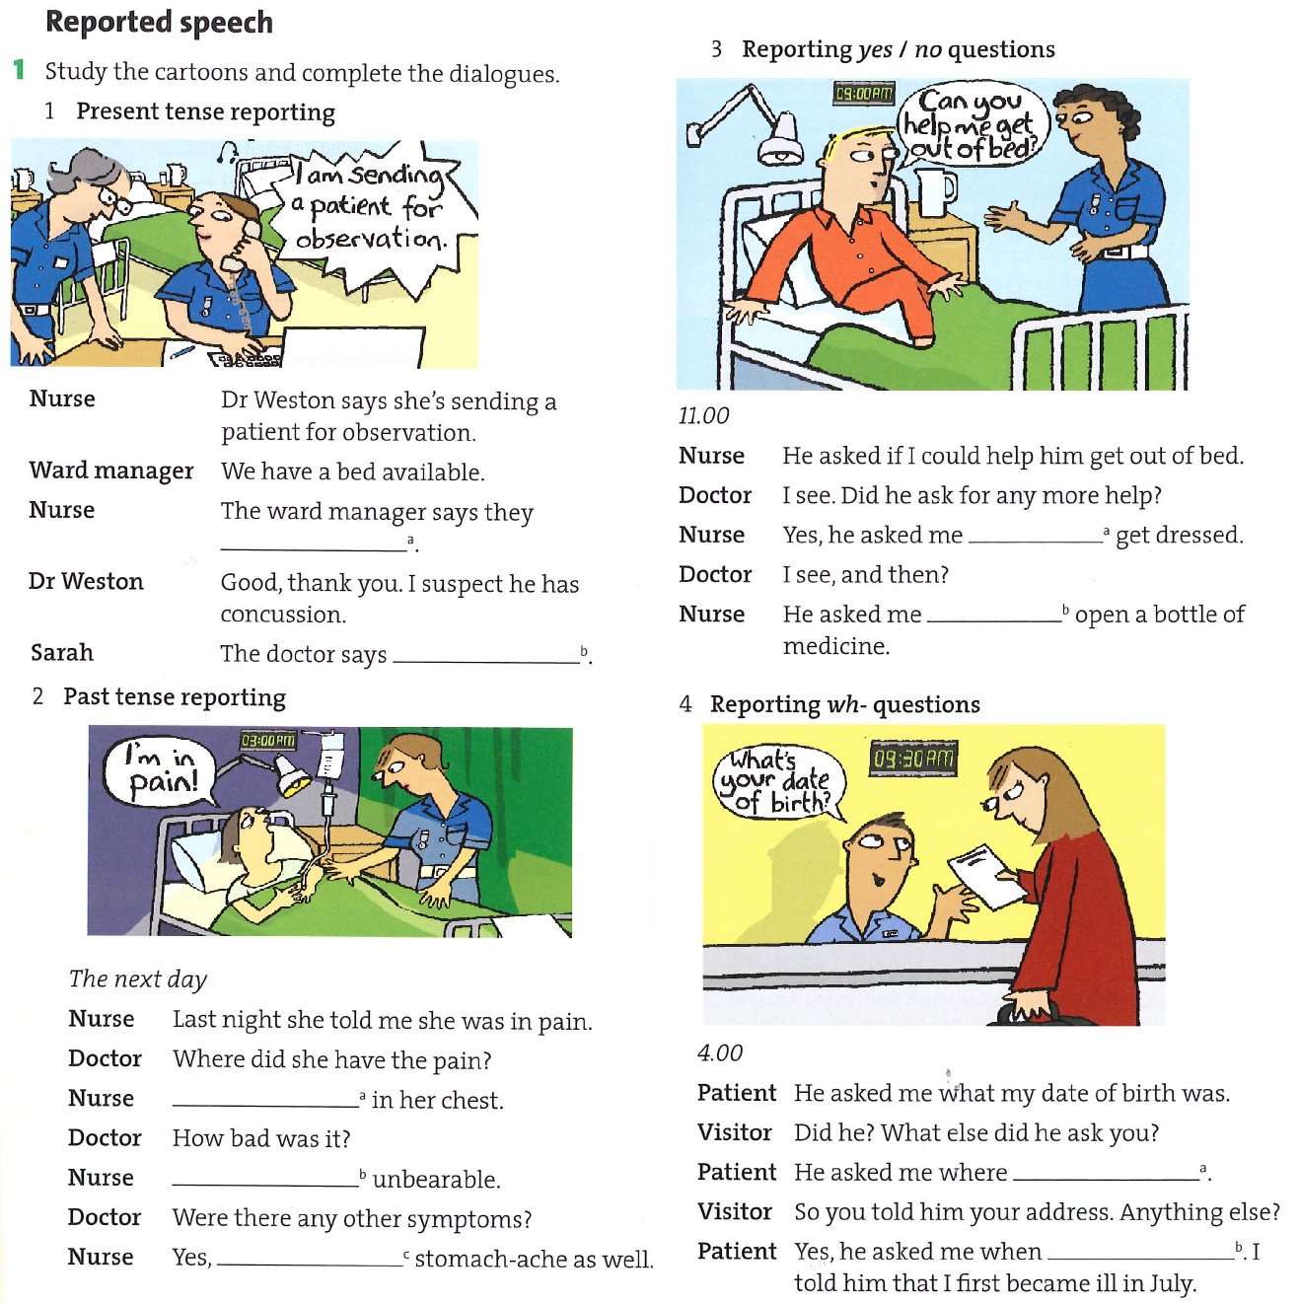
E Grammar point – Indirect speech

