X-Rays Worksheet

A History (cloze). Read the text and complete the missing words.
Medical radiology has now existed for over a century. It all started in 1895 when Wilhelm Roentgen discovered x-rays. On 28 December 1895 his manuscript ‘On a New Kind of Rays’ ___ (1) submitted to the Wurzburg Physical medical Institute. The essential features of x-rays were described and the new discovery aroused tremendous interest. Because the apparatus was available ____ (2) most physics departments, his results could easily _____(3) repeated.
At the start, the radiographs were made onto glass photographic plates; George Eastman introduced film in 1918. In recent years there has been a digital revolution and radiographic images are now recorded and stored digitally.
Most of the early x-ray work was performed _____(4) doctors and the departments were often combined with electro-therapeutic departments. However, from about 1903 lay x-ray operators were appointed _____(5) assistants. Training courses ______(6) set up and the Society of Radiographers _____(7) formed in 1920.
X-rays were used ___ (8) therapy from the earliest times. The techniques depended ____ (9) the development of more powerful apparatus, the use of multiple therapy beams and on the use of radium. The doctors in the x-ray department were involved in _____ (10) therapy and diagnosis. It was only _____ (11) the 1930s that doctors were appointed with specific interests in diagnosis or therapy.

B Vocabulary
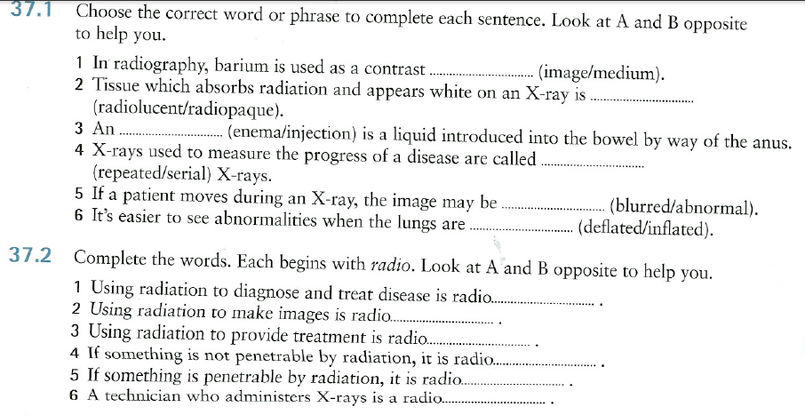

C Equipment – C-arm tutorial:
C1 Match the verbs with the nouns
1 push/hit a) the C-arm
2 turn b) the picture
3 unlock c) a tilt
4 take d) the button
5 save/flip e) the handle
6 pull/rotate f) a snapshot
7 make g) the foot brake

C2 Watch the video and answer the following questions
1 What is the purpose of the video?
2 What is the first thing to do when using the machine?
3 What kind of profiles are displayed?
4 What are the functions of the yellow and green buttons?
5 What is the function of the first two locks?
6 What two types of tilt are mentioned?
7 What happens if the footbrake is in a flat position?
8 What is the wig-wag used for?

D X-ray examination
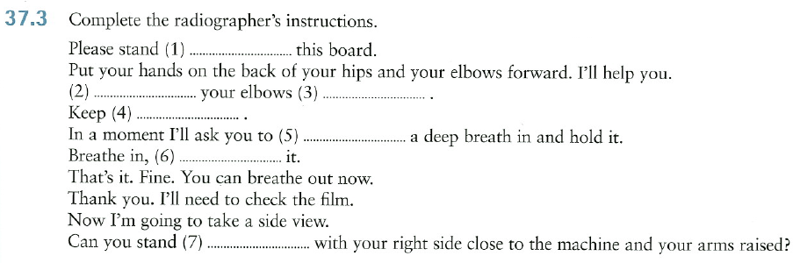

E Grammar Corner


