Nervous System
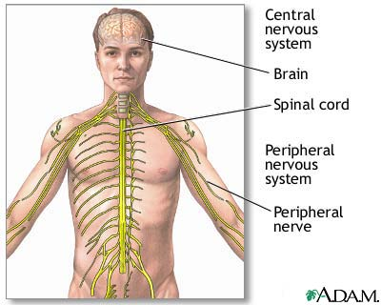
As a key homeostatic regulatory and coordinating system, it detects, interprets, and responds to changes in internal and external conditions. The nervous system integrates countless bits of information and generates appropriate reactions by sending electrochemical impulses through nerves to effector organs such as muscles and glands. The brain and spinal cord are the central nervous system (CNS); the connecting nerve processes to effectors and receptors serve as the peripheral nervous system (PNS). Special sense receptors provide for taste, smell, sight, hearing, and balance. Nerves carry all messages exchanged between the CNS and the rest of the body.

CNS: neurons, brain, spinal cord
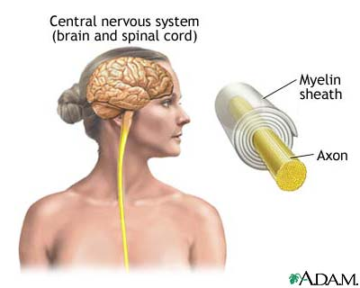
The neuron transmits electric signals like an electric wire. The perikaryon (cell body) is the neuron central part. Dendrites, short branches, extend from the neuron. These input channels receive information from other neurons or sensory cells (cells that receive information from the environment). A long branch, the axon, extends from the neuron as its output channel. The neuron sends messages along the axon to other neurons or directly to muscles or glands.
Neurons must be linked to each other in order to transmit signals. The connection between two neurons is a synapse. When a nerve impulse (electrical signal) travels across a neuron to the synapse, it causes the release of neurotransmitters. These chemicals carry the nerve signal across the synapse to another neuron.
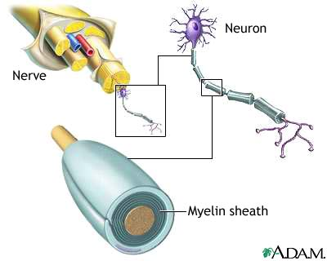
Nerve impulses are propagated (transmitted) along the entire length of an axon in a process called continuous conduction. To transmit nerve impulses faster, some axons are partially coated with myelin sheaths. These sheaths are composed of cell membranes from Schwann cells, a type of supporting cell outside the CNS. Nodes of Ranvier (short intervals of exposed axon) occur between myelin sheaths. Impulses moving along myelinated axons jump from node to node. This method of nerve impulse transmission is saltatory conduction.
The brain has billions of neurons that receive, analyze, and store information about internal and external conditions. It is also the source of conscious and unconscious thoughts, moods, and emotions. Four major brain divisions govern its main functions: the cerebrum, the diencephalon, the cerebellum, and the brain stem.
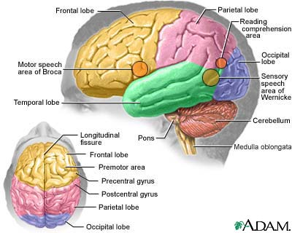
The cerebrum is the large rounded area that divides into left and right hemispheres (halves) at a fissure (deep groove). The hemispheres communicate with each other through the corpus callosum (bundle of fibers between the hemispheres). Surprisingly, each hemisphere controls muscles and glands on the opposite side of the body. Comprising 85 percent of total brain weight, the cerebrum controls language, conscious thought, hearing, somatosensory functions (sense of touch), memory, personality development, and vision.
Gray matter (unmyelinated nerve cell bodies) composes the cerebral cortex (outer portion of the cerebrum). Beneath the cortex lies the white matter (myelinated axons). During embryonic development, the cortex folds upon itself to form gyri (folds) and sulci (shallow grooves) so that more gray matter can reside within the skull cavity.
The diencephalon forms the central part of the brain. It consists of three bilaterally symmetrical structures: the hypothalamus, thalamus, and epithalamus. The hypothalamus 'master switchboard' resides in the brain stem upper end. It controls many body activities that affect homeostasis (maintenance of a stable internal environment in the body).
The hypothalamus is the main neural control center (brain part that controls endocrine glands). The pituitary gland lies just below the hypothalamus. The pituitary gland is a small endocrine gland that secretes a variety of hormones (organic chemicals that regulate the body's physiological processes). When the hypothalamus detects certain body changes, it releases regulating factors (chemicals that stimulate or inhibit the pituitary gland). The pituitary gland then releases or blocks various hormones. Because of this close association between the nervous and endocrine systems, together they are called the neuroendocrine system.
The hypothalamus also regulates visceral (organ-related) activities, food and fluid intake, sleep and wake patterns, sex drive, emotional states, and production of antidiuretic hormone (ADH) and oxytocin. The pituitary gland produces both these hormones.
The thalamus is a relay and preprocessing station for the many nerve impulses that pass through it. Impulses carrying similar messages are grouped in the thalamus, then relayed to the appropriate brain areas.
The epithalamus is the most dorsal (posterior) portion of the diencephalon. It contains a vascular network involved in cerebrospinal fluid production. Extending from the epithalamus posteriorly is the pineal body, or pineal gland. Its function is not yet fully understood; it is thought to control body rhythms.
At the rear of the brain is the cerebellum. The cerebellum is similar to the cerebrum: each has hemispheres that control the opposite side of the body and are covered by gray matter and surface folds. In the cerebellum, the folds are called folia; in the cerebrum, sulci. The vermis (central constricted area) connects the hemispheres. The cerebellum controls balance, posture, and coordination.
The brain stem connects the cerebrum and cerebellum to the spinal cord. Its superior portion, the midbrain, is the center for visual and auditory reflexes; examples of these include blinking and adjusting the ear to sound volume. The middle section, the pons, bridges the cerebellum hemispheres and higher brain centers with the spinal cord. Below the pons lies the medulla oblongata; it contains the control centers for swallowing, breathing, digestion, and heartbeat.
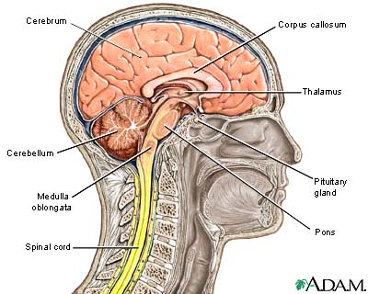
The reticular formation extends throughout the midbrain. This network of nerves has widespread connections in the brain and is essential for consciousness, awareness, and sleep. It also filters sensory input, which allows a person to ignore repetitive noises such as traffic, yet awaken instantly to a baby's cry.
The spinal cord is a continuation of the brain stem. It is long, cylindrical, and passes through a tunnel in the vertebrae called the vertebral canal. The spinal cord has many spinal segments, which are spinal cord regions from which pairs (one per segment) of spinal nerves arise. Like the cerebrum and cerebellum, the spinal cord has gray and white matter, although here the white matter is on the outside. The spinal cord carries messages between the CNS and the rest of the body, and mediates numerous spinal reflexes such as the knee-jerk reflex.
Meninges, three connective tissue layers, protect the brain and spinal cord. The outermost dura layer forms partitions in the skull that prevents excessive brain movement. The arachnoid middle layer forms a loose covering beneath the dura. The innermost pia layer clings to the brain and spinal cord; it contains many tiny blood vessels that supply these organs.
Another protective substance, cerebrospinal fluid, surrounds the brain and spinal cord. The brain floats within the cerebrospinal fluid, which prevents against crushing under its own weight and cushions against shocks from walking, jumping, and running.

PNS: somatic (voluntary) nervous system, autonomic (involuntary) nervous system
The peripheral nervous system includes sensory receptors, sensory neurons, and motor neurons. Sensory receptors are activated by a stimulus (change in the internal or external environment). The stimulus is converted to an electronic signal and transmitted to a sensory neuron. Sensory neurons connect sensory receptors to the CNS. The CNS processes the signal, and transmits a message back to an effector organ (an organ that responds to a nerve impulse from the CNS) through a motor neuron.
The PNS has two parts: the somatic nervous system and the autonomic nervous system. The somatic nervous system, or voluntary nervous system, enables humans to react consciously to environmental changes. It includes 31 pairs of spinal nerves and 12 pairs of cranial nerves. This system controls movements of skeletal (voluntary) muscles.
Thirty-one pairs of spinal nerves emerge from various segments of the spinal cord. Each spinal nerve has a dorsal root and a ventral root. The dorsal root contains afferent (sensory) fibers that transmit information to the spinal cord from the sensory receptors. The ventral root contains efferent (motor) fibers that carry messages from the spinal cord to the effectors. Cell bodies of the efferent fibers reside in the spinal cord gray matter. These roots become nerves that innervate (transmit nerve impulses to) muscles and organs throughout the body.
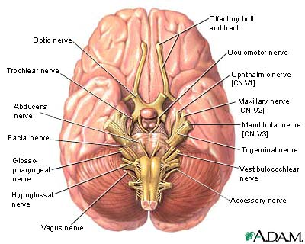
Twelve pairs of cranial nerves transmit from special sensory receptors information on the senses of balance, smell, sight, taste, and hearing. Cranial nerves also carry information from general sensory receptors in the body, mostly from the head region. This information is processed in the CNS; the resulting orders travel back through the cranial nerves to the skeletal muscles that control movements in the face and throat, such as for smiling and swallowing. In addition, some cranial nerves contain somatic and autonomic motor fibers.
The involuntary nervous system (autonomic nervous system) maintains homeostasis. As its name implies, this system works automatically and without voluntary input. Its parts include receptors within viscera (internal organs), the afferent nerves that relay the information to the CNS, and the efferent nerves that relay the action back to the effectors. The effectors in this system are smooth muscle, cardiac muscle and glands, all structures that function without conscious control. An example of autonomic control is movement of food through the digestive tract.
The efferent portion of the autonomic system is divided into sympathetic and parasympathetic systems. The sympathetic nerves mobilize energy for the 'Fight or Flight' reaction during stress, causing increased blood pressure, breathing rate, and blood flow to muscles. Conversely, the parasympathetic nerves have a calming effect; they slow the heartbeat and breathing rate, and promote digestion and elimination.
The relationship between sensory and motor neurons can be seen in a reflex (rapid motor response to a stimulus). Reflexes are quick because they involve few neurons. Reflexes are either somatic (resulting in contraction of skeletal muscle) or autonomic (activation of smooth and cardiac muscle). All reflex arcs have five basic elements: a receptor, sensory neuron, integration center (CNS), motor neuron, and effector.
Spinal reflexes are somatic reflexes mediated by the spinal cord. These can involve higher brain centers. In a spinal reflex, the message is simultaneously sent to the spinal cord and brain. The reflex triggers the response without waiting for brain analysis. If a finger touches something hot, the finger jerks away from the danger. The burning sensation becomes an impulse in the sensory neurons. These neurons synapse in the spinal cord with motor neurons that cause the burned finger to pull away. This spinal reflex is a flexor, or withdrawal reflex.
The stretch reflex occurs when a muscle or its tendon is struck. The jolt causes the muscle to contract and inhibits antagonist muscle contraction. A familiar example is the patellar reflex, or knee-jerk reflex, that occurs when the patellar tendon is struck. The impulse travels via afferent neurons to the spinal cord where the message is interpreted. Two messages are sent back, one causing the quadriceps muscles to contract and the other inhibiting the antagonist hamstring muscles from contracting. The contraction of the quadriceps and inhibition of hamstrings cause the lower leg to kick, or knee-jerk.

