**Disorders of the eye**

**Myopia (Short sight, nearsightedness):** The elongation of the eyeball results in myopia. The image of the object is formed in front of the retina rather than on it. Such persons are not able to see distant objects clearly. Concave lens is used to rectify this.

**Hypermetropia (Long sight, farsightedness):** What happens if the eyeball shortens? The image is formed behind the retina. Such persons cannot see near objects clearly though they are able to see distant objects. Convex lens is used to rectify this disorder.

**Astigmatism:** Like the shape of the eyes any disorder in the curvature of the cornea or lens affects the vision. This results in the formation of incomplete and blurred images of objects. This state is known as astigmatism. This disorder is rectified using suitable cylindrical lenses.

**The chemistry of vision**

We have understood that where the image of the objects are formed in the eye. Photoreceptors such as rod cells and cone cells are present in the retina. Rod cells get stimulated in dim light. Thus it helps the vision in dim light. But cone cells get stimulated only in bright light. The cone cells help to distinguish colours and to see the objects in bright light.

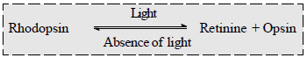 Observe the figure 4.8 and study the structure and distribution of rod cells and cone cells. The pigment seen in the rod cells is rhodopsin. When light falls on it, rhodopsin dissociates. Note the chemical change that takes place. The impulses formed as a result are received as a stimulus by the nerve cells. Retinine, which is the part of the rhodopsin, is synthesized from Vitamin A. Now it is clear that the deficiency of vitamin A causes Night blindness.

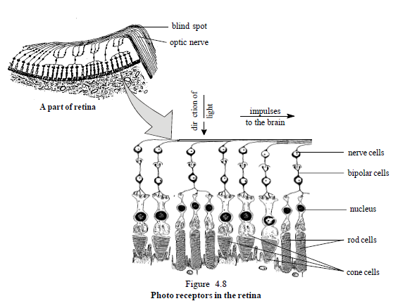 There are different types of cone cells to recognise the primary colours blue, green and red. They contain different types of a pigment called iodopsin which helps us to recognise the primary colours. Damages in any of these cone cells may cause inability to distinguish colours. This is called colour blindness.

**The blind spot and the yellow spot**

The part of the retina where the optic nerve begins lacks rod cells and cone cells. Can you see if the image is formed in this part? Therefore this part is called blind spot. The part which is seen almost in the centre of the retina is called yellow spot. More cone cells are present here. There are no rod cells. It is the point of highest vision. When we concentrate on small objects the image is formed here.

**Dalton and the colours**

"I am able to distinguish only blue and yellow". These are the words of John Dalton who formulated the atomic theory. This deficiency known as Daltonism was later named colour blindness. Colour blindness is found more in males than in females. What is the reason for this? The genes responsible for the synthesis of iodopsin is present in X chromosome. Though colour blindness was experienced by Dalton, it was Robert Boyle who explained it first.

**The physiology of vision**

You have understood that the light which falls on the photoreceptors cause a chemical change. This stimulus creates impulses that travel through the optic nerve which is formed by the clustering of axons of the photoreceptors, reaches the cerebrum. Though the image formed in the retina is inverted, do we feel it is our vision? It is the cerebrum which makes the vision a reality.

**Binocular vision**

Though the image of an object is formed in both the eyes we do not feel it as two separate images. It is the cerebrum which coordinates the images formed in both the eyes. Then what is the need for the two eyes?

The binocular vision helps us to calculate the distance from objects correctly. This is not possible for all animals. Binocular vision is obtained since it is possible to concentrate both eyes on a single object. The balanced movement of the two eyes is made possible by the muscles of the eyeball. There are three pairs of muscles which connect the eye to the walls of the eye sockets. What will happen if the balanced movement of the muscles is not possible? This condition is called squint. Early detection of this disorder can be rectified by a careful surgery.

**Glaucoma (ocular hypertension)**

We have understood that the production and reabsorption of the aqueous humour is a continuous process. If its reabsorption is prevented, the pressure inside the aqueous chamber is increased. The increase in pressure in the eyeball results in glaucoma. The curvature of the cornea changes due to the increase in pressure. The patient gets pain in his eyes and he sees colour rings around a flame. As this continues, the extraordinary pressure causes the receptor cells to disintegrate. If left untreated the patient may lose vision, and even become blind. The disease generally affects both eyes, although one may have more severe signs and symptoms than the other.

**The eyes that long to live**

Of the total blind population, 5% is in India. We know that there are various reasons for blindness. But the majority of the blind have blindness due to the disorder in their cornea. The only remedy for this is cornea transplantation. Removal of the damaged cornea and transplantation of a healthy cornea in its place is effected by a surgery known as keratoplasty.

It is not possible to make an artificial cornea. The only way is to receive it from a donor. This makes donation of the eye a great gift. If the eye is removed from the dead within reasonable time, it can be used for Keratoplasty. The eyes of the dead can thus continue to live through another.

**Disorders of the ear**

Deafness means a lack or loss of the sense of hearing, which may be partial or complete. Partial loss of hearing is often called hearing loss rather than deafness. Deafness can occur in one or both ears.

There are three primary types of hearing loss:

* Conductive-hearing loss caused by the inability of the sound to reach the inner ear. This can result from outer or middle ear problems, such as ear infection, excess wax, or swelling. This type of hearing loss is most likely to respond to medical or surgical treatment.
* Sensorineural-hearing loss caused by disorders of the inner ear or auditory nerve. This type of loss is usually permanent. It can be caused by heredity or congenital problems, excess noise, old age, medications, infections such as ear infections and meningitis, or from tumours compressing the nerve of hearing such as an Acoustic Neuroma.
* Mixed-hearing losses that are a combination of both conductive and sensorineural loss.

Otitis is a general term for inflammation or infection of the ear. It is subdivided into the following:

* Otitis externa, external otitis, or "swimmer's ear" involves the outer ear and ear canal. In external otitis, the ear hurts when touched or pulled.
* Otitis media or middle ear infection involves the middle ear. In otitis media, the ear is infected or clogged with fluid behind the ear drum, in the normally air-filled middle-ear space. This very common childhood infection sometimes requires a surgical procedure called "myringotomy and tube insertion".
* Otitis interna or labyrinthitis involves the inner ear. The inner ear includes sensory organs for balance and hearing. When the inner ear is inflamed, vertigo is a common symptom. Vertigo is a feeling of spinning or whirling when you are not moving. It can also be an exaggerated feeling of motion without moving your body. It is the most common form of dizziness, but is different from light-headedness (the feeling of nearly passing out).

**The tongue**

We know that tongue is the sense organ which helps to perceive taste. We can examine how this happens. Numerous papillae protrude from the surface of the tongue. Each papilla contains numerous taste buds. Taste buds are built up of many receptor cells. Do you know how these help us in tasting? The molecules of substances which dissolve in the saliva stimulate the receptors in the taste bud. This stimulus is carried to the brain by nerves. Our tongue has receptors which distinguish only the primary tastes sweet, sour, salt and bitter. Other tastes are secondary tastes which are created by the cerebrum.

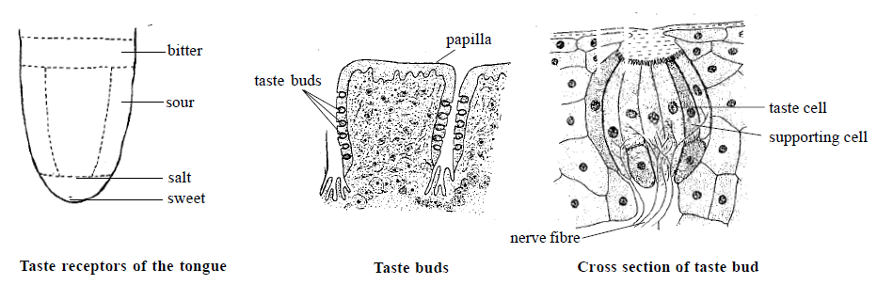

**Nose**

You know how the nose helps in breathing and olfaction. Observe the figure below and understand the position and distribution of the olfactory receptors. Where do the ends of the olfactory receptors touch?

You should also know how the olfactory receptors of the nose help in recognising smell. The chemical molecules of any odoriferous substance that enter the nose with the inspired air dissolve in the mucus and stimulate the olfactory receptors. This stimulus is carried by the olfactory nerve to the cerebrum and thereby helps in olfaction.

There are special centres in the cerebrum which helps in the perception of smell. We will not be able to perceive the smell if excess mucus is produced. Now you know why you are unable to recognise smell when you have a cold.

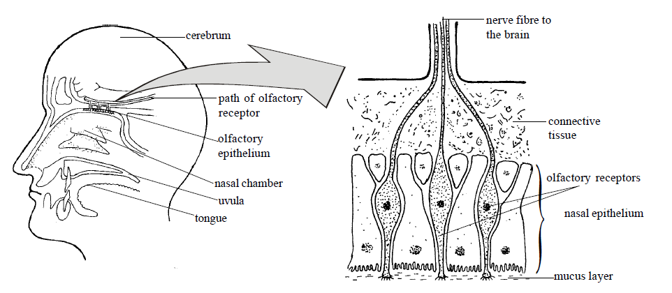

Sources:

http://www.thirdage.com/hc/g/ear-disease-types

http://en.wikipedia.org/wiki/Otitis