EIA / MEIA Worksheet

1 Vocabulary warm-up
1 microparticle vázat se
2 coated skleněná vlákna
3 capture molecule zvýšit/snížit
4 surface area promytí cely
5 reaction vessel značený
6 matrix cell rychlost
7 glass fibres odstranit
8 binding zadržet
9 cause mikročástice
10 retain povrch
11 labelled reakční nádobka
12 bind způsobit, zapříčinit
13 cell wash navázání
14 remove potažený
15 rate matricová buňka
16 increase/decrease záchytová molekula

2 Microtitre plates
Read and fill the gaps.

A microtitre plate (spelled Microtiter is a registered trade name in the United States) or microplate or microwell plate or multiwall, is a flat plate with _____ (MULTI) "wells" used as small test tubes. The microplate has become a standard tool in ______ (ANALYSIS) research and clinical ________ (DIAGNOSIS) testing laboratories. A very common usage is in the enzyme-linked immunosorbent assay (ELISA), the basis of most modern ______ (MEDICINE) diagnostic testing in humans and animals.

Each well of a microplate ________ (TYPICAL) holds somewhere between tens of nanolitres to several millilitres of liquid. They can also be used to store dry powder or as racks to support glass tube inserts. Wells can be either _______ (CIRCLE) or square. Microplates can be stored at low temperatures for long periods, may be heated to increase the rate of solvent ________ (EVAPORATE) from their wells and can even be heat-sealed with foil or clear film. Microplates with an ________ (EMBED) layer of filter material were developed in the early 1980s by several companies, and today, there are microplates for nearly every _________ (APPLY) in life science research which involves filtration, ________ (SEPARATE), optical detection, _________ (STORE), reaction mixing or cell culture.

Listening
A Listen and complete the gaps
1 the EIA can be done in a multi-well microtiter plate or any other solid adherent ___________
2 the plate is prepared to perform a particular assay by _________ the wells with antibodies that bind to the antigen of interest
3 then the _________ are filled with the clinical sample which could be a sample of serum, respiratory secretions, cerebrospinal fluid, urine or some other body fluid
4 if the antigen is present in the sample, it will ___________ to the fixed antibodies
5 the wells are then washed out to remove any of the unattached __________, leaving the antigen of interest stuck to the wells
6 the second _____________, directed against another epitope on the target antigen is added
7 these antibodies are conjugated covalently to an ________________
8 they bind to the antigen which is fixed in the well and this provides a second level of ___________ for the assay
9 the wells are washed again to remove any ______________ antibodies
10 a ____________ of colorigenic enzyme substrate is added

B Find words for the following definitions:
1 not soft, hard
2 determination of the amount of a particular constituent of a mixture
3 take away
4 joined together
5 causing a substance to change colour

3 Describing the assay
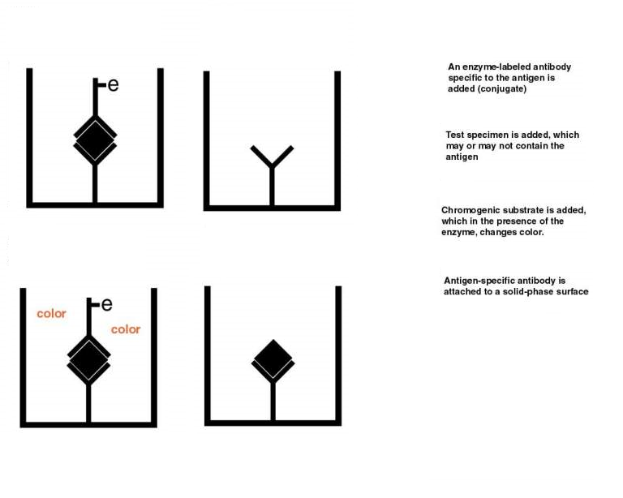

4 Grammar – Passive voice
