Flow Cytometry Worksheet

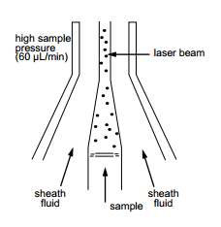
Flow cytometry is a technology that measures and then analyses multiple physical characteristics of single p_ _ _ _ _ _ _ _s, usually cells, as they flow in a f_ _ _d stream through a b_ _m of light. The properties measured include a particles’ relative size, relative g_ _ _ _ _ _ _ _ _y or internal c_ _ _ _ _ _ _ _y, and relative f_ _ _ _ _ _ _ _ _ _e intensity. These characteristics are determined using an optical-to-electronic coupling system. This system records how the cell or particle s_ _ _ _ _ _s laser light and e_ _ _s fluorescence.
A flow cytometer is made up of three main systems: fluidics, optics and electronics.
The fluidics system transports particles in a stream to the laser beam for interrogation.
The optics system consists of lasers to i_ _ _ _ _ _ _ _e the particles in the sample stream and optical filters to direct the resulting light signals to the a_ _ _ _ _ _ _ _ _e detectors.
The electronics system c_ _ _ _ _ _s the detected light signals into electronic signals. These signals can then be p_ _ _ _ _ _ _d by the computer.
In the flow cytometer, particles are carried to the laser intercept in a fluid stream. Any suspended particle or cell from 0.2-150 micrometers in size is suitable for analysis. The portion of the fluid stream where particles are located is called the sample core. When particles pass through the laser intercept, they scatter laser light. Any fluorescent molecules present on the particle fluoresce. The scattered and fluorescent light is collected by appropriately positioned l_ _ _ _s. A combination of beam splitters and filters brings the scattered and fluorescent light to the appropriate detectors. The detectors produce electronic signals. These signals correspond with the optical signals striking the detectors.

Questions:
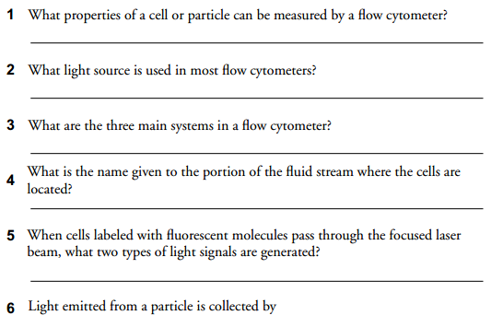

Flow cytometry – listening
A Match these words to make collocations:
1 compare a cells through the cytometer
2 treat b cells into a single file
3 put c through the laser beam
4 pass d to the blood
5 detect e patients
6 spread f results
7 label g leukaemia
8 align h with a fluorescent antibody

B Listen and decide if the statements are true or false.
1 Dr Wallace meets a lot of patients every day.
2 He mentions three examples of samples he works with.
3 As examples of antigens, CD4, leukaemia and lymphoma antigens are talked about.
4 As part of his job, he looks for ways to eradicate minimal residual disease.
5 The flow cytometers in their laboratory can handle up to 70 000 cells per hour.
6 With their equipment, they can find one cell out of 500 000.
7 They are able to get results in two hours.
8 Cytogenetics and the molecular are mentioned as examples of ancillary tests.

Vocabulary warm-up
1 Particles odpovídající, příslušný
2 Fluid vydávat, vyzařovat
3 Beam čočky
4 Granularity optická lavice/soustava
5 Complexity zpracovat
6 Fluorescence granularita
7 Emit částice
8 Scatter paprsek
9 Illuminate složení (buňky)
10 Appropriate kapalina
11 Convert světélkování
12 Process laločnatost
13 Lenses rozptýlit
14 Lobularity osvítit, ozářit
15 Optical bench přeměnit

Grammar point
Past perfect (předminulý čas)

