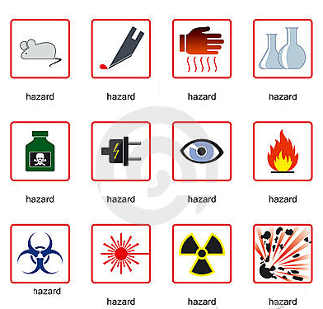
Safety in Laboratory
A Match the icons with the type of hazard
1 chemical
2 radioactive
3 fire
4 electrical
5 animal
6 bio
7 sharp instrument
8 glassware
9 eye and face
10 heat
11 explosive
12 laser radiation

B Some rules. Read the rules below and write a number according to the type of safety measure.
1 General and personal safety
2 Electrical safety
3 Chemical safety
4 Laser safety
Treat every chemical as if it were hazardous. ____
If leaving a lab unattended, turn off all ignition sources and lock the doors. ____
NEVER, EVER LOOK INTO ANY LASER BEAM, no matter how low power or "eye safe" you may think it is. ____
Avoid using extension cords whenever possible. ____
Never eat, drink, or smoke while working in the laboratory. ____
Clothing: When handling dangerous substances, wear gloves, laboratory coats, and safety shield or glasses. Shorts and sandals should not be worn in the lab at any time. ____
Never allow a solvent to come in contact with your skin. Always use gloves. ____
Never return chemicals to reagent bottles. ____
Wash hands before leaving the lab and before eating. ___
Never pipette anything by mouth. ____
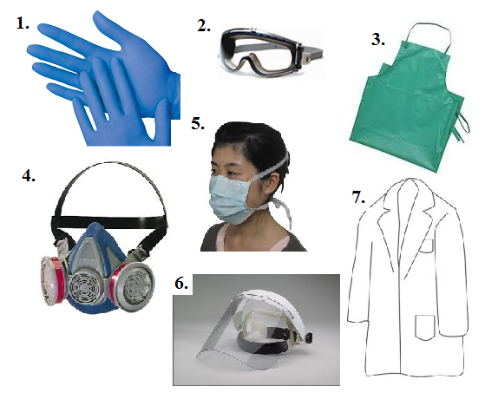
C Protective equipment
a) (face) mask
b) shield
c) gown/coat
d) gloves
e) respirator
f) goggles /glasses
g) apron
D Grammar point
1 Conditional (I would)

2 Conditional clauses I (real) and II (imaginary)
