## Instructions: BDAJ0222 Angličtina II (jaro 2016)

Homework till 16th/18th March:

1. Study Lesson 5 in New English File Elementary, and then complete the test “NEF UNIT 5”.

2. Print and bring “5_Lesson materials” from “Lesson 5 - First aid and instructions”.

### Online materials

The online materials, homework and quizzes for our English course are here:

Online materiály, domácí úlohy a kvízy pro náš kurz angličtiny jsou zde:

<https://www.schoology.com/home.php> access code: X4VM3-WW3N9

Textbook **– buy/borrow this textbook, you will need it for self-study**

**New English File Elementary Student’s Book and Work Book (NEF)**

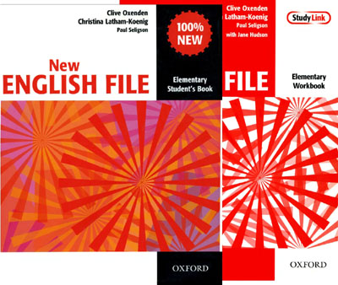

or

**New English File Elementary Multipack A (NEF) – and in the spring semester Multipack B**

To pass the course you must:

* not miss more than one lesson (miss=chybět, more than=více než)
* do homework and participate in the lessons actively – you get plus points for active participation, you get minus points for not doing homework (participate in=účastnit se, participation=účast, get=dostat, do homework=dělat domácí úkoly
* pass the mid-term test – study Lesson 5 and 6 from NEF + materials from the seminar, minimum 65 %, you can take the test twice (pass=složit, mid-term test=polosemestrový test, take test=dělat test, twice=dvakrát)
* pass the final test – study New English File Elementary (lessons 1-9= the whole book) + materials from the seminar (from the whole year), minimum 65 %, you can take the test up to three times

How to register in schoology

1. Enter the address: <https://www.schoology.com/home.php>

2. Click on “Sign up”

3. Click on “Student”

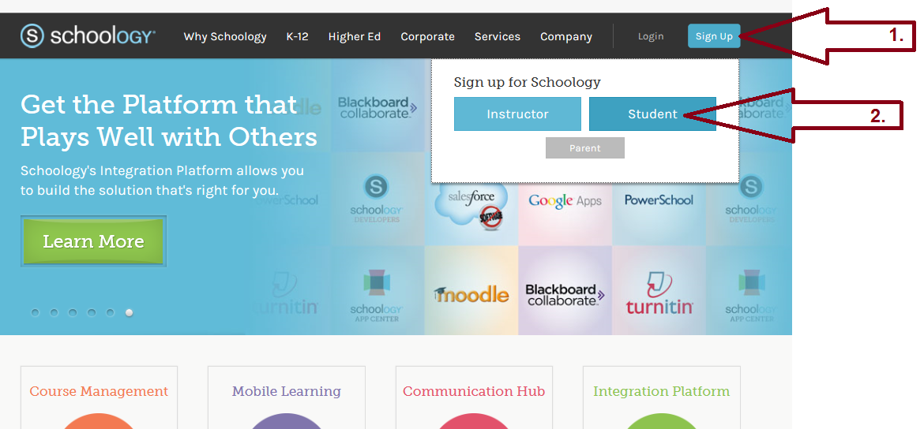

4. Enter the code: X4VM3-WW3N9

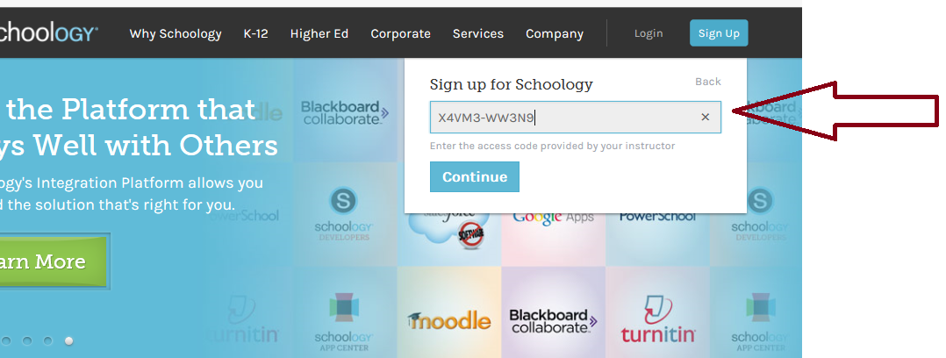

5. Complete your name etc., and click on “register”

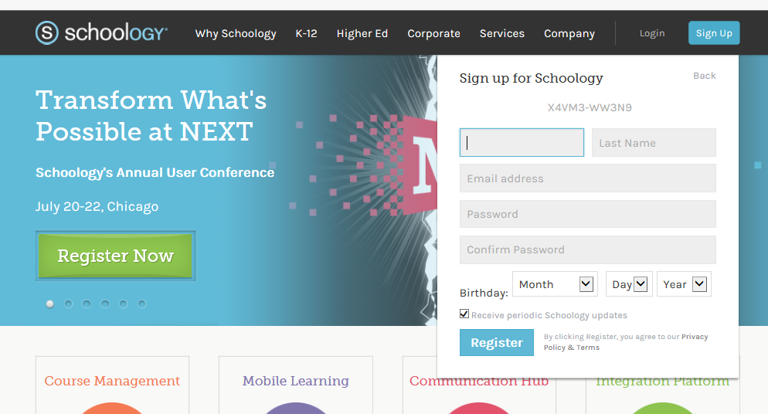

6. Click on “Courses” and then click on “Join”

