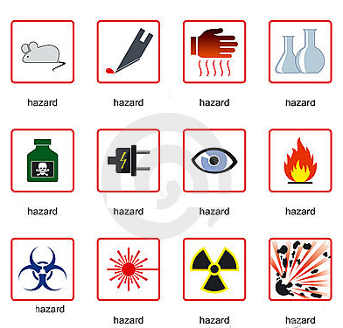
Safety in Laboratory
A Hazard. Use the icons to complete the type of hazard.
1 c_ _ _ _ _ _l
2 r_ _ _ _ _ _ _ _ _e
3 f_ _e
4 e_ _ _ _ _ _ _ _l
5 a_ _ _ _l
6 b _o
7 s_ _ _ _p instrument
8 g_ _ _ _ware
9 e _e and face
10 h_ _t
11 e_ _ _osive
12 l_ _ _ _r radiation

B Safety measures. Read the rules below and decide about the type of hazard.
Treat every chemical as if it were hazardous. ____
If leaving a lab unattended, turn off all ignition sources and lock the doors. ____
NEVER, EVER LOOK INTO ANY LASER BEAM, no matter how low power or "eye safe" you may think it is. ____
Avoid using extension cords whenever possible. ____
Never eat, drink, or smoke while working in the laboratory. ____
When handling dangerous substances, wear gloves, laboratory coats, and safety shield or glasses. Shorts and sandals should not be worn in the lab at any time. ____
Never allow a solvent to come in contact with your skin. Always use gloves. ____
Never return chemicals to reagent bottles. ____
Wash hands before leaving the lab and before eating. ___
Never pipette anything by mouth. ____

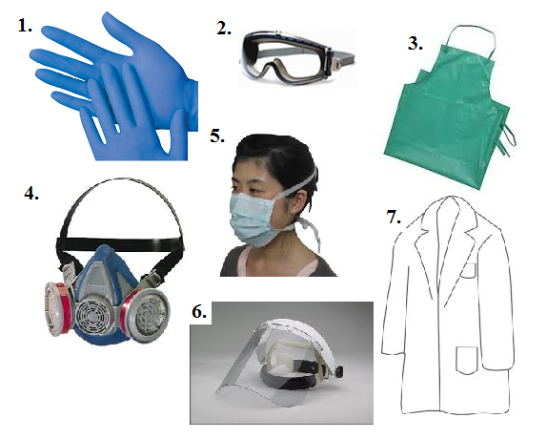
C Protective equipment
a) (face) mask
b) shield
c) gown/coat
d) gloves
e) respirator
f) goggles /glasses
g) apron

D Grammar point
1 Conditional (I would)

2 Conditional clauses I (real) and II (imaginary)
