Microscope/microbiology worksheet

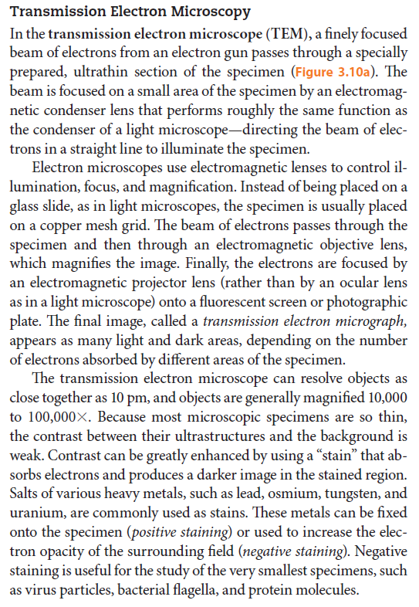
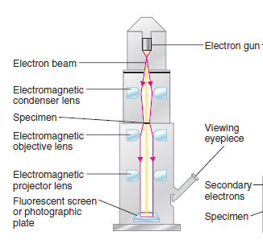

A Read the text and find the synonyms for these words:
1 very thin (1)
2 approximatively (1)
3 to shine light on sth (1)
4 to make look larger (2)
5 last (2)
6 to start to be seen (2)
7 to determine (3)
8 to improve the quality (3)

B Read the text and answer the questions:
1 Which part of the electron microscope is used to direct the beam of electrons onto the specimen?
2 Which part of the EM controls focus?
3 Where is the specimen usually placed in the EM?
4 Does the beam of electrons pass first through the specimen or the objective lens?
5 How do you call the picture obtained by the EM?
6 What is the resolution and the magnification of the EM?
7 How do you improve the contrast?
8 What is the difference between positive and negative staining?

How to properly prepare and use a microscope
Listen and complete:
Step 1 When transporting a microscope, always use ________________, using your left hand to hold the ________________. Hold the ______________ with your right hand for support.
Step 2 Rotate the revolving ___________ to the lowest power or the shortest _____________ lens
Step 3 Fasten the microscope __________ to the stage using the stage ____________
Step 4 Use the coarse adjustment ____________ to lower the lenses as far as they will go without touching the _____________
Step 5 While looking through the ___________, you can maintain better viewing by keeping both eyes open
Step 6 Adjust the light source and _______________ to get the greatest amount of light
Step 7 Slowly turn the ______________ adjustment knob towards your body
Step 8 Use the _____________ adjustment knob to focus the image as much as possible
Step 9 Move the ___________ to centre the image in your filter view
Step 10 Rotate the _______________ nosepiece to increase the objective lens power
Step 11 Use the coarse adjustment knob to _____________ the objective lens
Step 12 _______________ the slide and click the lowest power objective lens into position

Match the parts of the microscope with their function:
1 The ocular lens a) is used for moving the stage greater distances
2 The body tube b) hold the slides in place
3 The arm c) is used for focusing the specimen
4 The base d) is used to vary the intensity and size of the cone of light
5 The light source e) supports the tube and connects it to the base
6 The stage f) connects the eyepiece to the objective lenses
7 Stage clips g) is usually 10-15 magnification
8 The revolving nosepiece h) is used to send light up to the bottom of the stage
9 The diaphragm i) is the flat platform for placing slides
10 The coarse adjustment knob j) holds two or more objective lenses
11 The fine adjustment knob k) is the bottom of the microscope and is used for support

Grammar corner – relative clauses



