**03_Key: Musculoskeletal system-disorders**

**1. Explain these words in English:**

ligament

sling

to tear

to sprain

dislocation

herniated disc

impair

inflammation

crutches

curvature

joint

plaster

**2. Discuss these questions with your partner:**

1. What happens if skeletal system does not manage to withstand the pressures and stresses of daily activities?

2. What human activities often jeopardize the bones? And what toll do they take on the musculoskeletal system?

3. What are the negative effects of dislocation? (consider ligaments, nerves and bones)

4. What problems can people have with their vertebral column due to injury and what due to hereditary factors?

5. What disorders in musculoskeletal system are caused due to wear and tear of the body?

6. What disease/disorder which impairs the function of skeletal system do you consider the most serious and why?

**1. Fractures**

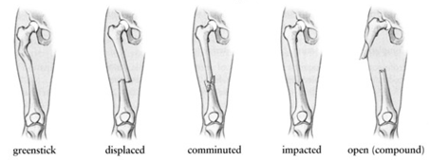

1.a, 2. c, 3. d, 4. b, 5. e

**2. Treatment of fractures: Word Formation.**

1. broken, 2. Union, 3. anatomical, 4. reduction/reducing, 5. excessive, 6. fixation, 7. malunion

**Disorders of the skeletal system: Describe the diseases with the help of the verbs which follow the respective disease.**

Arthritis: mean, involve, persist, be widespread, cripple

Osteoarthritis: occur, to be characterized by, to be seen in, include, wear away, rub, cause, to be affected by, use, reduce

Osteoporosis: mean, occur, dissolve, maintain, decrease, become, break, sneeze, cause, prevent, adhere to (keep to), avoid, smoke, drink, exercise

Scoliosis: view, appear, cause, interfere with, lead to, depend on, wear, correct, slow down, require, progress, straighten, fuse together

Spina bifida: include, cause, open, fail, wrap completely, leave unprotected, treat, close, prevent, operate, be dependent on

**4. Listening:** see the transcript below

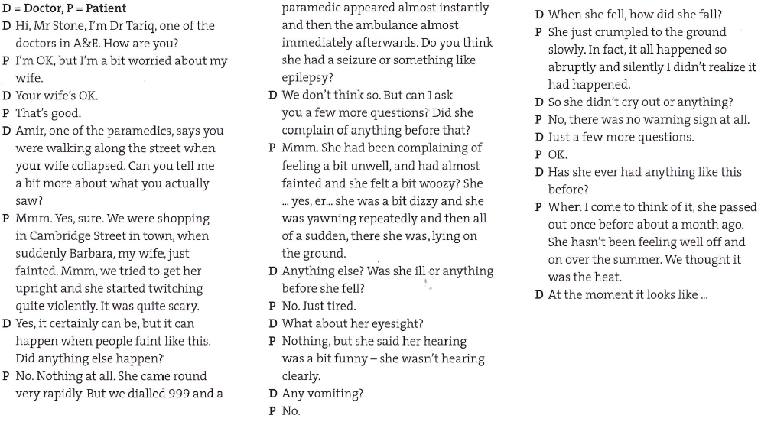

Make sure you know what these words mean:

A&E, Faint = pass out x pass away = die; to twitch; came around/round; seizure = fit; complain, yawn, dizzy, woozy, vomit, abruptly,

2) 1. were walking, passed out; 2. has never had, experienced, 3. had been admitted/was admitted, became; 4. has never suffered, has been feeling; 5. was yawning, has not done, fainted; 6. had fallen/fell, started, tried; 7. was lying, was not shaking; 8. happened, fell; 9. bit, messed, has been feeling

3) 1.We were eating in a restaurant, when I suddenly felt woozy and I fainted. This has never happened before.

2. Ahmed had never been ill before but he felt unwell yesterday. He abruptly cried and passed out.

3. We were travelling by train to the city. He had not eaten since the morning. He vomited and we came straight here.

4. Mary has been having fainting fits for the past few days. She was doing a lot of running around when it happened the second time. She has never have them before. An none of us has have them either.

5. She was getting out of bed when she came over all giddy, but she had had it before, so we thought nothing of it.

**5. Injuries**

**Key:** bleed, scar, bruise, in pain, scratched, scab, injuries, grazed, wound, swollen, blister, sprained/twisted, scalded, sting

**7. Talk to your partner and use as many types of past tense as possible.**

Have you ever had any injury (a broken bone, twisted joint or torn muscle, etc.)?

How did it happen?

How was that injury treated?

**8. Picture description**

Look at these two picture - what do they have in common and what differences can you see?

Describe what is happening in each of them.

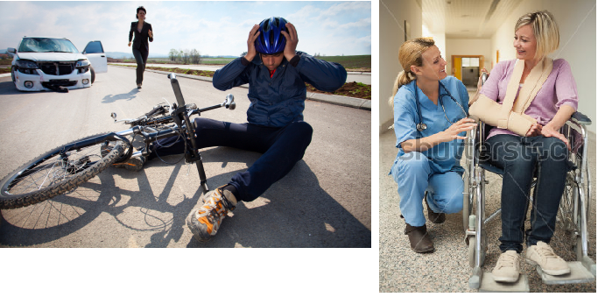

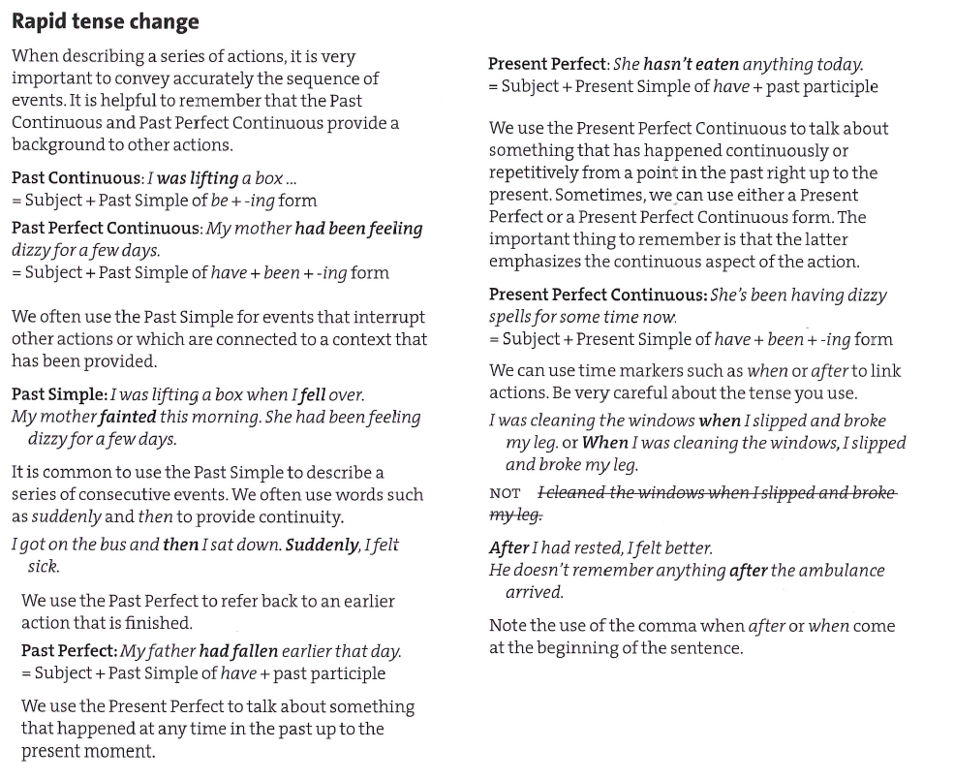

See further grammar explanation and exercises in Basic and Advanced past tenses