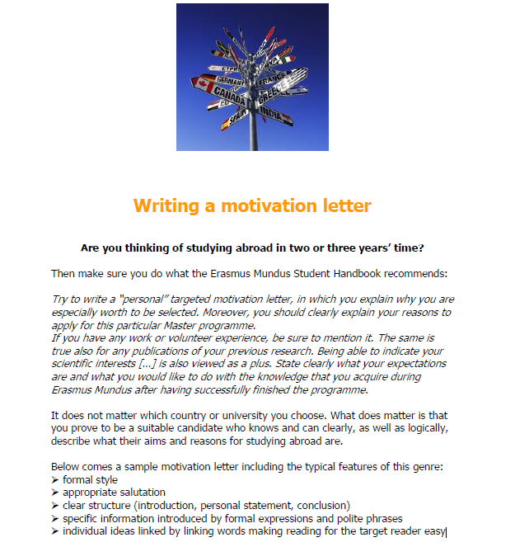

***Your task is to read the letter below and identify its positive features. If you like, you can use the letter as a model in case you decide to apply for a stay with Erasmus or IFMSA.***

**SAMPLE MOTIVATION LETTER**

Dear Sir or Madam,

With this letter, I would like to express my interest in studying at the University of ….. as an Erasmus student.

I am currently studying my master´s degree programme in Regional Geography at Masaryk University, Brno, Czech Republic. Having looked through the materials of the Foreign Department of my university, I was very delighted to find the opportunity to spend one semester learning geography at your university. I have decided to apply for this programme because I am sure it would strongly enrich my future studies and help in my prospective career. Moreover, I consider this programme as a great opportunity to get in touch with British culture and educational system. Last but not least, I am curious about different approaches to the geography at your institution.

I have chosen to apply for the University of ……….. because I really like its module system of study. I in particular appreciate the wide range of offered modules and the freedom in making your own study plan. Many of the modules offered are unique for me as there is no equivalent at my home university. Very important for me is also the “excellent” rating for teaching of the Geography department and the overall friendly atmosphere at both university as well as the city. The third main reason why I have chosen your university is its Urban and Regional Policy Research Institute – it specializes in interdisciplinary research on regional policy issues, which is the field I would like to focus on.

In my prior studies I found out that I would like to specialize in Urban and Transport Geography. Your offer gives me a chance to come across these subjects through modules from both Departments of Geography and Department of Town and Regional Planning. In my last year at university I worked on an empirical study with main focus on transportation costs in suburban areas. I really liked my project and I am keen to continue in it. I would like to use my stay at your university for further developing my skills in empirical research and starting working on my diploma project. The possibilities you offer further expand those at my home university. I would like to take modules focusing on Transport and Urban geography and European Studies.

I would like to spend one semester at the University of ……. since this would give me chance to deepen my geographical knowledge in the inspiring, creative and cosmopolitan environment of one of the largest British universities. Furthermore, I could improve my English and increase my confidence in passing the Cambridge advanced examination after I return. I am confident that experience in Sheffield would be very valuable for both my studies and overall general development.

Thank you for considering my request. I look forward to your response.

Yours faithfully,

…………………………..