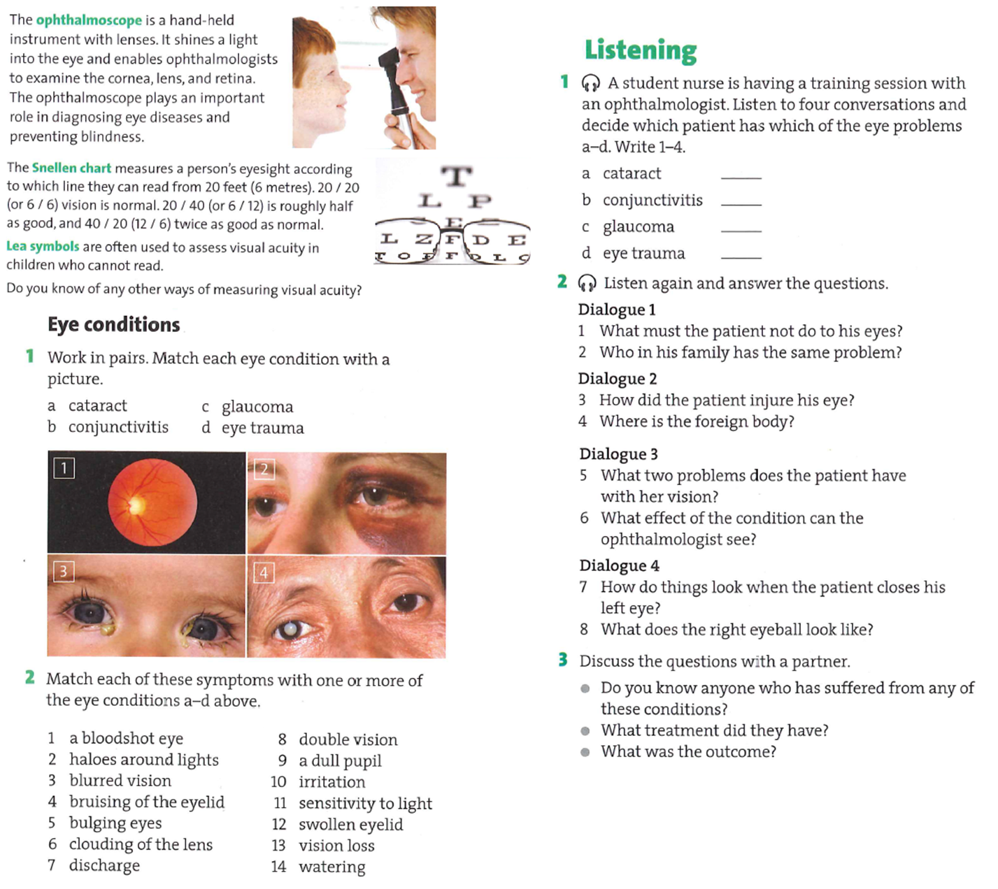

**4. Listening:** Listen to a radio program on otitis media and fill in one to three words into each space.

1. What amount of children had three and more ear infection before the age of six? About ___________________ of all children.

2. What problems can be caused if the otitis media is not treated?

Untreated otitis media can cause _____________________ and delayed speech development.

3. If the sick child is taken to a doctor soon, there are usually no______________________.

4. Why did Johnny miss so many days in the day care? He had many ________________________________ in the last year.

5. What is the purpose of the programme mentioned?

To address _____________ of concern of parents whose children suffer from otitis media.

6. What do the children who can speak complain about? _____________ and____________________ in one or both ears.

7. When there is a discharge from the ear due to otitis media? When the ____________________________________.

**5. Complete one word into each gap.**

Ear infections are very common ________ young children. In ________, roughly 70 % of all children have at least one ear infection before the age of six. Most of these infections happen in the middle ear, which is a small place located right behind the ear ________. The use of antibiotics to treat ear infections has ________ questioned recently by those who argue that some ear infections, like colds, are caused by viruses rather ________ bacteria. Antibiotics are not effective ________ treating viruses, and many people are justifiably concerned ________ the overuse of antibiotics. Studies have also shown ________ about 30 % of middle ear infections do not heal without the use of antibiotic treatment. This means that about 70 % of infections go away on their ________ . The difficulty is that it is impossible, just by examining the ear even by using otoscope, to identify the 30% of children who will need the antibiotics. Identifying these children is important, as untreated inflammation of the middle ear, so called ________ media, has the potential to develop serious infectious complications and lead to hearing ________.

Today, in certain situations, such as an older child with a mild infection (red ________ membrane, without any fluid in the middle ear), some physicians may choose not to treat the inflammation right away with antibiotics. ________ , if the middle ear is filled with fluid which does not drain naturally through the ________ tube or if there is persistent discharge from the ear, antibiotics will be prescribed.