**EXAMINATION OF HUMAN REFLEXES**

|  |  |  |  |
| --- | --- | --- | --- |
|  | Reflexes | Right Side | Left Side |
| Proprioceptive reflexes | Nasopalpebral r. |  |  |
| Bicipital r. |  |  |
| Triceps r. |  |  |
| Patellar r. |  |  |
| Achilles’tendom |  |  |
| Exteroceptive reflexes | Epigastric r. |  |  |
| Mesogastric r. |  |  |
| Hypogastric r. |  |  |
| Plantar r. |  |  |
| Sensory reflexes | Direct response to light |  |  |
| Indirect response to light |  |  |
| Response to convergence |  |  |
| Twinkle reflex |  |  |

**Conclusion:……………………………………………………………………………………………………………………………………………………………………………………………………………………………………………………………………………………………..…………………………………………………………………………………………………………………………………………………………..**

**ACHILLES TENDON REFLEX**

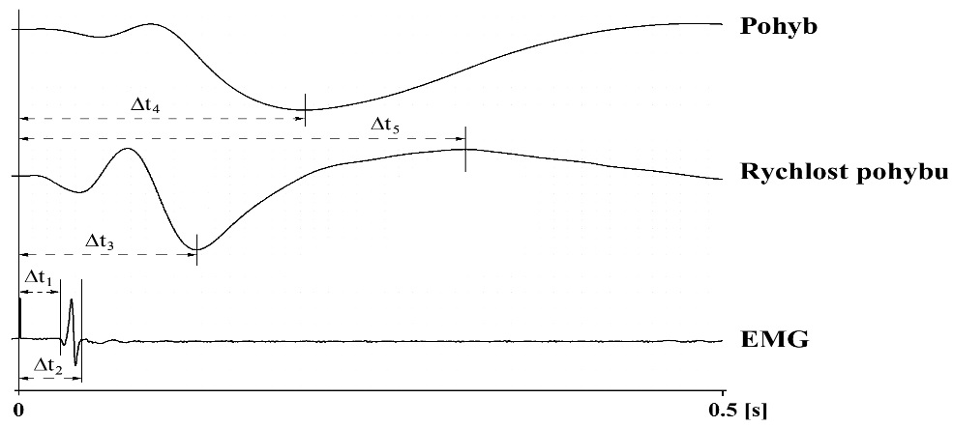

Movement

Velocity of Movement

EMG

|  |  |  |  |  |  |  |  |
| --- | --- | --- | --- | --- | --- | --- | --- |
|  | 1 | 2 | 3 | 4 | 5 | Value | Physiological Values |
| t1 |  |  |  |  |  |  |  |
| t2 |  |  |  |  |  |  |  |
| t3 |  |  |  |  |  |  |  |
| t4 |  |  |  |  |  |  |  |
| **t5** |  |  |  |  |  |  |  |

**Conclusion:………………………………………………………………………………………………………………………………………………………………………………………………………………………………………………………………………………………………………………………………………………………………………………………………………………………………………………………**

#### VERTIGO AND NYSTAGMUS

|  |  |  |
| --- | --- | --- |
| Classic pose on a chair | Direction of Nystagmus | Plane of Nystagmus |
|  |  |

**Conclusion:**………………………………………………………………………………………………………………………………………………………………………………………………………………………………………………………………………………………………………………………………………………………………………………………………………………………………………………………………………………………………………………………………………………………………………………………………………………………………..

**RECRUITMENT AND SUMMATION IN SKELETAL MUSCLE**

**A) RECRUITMENT**

|  |  |  |  |  |  |  |  |
| --- | --- | --- | --- | --- | --- | --- | --- |
| Stimulus intensity [mA] | Force of contraction [mN] | Stimulus intensity [mA] | Force of contraction [mN] | Stimulus intensity [mA] | Force of Contraction [mN] | Stimulus Intensity [mA] | Force of Contraction [mN] |
|  |  |  |  |  |  |  |  |
|  |  |  |  |  |  |  |  |
|  |  |  |  |  |  |  |  |
|  |  |  |  |  |  |  |  |
|  |  |  |  |  |  |  |  |

*Set up the graph of the force/intensity curve).*

Force of contraction [mN]

Threshold intensity (Ip)-………….mA

Maximal intensity (Imax)-…...mA

stimulus intensity [mA]

**Conclusion:…………………………………………………………………………………………………………………………………………………………………………………………………………………………………………………………………………………………….………………………………………………………………………………………………………………………………………………………….**

**B) SUMMATION**

Number of stimuli is 2

|  |  |  |  |  |  |
| --- | --- | --- | --- | --- | --- |
| 2 Hz | 7Hz | 10Hz | 15Hz | 20Hz(Ip) | 20Hz(Imax) |

Number of stimuli is 25

|  |  |  |  |  |  |
| --- | --- | --- | --- | --- | --- |
| 2 Hz | 7Hz | 10Hz | 15Hz | 20Hz(Ip) | 20Hz(Imax) |

**Conclusion:…………………………………………………………………………………………………………………………………………………………………………………………………………………………………………………………………………………………….…………………………………………………………………………………………………………………………………………………………..**

**ERECT POSTURE EXAMINATION USING STABILOMETRY**

|  |  |  |
| --- | --- | --- |
| state of rest | elimination of visual afferentation | elimination of visual and tactile afferentation |

|  |  |  |
| --- | --- | --- |
| Mean velocity….…………………  x-axis movement…………………  y-axis movement ………………… | Mean velocity….…………………  x-axis movement…………………  y-axis movement ………………… | Mean velocity….…………………  x-axis movement…………………  y-axis movement ………………… |

|  |  |  |
| --- | --- | --- |
| **Romberg 1** | **Romberg 2** | **Romberg 3** |

|  |  |  |
| --- | --- | --- |
| Mean velocity….…………………  x-axis movement…………………  y-axis movement ………………… | Mean velocity….…………………  x-axis movement…………………  y-axis movement ………………… | Mean velocity….…………………  x-axis movement…………………  y-axis movement ………………… |

**Conclusion:**……………………………………………………………………………………………………………………………………………………………………………………………………………………………………………………………………………………………………………………………………………………………………………………………………………………………………………………………………

**ESTIMATION OF REACTION TIME USING COMPUTER**

|  |  |  |  |  |
| --- | --- | --- | --- | --- |
|  | Reaction on  visual and acoustic stimuli | | Reaction on  visual stimuli | GO - NO GO reaction |
| Reaction time[ms] |  |  |  |  |
| ±SD |  |  |  |  |

**Conclusion:**……………………………………………………………………………………………………………………………………………………………………………………………………………………………………………………………………………………………………………………………………………………………………………………………………………………………………………………………………