**MEDICAL PRESCRIPTION (unit 10)**

1. **LIST OF ABBREVIATIONS USED IN MEDICAL PRECRIPTIONS**

|  |  |  |
| --- | --- | --- |
| *a) VERBAL FORMS* | | |
| *abbreviation* | *full form* | *translation* |
| add. | adde/addatur/addantur | add/it should be added/they should be added |
| d. s. | da signa/detur signetur | give and sign/it should be given and signed |
| d./dent. | da/detur/dentur | give/it should be given/they should be given |
| d./div. | divide/dividatur | divide/it should be divided |
| div. in dos. aeq. | divide in doses aequales | divide in equal doses |
| d. t. d. | dentur tales doses | such doses should be given |
| disp. | dispensa/dispensetur | divide, distribute/it should be divided, distributed |
| f. | fiat/fiant | it should be made/they should be made |
| m. | misce/misceatur | it should be mixed/they should be mixed |
| m. f. | misce fiat/misce fiant | mix, it should be made/mix, they should be made |
| rep. | repete/repetatur | repeat/it should be repeated |
| rp. | recipe | take |
| s./sig. | signa/signetur | sign/it should be signed |
| solv. | solve | dissolve |
| sterilis. | sterilisetur | it should be sterilised |
| ut f. | ut fiat… | in order to make... (sth) |

|  |  |  |
| --- | --- | --- |
| *b) FORMS OF MEDICATIONS* | | |
| *abbreviation* | *full form* | *translation* |
| caps. | capsula/capsulae | capsule/capsules |
| comp. | compositus, a, um | composed of more constituents |
| conc. | concentratus, a, um | concentrated |
| decoct. | decoctum | decoction |
| drg. | dragées | dragee, coated pill |
| empl. | emplastrum | sticking-plaster |
| extr.  extr. fluid.  extr. sicc. /exsicc.  extr. spiss. | extractum  extractum fluidum  extractum siccum/exsiccatum  extractum spissum | extract  liquid extract  dry/dried extract  thick, dense extract |
| garg. | gargarisma | gargle |
| gtt./gutt. | guttae | drops |
| gossyp. | gossypium | cotton wool |
| herb. | herba | plant, herb |
| inj.  inj. i. c.  inj. i. m.  inj. i. v.  inj. subcut. | injectio  injectio intracutanea  injectio intramuscularis  injectio intravenosa  injectio subcutanea | injection  injection into the skin  injection into the muscle  injection into the vein  injection under the skin |
| linim. | linimentum | liniment |
| mixt. | mixtura | mixture |
| ol. | oleum | oil |
| pulv./plv.  pulv. adsp.  pulv. div. | pulvis/pulveres  pulvis adspersorius  pulveres divisi | powder/powders  dusting powder  divided powders |
| sol. | solutio/solubilis/solutus | solution/dissolvable/dissolved |
| spec. | species | mixture of dried plants, tea |
| succ. | succus | juice, draught |
| supp. | suppositorium/suppositoria | suppository |
| susp. | suspensio | suspension |
| tbl.  tbl. efferv.  tbl. obd. | tabulettae  tabulettae effervescentes  tabulettae obductae | tablets  effervescent tablets  coated tablets |
| ung. | unguentum | ointment |

|  |  |  |
| --- | --- | --- |
| *b) OTHER INSTRUCTIONS concerning dosage, storage, etc.* | | |
| *abbreviation* | *full form* | *translation* |
| aa | ana (partes aequales) | in equal quantities |
| ad amp. | ad ampullam | into ampule |
| ad caps. | ad capsulam/as | into capsule/s |
| ad ch (art). (cer.) | ad chartam ceratam | into waxed sachet |
| ad lag. | ad lagoenam | into bottle |
| ad man. med. | ad manus medici | into the hands of doctor |
| ad oll. | ad ollam | into gallipot |
| ad scat. | ad scatulam/as | into box/es |
| ad us. ext. | ad usum externum | for external use |
| ad us. int. | ad usum internum | for internal use |
| ad vitr. | ad vitrum | into glass |
| aliq. | aliquot | a little of |
| aq.  aq. pro inj.  aq. purif.  aq. steril. | aqua  aqua pro injectione  aqua purificata  aqua sterilisata | water  water for injection  purified water  sterilized water |
| cochl. mag./parv. | cochlear magnum/parvum | table-/teaspoon |
| c. | cum | with |
| ctr. | contra | against |
| d. | dies, ei, m. | day |
| dupl. | duplex | double |
| exp. orig. | expeditio originalis/expeditiones originales | original packaging (sg./pl.) |
| fort. | fortis | strong |
| fortiss. | fortissimus | the strongest |
| guttator. | guttatorium | drop-glass, dropper |
| h. | hora, ae, f | hour |
| l. a./leg. art. | lege artis | according to the rules of medicine |
| m. p. | manu propria | (signed) with one's own hand |
| no. | numero | in number |
| p. d. | pro dosi | per dose |
| p. die | pro die | per day |
| p. o. | peroralis/perorales | peroral (taken through mouth) |
| pro adult. | pro adultis | for adults |
| pro inf. | pro infantibus | for children |
| q. s. | quantum satis | as much as it is necessary |
| simpl. | simplex | simple |
| spir(it). | spiritus | spirit, grain alcohol |
| tot. | totus, a, um | all, whole |

1. **FORMS OF PHARMACEUTICAL PREPARATIONS AND AGENTS**

***capsula*** (e.g. *mollis/enterosolvens* = soft/dissolvable in gastrointestinal tract) = capsule

***fascia*** (e.g. *hydrophila*) = tightening bandage

***lana*** = cotton wool

***granulum*** (e.g. *effervescens*) = granulated powder

***charta*** = paper

***ligamentum*** = bandage

***pulvis*** (e.g. *nasalis*/*adspersorius*) = powder

***species*** = mixtures to make tea

***tabuletta*** (e.g. *obducta*) = tablet

***tela*** (e.g. *hydrophila*)= gauze

***filum*** (e.g. *sterile*) = thread

***emplastrum*** = sticking-plaster

***globulus*** (e.g *vaginalis*) = globule, ball

***unguentum*** = ointment

***pasta*** (e.g. *dentrifricia* = tooth-) = paste

***sapo***, onis, m. (e.g. *kalinus* = potassium) = soap

***stylus*** (e.g. *nasalis*) = stick

***suppositorium*** (e.g. *rectale*) = suppository

***vaselinum*** (e.g. *flavum*/*purum*) = vaseline

***cremor*** (e.g. *refrigerans* = cooling) = cream

***guttae*** (e.g. *oculoguttae*) = drops

***decoctum*** = decoction

***infusio*** (e.g. *sodii* *chloridi*) = infusion

***oleum*** = oil

***tinctura*** (e.g. *opii* = of opium) = alcoholic solution made from plants

***spuma*** (e.g. *dermalis*) = foam

1. **PARTS OF PLANTS USED IN PHARMACOLOGY**

***flos***, ris, m. (e.g. *tiliae*, *sumbuci*) = flowers

***folium***, ii, n. (e.g. *menthae*, *salviae*) = leaves

***fructus***, us, m. (e.g. *foeniculi*) = fruit

***herba***, ae, f. (e.g.*absynthii*, *thymi*) = herbs, tops of plants

***lignum***, i, n. (e.g. *cinammi*) = wood

***radix***, cis, f. (e.g. *liquiritiae*) = roots

***resina***, ae, f. (e.g. *cannabis*) = resin

***semen***, inis, n. (e.g. *arnicae*) = seeds

***succus***, i, m. (e.g. *belladonnae*) = draught, juice

**Match the pictures with the terms above:**

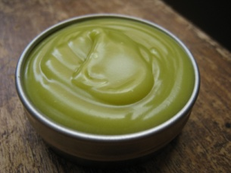 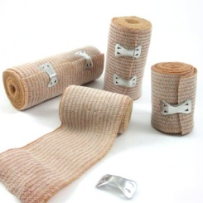 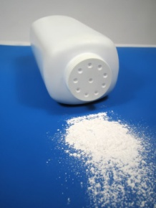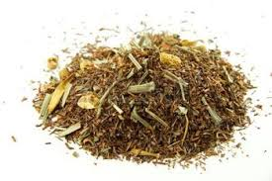 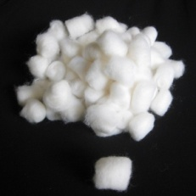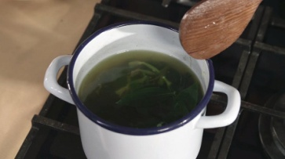 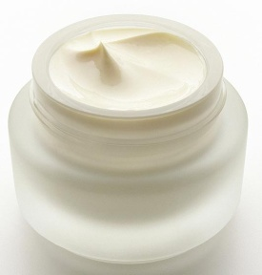 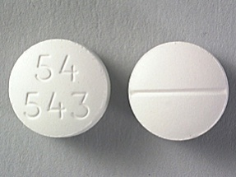 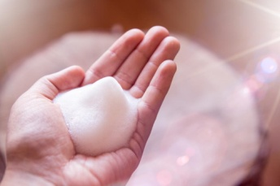 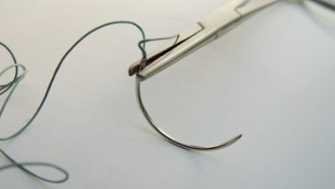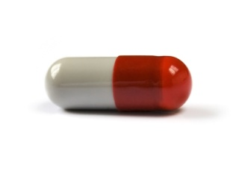 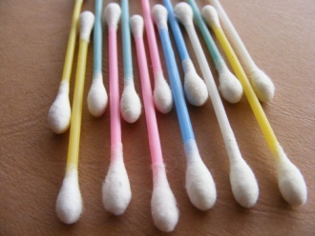 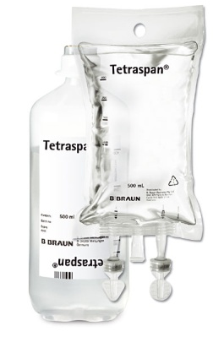 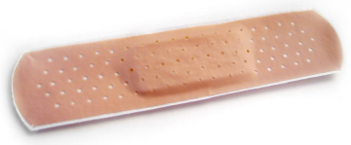 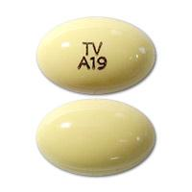 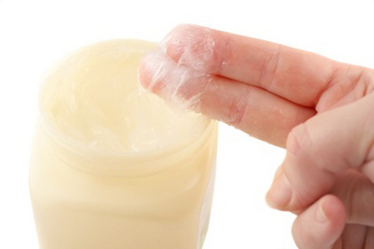 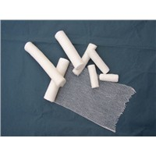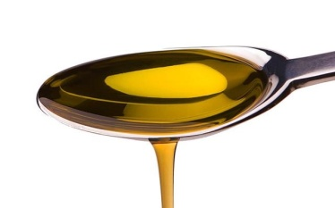 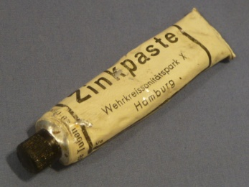 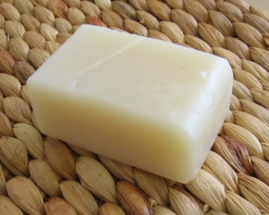 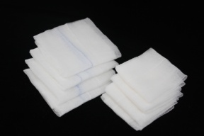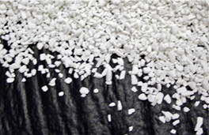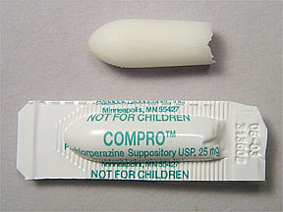 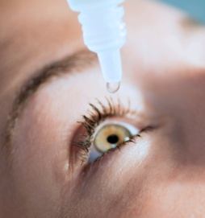 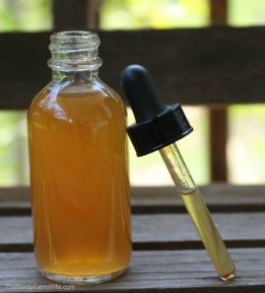

1. **PARTS OF THE PRESCRIPTION**

**The prescription consists of seven parts. Their Latin names are:**

1. **INSCRIPTIO**

*The name and the surname of the doctor, the hospital, clinic or polyclinic medical center, their address, and the date.* The date is important from the standpoint of ascertaining for determining the life of the prescription.The prescription of narcotics and controlled substances are governed by special laws and regulations.

1. **NOMEN AEGROTI**

*Name, address and age of the patient.* This part serves to identify for whom the prescription is intended. The full name and the address are required by law on all prescriptions for controlled substances. The age of the patient is a good additional piece of information, especially with pediatric pаtients where dosage calculations have to be double-checked for safety. This part may be located on the designated area, or after the last drug on the back of the form.

1. **INVOCATIO**

Consists of the message to the chemist/pharmacist, and it includes only the expression ***Rp./*** – an abbreviation for Recipe, the Latin for Get! (Take)

1. **ORDINATIO**

This is the main part of the medical prescription, because this is the doctor’s order. Here are the *names of medicinal substances, the medicinal forms, and the dosages* (in case of individually prepared medicines) *or brand name* (in case of ready-made preparations). The medicinal substances are required to begin with a capital letter and to be in the genitive case. Brand names are also written with the capital letter, but these are not inflected and are written as seen in the original packaging.

The dosage is noted after the substance or medicinal form using metric units (grams) and Arabic decimal numerals (individually prepared medicines, when read aloud, these should be in accusative case) or number of original packages (ready-made medicines) is given in Roman numerals and full word in the brackets (it is also accusative case).

1. **SUBSCRIPTIO**

In this part are written, if necessary, *instructions to the chemist* on how to make the preparation and the number of doses, or medicinal forms to be supplied to the patient.

1. **SIGNATURA**

Notes are written in Czech. The signature is the *message intended for the patient*. It provides instructions as to how the medicine should be taken by the patient. This information must be sufficient to allow the patient to understand fully the amount of the drug product to be taken and the frequency and manner of administration: if the drug has to be used externally only, or to be shaken well before use, or whether it is a poison, and other such facts are included.

1. **NOMEN MEDICI**

*The signature of the doctor* may be placed on the designated area, or after the last drug, and this is for identification data.

**CZECH MEDICAL PRESCRIPTION**

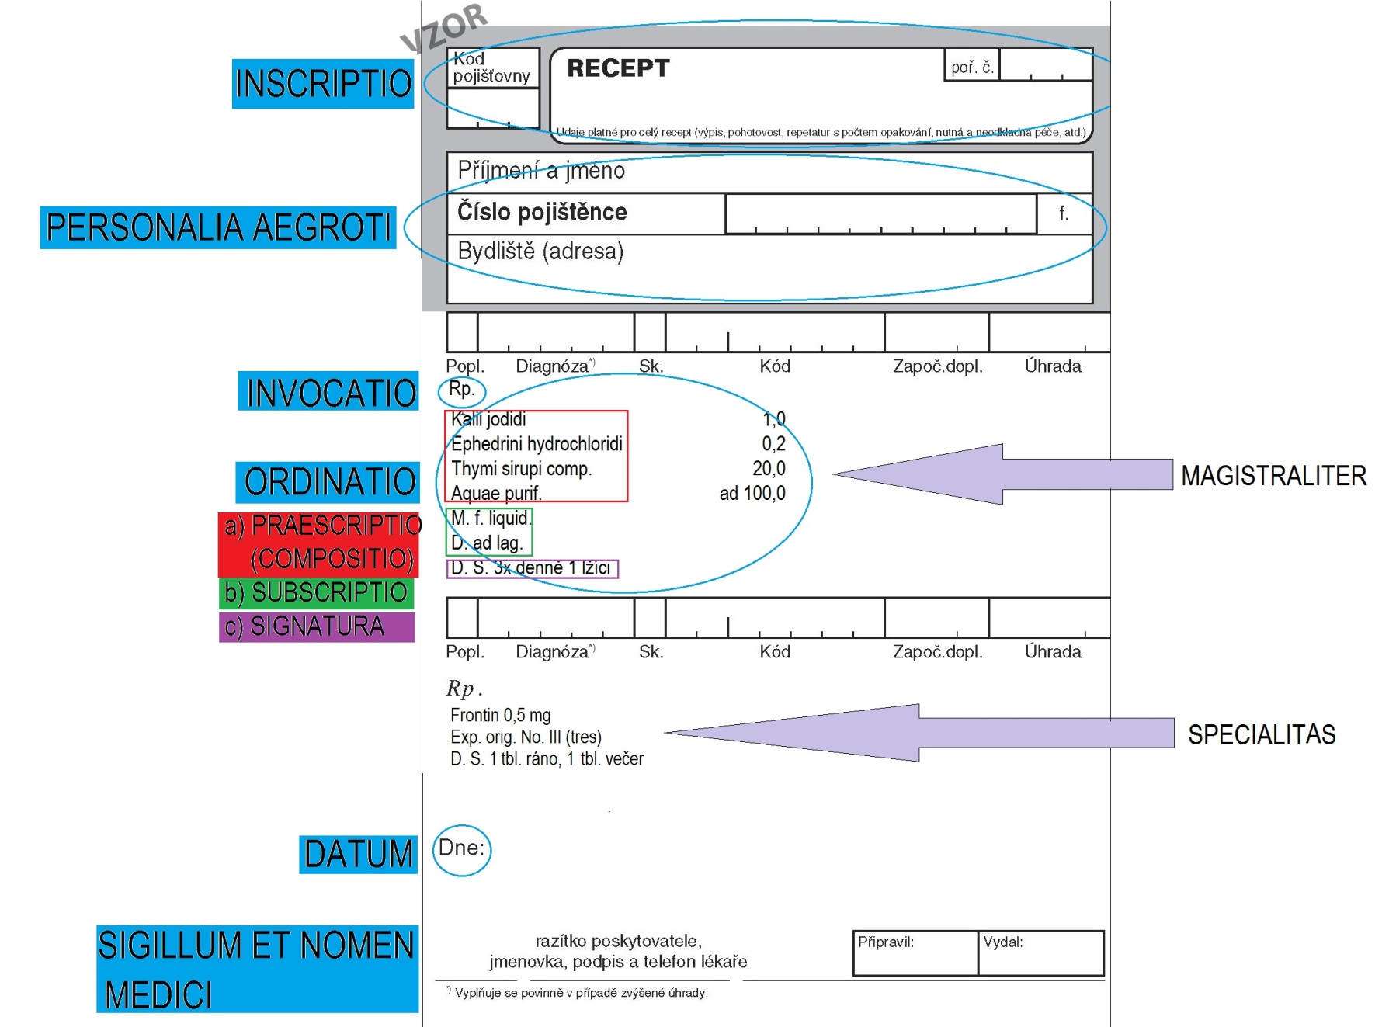

1. **PRESCRIPTION TYPES**

Prescriptions can be classified as *individually prepared* and *ready-made*.

1. **Individually prepared medication**, also called ***magistraliter*** (from Latin word magister – teacher) is an order that requires mixing of one or more ingredients (active medicaments) with one or more pharmaceutical necessities (vehicle, suspending agent). The physician selects the drugs, doses, and pharmaceutical form that he/she desires and the pharmacist prepares the medication accordingly. The name of each drug is placed on a separate line right under the preceding one. The order of ingredients is as follows:

***Remedium cardinale (basis).*** The basis is the principal drug and gives the prescription its chief action.

***Remedium adjuvans (adjuvant).*** As the name suggests, the adjuvant is a drug that aids or increases the action of the principal ingredient.

***Remedium corrigens (corrective).*** The corrective modifies or corrects undesirable effects of the basic or adjuvant.

***Remedium constituens (vehicle).*** The vehicle is the agent used as a solvent in the solution, to increase the size and volume, or to dilute the mixture. The most potent or principal drug is written first, the other ingredient second, and the vehicle last, as shown in the example.

*E.g.*: Invocatio: *Rp./* (= Recipe = take)

Ordinatio: *Natrii bromati (bromatis) 6,0* Rem. basis

*Phenobarbitali 0,6*  Rem. adjuvans

*Sirupi Menthae 60,0* Rem. corrigens

*Aquae destillatae ad 300,0*  Rem. constituens

Subscriptio: *M. f. mixt.* (=Misce fiat mixtura = Mix to obtain mixture).

Signatura: *D. S.* (= Da. Signa. = Give. Sign.) *Jedna lžička třikrát denně po jídle.* (= One tablespoon 3 times a day after meal).

1. **Ready-made medication**, or ***specialitas****,* does not require mixing of two or more ingredients to obtain a finished product. A precompounded order consists of a drug or a mixture of drugs supplied by a pharmaceutical company by its official or proprietary name and, if it contains more than one substance, the specific ingredients do not have to be listed. Usually, it contains abbreviation ***Exp. orig.*** (= Expeditio originalis = original package).

E.g.: Invocatio: *Rp./*  (= Recipe = take)

Ordinatio: *Ospamox 750 mg tbl.* (= tabulettas)

*Exp. orig. No. II.*(= expeditiones originales numero du**as** = two originaL packages)

Signatura: *D. S.* (= Da. Signa. = Give. Sign) *Jedna tableta každých 12 hodin /po dobu dvou týdnů/* (= One tablet every 12 hours /for two weeks/).

**SOME EXAMPLES OF MEDICAL PRESCRIPTIONS**

analgeticum + antipyreticum diureticum

*Rp.*

*Acidi acetylsalicylici*

*Paracetamoli aa 0,3*

*Codeinii dihydrogenphosphorici 0,02*

*Coffeini cum natrio benzoico 0,1*

*Magnesii oxydati 0,05*

*M. f. pulv.*

*D. t. d. No. XX (viginti) ad caps.*

*S. 3krát denně 1 prášek.*

*Rp.*

*Aminophyllini 1,8*

*Olei cacao q. s. ut f. supp.*

*D. t. d. No. VI (sex)*

*S. 2krát denně zavést 1 čípek do konečníku.*

antimycoticum

*Rp.*

*Ureae 40,0*

*Acidi lactici 1,0*

*Ung. lanalcoli 20,0*

*Cerae albae 5,0*

*Vaselini albi ad 100,0*

*M. f. ung. Týden používat v okluzním obvazu na nehty před aplikací antimykotik.*

antacidum

*Rp.*

*Extracti belladonnae sicci 0,4*

*Papaverinii chlorati 1,0*

*Magnesii oxydati 20,0*

*M. f. pulv.*

*Div. in dos. aeq. No. XX (viginti) ad caps.*

*D. S. 3krát denně 1 prášek mezi dvěma jídly.*

urologicum antidotum

*Rp.*

*Carbonis adsorbentis 30,0*

*Magnesii sulfurici*

*(seu Natrii sulfurici) 15,0*

*Aquae purificatae ad 300,0*

*M. f. susp.*

*D. S. Cum formula. Pro medico. Po ukončení výplachu vstříknout do žaludku.*

*Rp.*

*Herbae equiseti*

*Folii uvae ursi aa 15,0*

*Herbae herniariae*

*Radicis levistici aa 20,0*

*Folii betulae 30,0*

*M. f. spec.*

*D. S. 1 lžíce na šálek nálevu. Denně vypít 3 – 4 šálky.*

gynaecologicum antibioticum

*Rp.*

*Framykoin plv. ads. 1 x 20 gm*

*Exp. orig. No. II (duas)*

*D. S. Aplikovat 2krát denně na postižená místa po dobu 10 dnů.*

*Rp.*

*Acidi borici pulv. 100,0*

*D. ad scat.*

*S. Jednu lžíci na litr teplé vody k výplachům.*

myorelaxans immunostimulans

*Rp.*

*Imunor p. o. 4 x 10 mg*

*Exp. orig. No. I (unam)*

*D. S. Dle rozpisu.*

*Rp.*

*Mydocalm 150 mg tbl. p. o. 30 x 150 mg*

*Exp. orig. No. III (tres)*

*D. S. 3krát 1 tableta denně.*

antidepresivum hypnoticum

*Rp.*

*Amobarbitali 0,15*

*Codeinii dihydrogenphosphorici 0,03*

*Aminophenazoni 0,25*

*Olei cacao q. s. ut f. supp.*

*D. t. dos. No VI (sex)*

*S. Na noc zavést 1 čípek.*

*Rp.*

*Asentra 50 tbl. p. o. 28 x 50 mg*

*Exp. orig. No. IV (quattuor)*

*D. S. 2 tablety denně.*