GREEK AND LATIN SUFFIXES
1. SUBSTANTIVE SUFFIXES
A) LATIN
suffix | meaning | example
-io | act of, result of, process of | inflammat-io inflammation
-or | agent | flex-or a muscle the action of which is to flex a joint
-ura | act or result of action | flex-ura flexion, result of bending
-itas | quality, state | obes-itas obesity
-mentum | instrument, tool | liga-mentum ligament
-culus, a, um  -ulus, a, um  -olus, a, um  -illus, a, um  -ellus, a, um | diminutive | canali-culus small canal  capit-ulum small head  alve-olus small cavity or pit  pupilla pupil (the dark circular aperture at the centre of the iris of the eye)  cereb-ellum posterior brain mass
B) GREEK
suffix | meaning | example
-ia | disease | allerg-ia allergy
-iasis | disease, pathological state | psor-iasis a chronic skin disease characterized by circumscribed red patches covered with white scales
-ismus | 1. state  2. addiction | nan-ismus dwarfism (a genetic abnormality resulting in short stature)  alcohol-ismus alcoholism
-itis | inflammatory disease | gastr-itis inflammation of the stomach
-osis | 1. non-inflammatory disease  2. degenerative disease | nephr-osis a non-inflammatory disease of a kidney  arthr-osis a degenerative disease of a joint
-oma | tumor | carcin-oma a malignant tumor of epithelial origin

2. ADJECTIVE SUFFIXES
A) Latin
suffix | meaning | example
-alis, e | relation | vertebr-alis
-aris, e | relation | muscul-aris
-inus, a, um | relation | uter-inus
-eus, a, um | relation | cartilagin-eus
-osus, a, um | full of | ven-osus
-atus, a, um | equipped with | caud-atus
-bilis, e | possibility | mo-bilis
-ilis, e | having the quality | frag-ilis
B) Greek
suffix | meaning | example
-icus, a, um | relation | thorac-icus
-ideus, a, um | similar to | xipho-ideus

EXERCISE 1
Form adjectives from the given nouns:
 | 1. cranium, ii, n.  1a. facies, ei, f.  2. vertebra, ae, f.  3.corpus, oris, n.  4. os (sacrum), ossis, n.  5. coccyx, gis, f.  6. sternum, i, n.  7. costa, ae, f.  8. pelvis, is, f.  9.-16. manus, us, f.  9. clavicula, ae, f.  10. scapula, ae, f.  11. humerus, i, m.  12. radius, ii, m.  13. ulna, ae, f.  14. carpus, i, m.  15. metacarpus, i, m.  16. digitus, i, m.  17. pelvis, is, f.  18. cervix, icis, f.  19. femur, oris, n.  20. patella, ae, f.  21. tibia, ae, f.  22. fibula, ae. f.  23. phalanx, gis, f. | 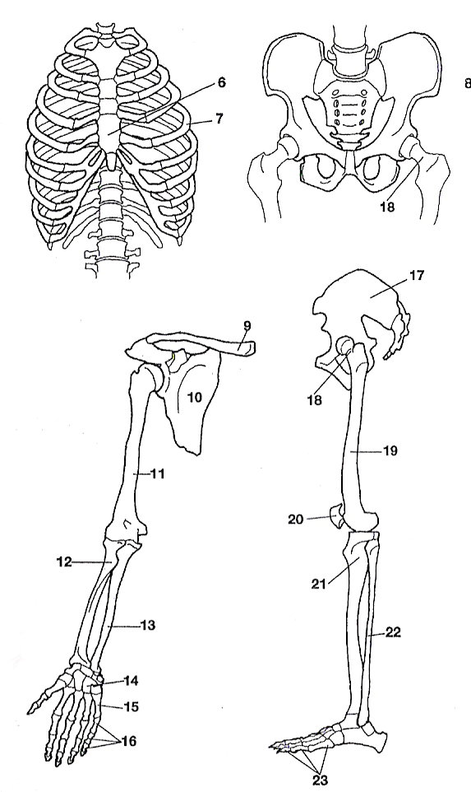

EXERCISE 2
Give the nouns which the following adjectives come from:
Note: The adjectives contain the suffix -icus, -a, -um, which is usually combined with nouns of Greek origin.
gastricus, a, um thoracicus, a, um
diabeticus, a, um hepaticus, a, um
traumaticus, a, um caroticus, a, um
allergicus, a, um diphthericus, a, um

EXERCISE 3
Use the suffixes to derive adjectives with the meaning of words in brackets:
-osus: arteria > .................................... (arterious, arterial)
gangrena > .................................... (gangrenous)
nervus > .................................... (nervous)
ligamentum > .................................... (limagentous, ligamental)
-icus allergia > .................................... (allergic)
anatomia > .................................... (anatomic, anatomical)
diphtheria > .................................... (diphtherial)
haemorrhagia > .................................... (haemorrhagic)
lympha > .................................... (lymphatic)
ovarium > .................................... (ovarian)

-inus palatum > .................................... (palatal, palatine)
uterus > ................................ (uterine)

EXERCISE 4
Derive names of inflammatory diseases from the given nouns:
Example: gaster → genitive gastr-is → gastr-itis (gastritis, inflammatory disease of stomach)

bronchus hepar
meninx periosteum
larynx myocardium
colon pharynx

EXERCISE 5
Derive names of inflammatory diseases from the given nouns, and match them with the adjectives in the correct form:
Example: duodenum + acutus, a, um → duodenitis acuta
appendix + gangraenosus, a, um
pharynx + chronicus, a, um
meninx + tuberculosus, a, um
myocardium + purulentus, a, um
colon + mucosus, a, um
pericardium + siccus, a, um
pancreas + acutus, a, um

EXERCISE 6
Fill in missing diminutives/nouns which the diminutives were derived from:
__________________ventriculus ___________________ septulum
tuber _____________________ os (bone) __________________
____________________cuticula ___________________ musculus
canalis____________________ vena _______________________
____________________ nodulus ____________________ auricula
dens ______________________ valva _______________________

