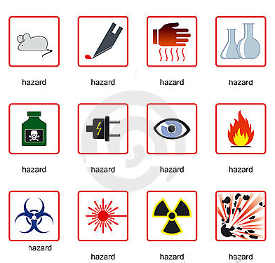
Safety in Laboratory
A Match the icons with the type of hazard
1 chemical
2 radioactive
3 fire
4 electrical
5 animal
6 bio
7 sharp instrument
8 glassware
9 eye and face
10 heat
11 explosive
12 laser radiation

B Some rules. Read the rules below and write a number according to the type of safety measure.
1 General and personal safety
2 Electrical safety
3 Chemical safety
4 Laser safety
Treat every chemical as if it were hazardous. ____
If leaving a lab unattended, turn off all ignition sources and lock the doors. ____
NEVER, EVER LOOK INTO ANY LASER BEAM, no matter how low power or "eye safe" you may think it is. ____
Avoid using extension cords whenever possible. ____
Never eat, drink, or smoke while working in the laboratory. ____
Clothing: When handling dangerous substances, wear gloves, laboratory coats, and safety shield or glasses. Shorts and sandals should not be worn in the lab at any time. ____
Never allow a solvent to come in contact with your skin. Always use gloves. ____
Never return chemicals to reagent bottles. ____
Wash hands before leaving the lab and before eating. ___
Never pipette anything by mouth. ____

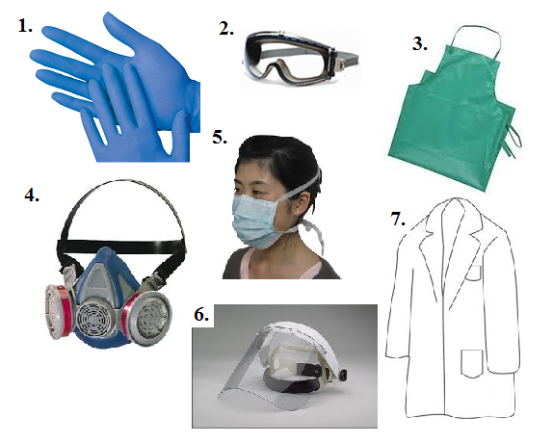
C Protective equipment
1 shield
2 respirator
3 gown/coat
4 goggles /glasses
5 apron
6 gloves
7 (face) mask

D Grammar point
1 Conditional (I would)
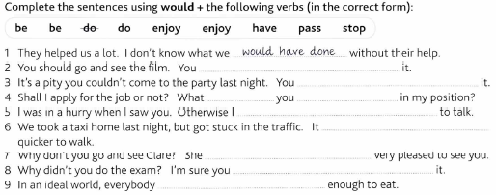
2 Conditional clauses I (real)
A If I _________ (study), I ___________ (pass) the exam.
B If the sun _________ (shine), we ____________ (walk) to the town.
C If you ___________ (push) this button, the analyser __________ (stop).
D If she ___________ (not wear) the coat, she ___________ (be able) to enter the lab.

3 Conditional clauses II (imaginary)
A If you ___________ (come) earlier, I _____________ (prepare) dinner.
B If Susan ___________ (study) harder, she ___________ (be) better at school.
C If we __________ (hurry), we ____________ (spoil) the experiment.
D If you __________ (turn off) the fire, the lab _____________ (explode).

