Microbiology - Gram stain

A Lead-in. Practice the pronunciation of the following words:
pneumonia – pneumococcus – meningitis – bronchitis – bacteria – bacteriuria – pyogenic – fungus – fungi – sputum – urine – epithelial – identify – identification – preparation – gangrene – causative – agent – microbes – microbial – antimicrobial – fusobacteria – spirochetes – diagnosis – diagnostic

B Read the text and decide if the statements below are true (T) or false (F).

The Gram stain procedure was originally developed by the Danish pharmacist Hans Christian Gram to differentiate pneumococci from Klebsiella pneumonia. The Gram stain is particularly useful in the diagnosis of bacterial meningitis, bacterial pneumonia, bacteriuria, gonorrhoea, and pyogenic infections of the brain, lung, abdomen, pelvis, and wounds.
Statistically about one third of all patients admitted to general hospitals have, or develop, infections, a large proportion of which are caused by bacteria and fungi. The Gram-stained smear of a specimen often provides valuable results that cannot be obtained from culture of the specimen alone. The Gram-stained smear is also useful in judging the adequacy of the specimen obtained. In sputum and urine specimens, for example, a poorly collected or contaminated specimen can be recognised by the presence of many epithelial cells in the smear.
Information obtained from the Gram-stained preparation rarely permits definitive identification of organisms, but usually narrows the possibilities in diseases such as gas gangrene, pneumonia or meningitis, which have a variety of causative agents. Early diagnostic information obtained from Gram-stained smears often allows the physician to prescribe narrow-spectrum antimicrobial therapy, thereby reducing the risk of toxicity or superinfection.
Moreover, in certain infections, such as Vincent's angina (associated with fusobacteria and spirochetes), the organisms cannot be identified by the culture techniques employed in most diagnostic microbiology laboratories, and the Gram-stained smear together with the clinical findings form the basis for diagnosis.

1 H. C. Gram developed the staining procedure because he had problems with pneumonia.
2 More than half of the patients in hospitals get an infection of some type.
3 Epithelial cells in the smear mean that the sample is of bad quality.
4 Thanks to the data from Gram-stain smear, we can identify a disease precisely.
5 In certain infections, the Gram-stain smear is the only basis for diagnosis.

Preparing a smear - video

Listening
A What are the steps to follow?
1 rinse with water
2 rinse with water
3 rinse with water
4 immediately rinse with water
5 dry the slide
6 decolourise with alcohol
7 put the Gram’s iodine on (for 10 sec)
8 put safranin on (for 30 sec)
9 fix the smear
10 flood with crystal violet (for 30 sec)

B Answer these questions:
1 Why is Gram-stain called differential?
2 How long does it take to have a result?
3 What type of bacteria are resistant to penicillin?
4 Which of the stains is called mordant? What happens if you forget to use it?
5 For how long do you put alcohol on the stain?
6 What kind of the counter-stain is used here?
7 What do you do before you put the stain under the microscope?

Grammar point – Relative Clauses

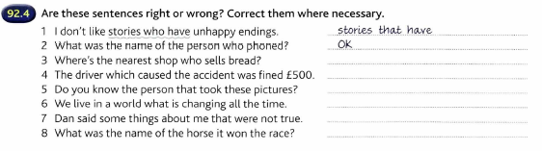

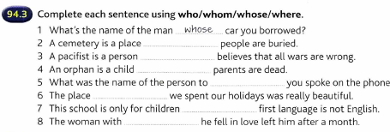

Complete the respective relative pronouns:
1. The man ….... ...............has just entered is Mr. Cox.
2. The lady ........................…. you met there is an undergraduate.
3. The magazine ............................…. you were showing me is published in Germany.
4. The Blacks …........................... live next door have five children.
5. The town of Plzeň .........................…. name is often translated as Pilsen into English is famous for its beer.
6. My teacher for …....................... I am waiting lives very near.
7. Oxford University .........................…. colleges I’ve heard so much about is famous all over the world.
8. This is the first thing .....................we have to do.
9. You may have anything .…................. you wish.
10. The assay ................…. Mr Burns ran yesterday went all wrong.

