## Slovesa pohybu (verbs of motion)

|  |  |  |  |
| --- | --- | --- | --- |
| **imperfective 1** | **repeated** | **perfective** | ***imperfective*** |
| *basic imperfective verbs refer to single act of motion with a definite goal and explicit direction*   * Kam jdeš? Jdu do baru. * ~~Co (rád) děláš? (rád) jdu.~~ * Co děláš? Jdu na tramvaj. | *Those verbs do not have a directional or goal-oriented focus, they express regular or habitual going, or the ability to perform a*  *movement*   * Můj syn umí chodit. * Otec rád jezdí autem. | *Those verbs are made of* imperfective 1—verbs*; by using the prefix, the meaning is modified*  *(see the table bellow for basic meanings) in a) aspect (perfective: completion of the action, one-time-activity), b) its sense (jít = to go on foot × přijít = to come): sometimes completely different english verbs is needed for translation* | *Those verbs are made of imperfective 2—verbs; by using the given prefix, they mean the same as perfective verbs but they keep the imperfective meaning; usualy they refer to “right now” action (*Vlak z Berlína právě přijíždí an druhé nástupiště... = Train from Berlin is coming right now to platform 2*), or repetitive action (*Každý den vycházím z domu v 6:00 = every day I leave the house at 6:00*)* |
| **JÍT\*** | CHODIT | **PŘI**JÍT | *PŘICHÁZET* |
| **JET\*** | JEZDIT | **OD**JET | *ODJÍŽDĚT* |
| **letět** | létat | **při**letět | *přilétat* |
| **běžet** | běhat | **vy**běhnout | *vybíhat* |

for details in english: <http://cokdybysme.net/pdfs/verbsofmotion.pdf>

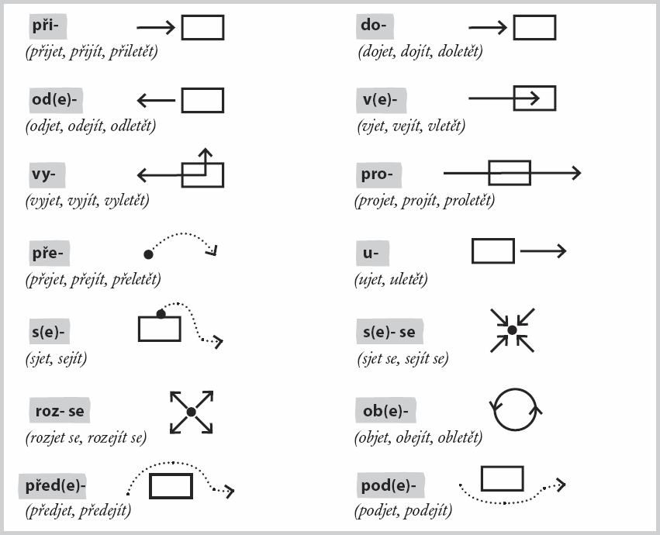

## Basic / important verbs

**při**jít/přijet: to come (Petr přišel do práce v 7:00.)

**ode**jít/odjet: to leave (Petr odešel z práce v 17:00.)

**na**jít: to find (Petr našel na ulici 100 korun.)

**se**jít se: to meet (Petr se sešel s Evou v 17:30.)

**roz**ejít se: to break up (Petr se rozešel s Evou po sedmi letech.)

**pro**jít se // procházet se: to go for a walk (Petr se rád prochází v parku.) < procházka = a walk