1. **PRESCRIPTION TYPES**

Prescriptions can be classified as *individually prepared* or *ready-made*.

1. **Individually prepared medication**, also called ***magistraliter*** (from Latin word magister – teacher) is an order that requires mixing of one or more ingredients (active medicaments) with one or more pharmaceutical necessities (vehicle, suspending agent). The physician selects the drugs, doses, and pharmaceutical form that he/she desires and the pharmacist prepares the medication accordingly. The name of each drug is placed on a separate line right under the preceding one. The order of the ingredients is as follows:

***Remedium cardinale (basis).*** The basis is the principal drug and gives the prescription its chief action.

***Remedium adjuvans (adjuvant).*** The adjuvant is a drug that aids or increases the power of the principal ingredient.

***Remedium corrigens (corrective).*** The corrective modifies or corrects undesirable effects of the basic or adjuvant.

***Remedium constituens (vehicle).*** The vehicle is the agent used as a solvent in the solution to increase the size and volume or to dilute the mixture. The most potent or principal drug is written first, the other ingredient second, and the vehicle last, as shown in the example.

*E.g.*: Invocatio: *Rp./* (= Recipe = take!)

Ordinatio: *Natri****i*** *bromat****i*** *(bromatis) 6,0* Rem. cardinale

*Phenobarbital****i*** *0,6*  Rem. adjuvans

*Sirup****i*** *Menth****ae***  *60,0* Rem. corrigens

*Aqu****ae*** *destillat****ae*** *ad 300,0*  Rem. constituens

Subscriptio: *M. f. mixt.*

= Misce fiat mixtura = Mix (the ingredients) to obtain a mixture.

Signatura: *D. S.*

= Da. Signa. = Give! Sign! *Jedna lžička třikrát denně po jídle.*

(= One tablespoon 3 times a day after meal).

1. **Ready-made medication**, or ***specialitas****,* does not require mixing of two or more ingredients to obtain the final product. It consists of a drug or a mixture of drugs supplied by a pharmaceutical company by its official or proprietary name and, if it contains more than one substance, the specific ingredients do not have to be listed. Usually, it is distinguishable by the abbreviation ***Exp. orig.*** (= *Expeditio originalis* = original package).

E.g.: Invocatio: *Rp.* (= Recipe = take!)

Ordinatio: *Ospamox 750 mg tbl.* (= tabulett**as**)

*Exp. orig. No. II.*

(=expedition**es** original**es** numero du**as** = two original packages)

Signatura: *D. S.*

(= Da. Signa. = Give! Sign!) *Jedna tableta každých 12 hodin po dobu dvou týdnů.* (= One tablet every 12 hours for two weeks).

**CZECH MEDICAL PRESCRIPTION**

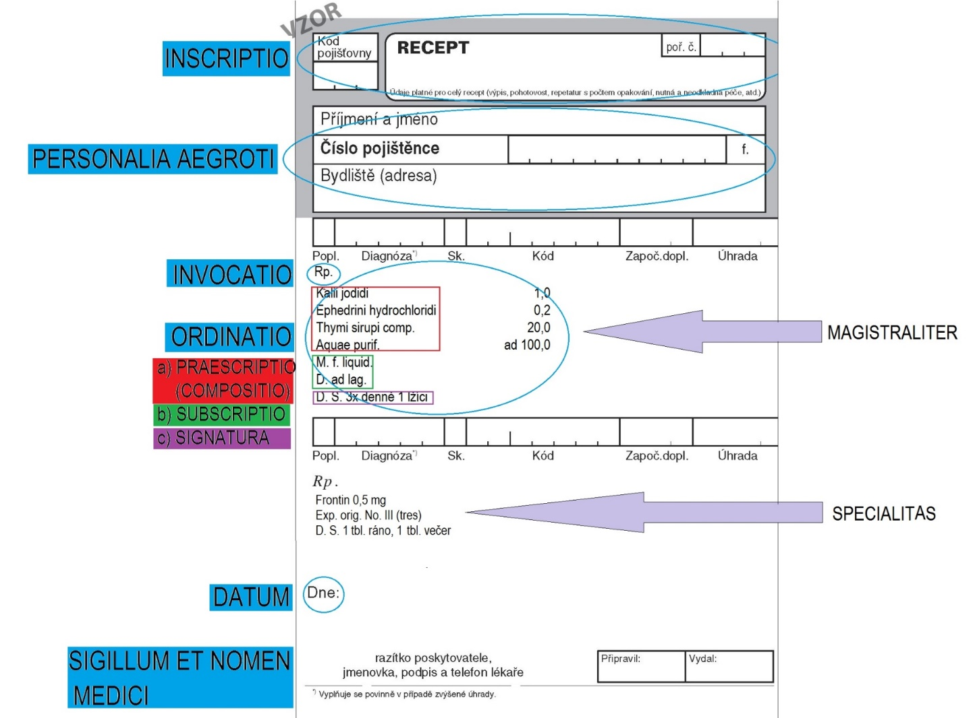

1. **PARTS OF THE PRESCRIPTION**
2. **INSCRIPTIO**

*The name and the surname of the doctor, the hospital, clinic or polyclinic medical center, their address, and the date.* The date is important to determine the expiration of the prescription. The prescription of narcotics and controlled substances is governed by special laws and regulations.

1. **PERSONALIA AEGROTI**

*Name, address and age of the patient.* This part serves to identify for whom the prescription is intended. The full name and the address are required by law on all prescriptions for controlled substances. The age of the patient is a good additional piece of information, especially with pediatric pаtients where dosage calculations have to be double-checked for safety. This part may be located on the designated area, or after the last drug on the back of the form.

1. **INVOCATIO**

Consists of the message to the chemist/pharmacist, and it includes only the formula ***Rp.*** – an abbreviation for *Recipe* meaning *Take!* in Latin.

1. **ORDINATIO**

This is the main part of the medical prescription. There are the *names of medicinal substances, the medicinal forms, and the dosages* (in the magistraliter prescriptions) *or brand name* (in the specialitas prescriptions).

**Magistraliter**: The *medicinal substances* are required to begin with a capital letter and to be in***genitive***(since it is always *a particular amount OF*...). The dosage is noted after the substance or medicinal form using metric units (grams) and Arabic decimal numerals. There can also be instructions concerning in what form or into what package the medicinal preparation should be given, usually with preposition AD + Accusative: e.g. *ad lagoenam*, *ad capsulas*, etc.

**Specialitas**: Brand names are written with capital letter, but these are not inflected and are written as seen in the original packaging. Then *the number of original packages* (ready-made medicines) is given in Roman numerals and full word in the brackets in***accusative*** using the ***Exp. orig.*** formula (or its versions like *Tbl. orig.*).

1. **SUBSCRIPTIO**

In this part there are, if necessary, *instructions to the chemist* on how to make the preparation and the number of doses, or *medicinal forms* to be supplied to the patient, usually introduced by the ***M. f.*** formula (*Misce fiat* = mix to make...!).

1. **SIGNATURA**

This part conventionally starts with the ***D.S.*** formula (*Da. Signa.* = Give!Sign!). *Notes* *intended for the patient* are written in Czech. It provides instructions on how the medicine should be taken. This information must be sufficient to allow the patient to understand fully the amount of the drug product to be taken and the frequency and manner of administration.

1. **SIGILLUM ET NOMEN MEDICI**

*The signature of the doctor* may be placed on the designated area, or after the last drug, and this is for identification data.

1. **FORMS OF PHARMACEUTICAL PREPARATIONS AND AGENTS**

|  |  |
| --- | --- |
| ***capsula*** =capsule (e.g. *mollis/enterosolvens* = soft/dissolvable in gastrointestinal tract) | ***oleum*** = oil |
| ***charta*** = a strip of paper (impregnated with medicinal substance) | ***pasta*** = paste (e.g. *dentrifricia* = toothpaste) |
| ***cremor*** = cream (e.g. *refrigerans* = cooling) | ***pulvis*** = powder (e.g. *adspersorius* = dusting powder) |
| ***decoctum*** = decoction (extraction of medicinal substances by boiling) | ***sapo***, onis, m. = soap (e.g. *kalinus* = potassium) |
| ***emplastrum*** = sticking-plaster | ***species*** = mixture od fried plants to make tea of |
| ***fascia*** = tightening bandage (e.g. *hydrophila* = absorbing or dissolving in water) | ***spuma*** = foam (e.g. *dermalis*) |
| ***filum*** = a thread (e.g. *sterile*) | ***stylus*** = stick (e.g. *nasalis*) |
| ***globulus*** = globule, ball (e.g *vaginalis*) | ***suppositorium*** = suppository (e.g. *rectale*) |
| ***granulum*** = granulated powder (e.g. *effervescens*) | ***tabuletta*** = tablet (e.g. *obducta* = coated) |
| ***guttae*** = drops (e.g. *oculoguttae* = eye drops) | ***tela*** = gauze (e.g. *hydrophila*) |
| ***infusio*** = infusion (e.g. *sodii* *chloridi*) | ***tinctura*** = alcoholic solution made from plants (e.g. *opii*) |
| ***lana*** = cotton wool | ***unguentum*** = ointment |
| ***ligamentum***= bandage | ***vaselinum*** = vaseline (e.g. *album*) |

1. **PARTS OF PLANTS USED IN PHARMACOLOGY**

|  |
| --- |
| ***flos***, ris, m. = flower (e.g. *tiliae* = of linden) |
| ***folium***, ii, n. = leaves (e.g. *menthae* *=* of mint) |
| ***fructus***, us, m. = fruit (e.g. *foeniculi* = of fennel) |
| ***herba***, ae, f. = the whole plant (e.g.*absynthii* = of absinthe) |
| ***lignum***, i, n. = wood (e.g. *cinammi* = of cinnamon) |
| ***semen***, inis, n. = seed (e.g. *arnicae* = of wolf´s bane) |
| ***radix***, cis, f. = roots (e.g. *liquiritiae* = of licorice) |
| ***resina***, ae, f. = resin, pitch (e.g. *cannabis*) |
| ***succus***, i, m. = draught, juice (e.g. *belladonnae* = od deadly nightshade) |

1. **LIST OF ABBREVIATIONS USED IN MEDICAL PRESCRIPTIONS**

|  |  |  |
| --- | --- | --- |
| *a) VERBAL FORMS, INSTRUCTIONS* | | |
| *abbreviation* | *full form* | *translation* |
| add. | adde/addatur/addantur | add/it should be added/they should be added |
| d. s. | da signa/detur signetur | give and sign/it should be given and signed |
| d./dent. | da/detur/dentur | give/it should be given/they should be given |
| d./div. | divide/dividatur | divide/it should be divided |
| div. in dos. aeq. | divide in doses aequales | divide in equal doses |
| d. t. d. | dentur tales doses | such doses should be given |
| disp. | dispensa/dispensetur | divide, distribute/it should be divided, distributed |
| f. | fiat/fiant | it should be made/they should be made |
| m. | misce/misceatur | it should be mixed/they should be mixed |
| m. f. | misce fiat/misce fiant | mix, it should be made/mix, they should be made |
| rep. | repete/repetatur | repeat/it should be repeated |
| rp. | recipe | take |
| s./sig. | signa/signetur | sign/it should be signed |
| solv. | solve | dissolve |
| sterilis. | sterilisetur | it should be sterilised |
| ut f. | ut fiat… | in order to make... (sth) |

|  |  |  |
| --- | --- | --- |
| *b) FORMS OF MEDICATIONS* | | |
| *abbreviation* | *full form* | *translation* |
| caps./cps. | capsula/capsulae | capsule/capsules |
| comp. | compositus, a, um | composed of more constituents |
| conc. | concentratus, a, um | concentrated |
| decoct. | decoctum | decoction |
| drg. | dragées | dragee, coated pill |
| empl. | emplastrum | sticking-plaster |
| extr.  extr. fluid.  extr. sicc. /exsicc.  extr. spiss. | extractum  extractum fluidum  extractum siccum/exsiccatum  extractum spissum | extract  liquid extract  dry/dried extract  thick, dense extract |
| garg. | gargarisma | gargling water |
| glob. | globuli | globules |
| gtt./gutt. | guttae | drops |
| gossyp. | gossypium | cotton wool |
| herb. | herba | plant, herb |
| inf. | infusio | infusion |
| inj.  inj. i. c.  inj. i. m.  inj. i. v.  inj. subcut. | injectio  injectio intracutanea  injectio intramuscularis  injectio intravenosa  injectio subcutanea | injection  injection into the skin  injection into the muscle  injection into the vein  injection under the skin |
| linim. | linimentum | liniment |
| liq. | liquidum | liquid |
| mixt. | mixtura | mixture |
| ol. | oleum | oil |
| past. | pasta | paste |
| p.o. | peroralis/per os | taken perorally (through mouth) |
| pro adult.  pro inf. | pro adultis  pro infantibus | for adults  for children |
| pulv./plv.  pulv. adsp.  pulv. div. | pulvis/pulveres  pulvis adspersorius  pulveres divisi | powder/powders  dusting powder  divided powders |
| sir. | sirupus | sirup |
| sol. | solutio/solubilis/solutus | solution/dissolvable/dissolved |
| sp./spec. | species | tea mixture |
| succ. | succus | juice, draught |
| supp. | suppositorium/suppositoria | suppository |
| susp. | suspensio | suspension |
| tbl.  tbl. efferv.  tbl. obd. | tabulettae  tabulettae effervescentes  tabulettae obductae | tablets  effervescent tablets  coated tablets |
| tinct. | tinctura | tincture |
| ung. | unguentum | ointment |

|  |  |  |
| --- | --- | --- |
| *b) OTHER INSTRUCTIONS concerning dosage, storage, etc.* | | |
| *abbreviation* | *full form* | *translation* |
| aa | ana (partes aequales) | in equal quantities |
| ad amp.  ad caps.  ad ch (art). (cer.)  ad lag.  ad man. med.  ad oll.  ad sacc.  ad scat.  ad us. ext.  ad us. int.  ad us. propr.  ad vitr.  ad vitr. fusc. | ad ampullam  ad capsulam/-as  ad chartam ceratam  ad lagoenam  ad manus medici  ad ollam  ad saccos  ad scatulam/as  ad usum externum  ad usum internum  ad usum proprium  ad vitrum  ad vitrum fuscum | into ampule  into capsule/s  into waxed sachet  into bottle  into the hands of doctor  into gallipot  into sachets  into box/es  for external use  for internal use  for one's own use  into glass (bottle)  into the brown bottle |
| aliq. | aliquot | a little of |
| aq.  aq. dest.  aq. pro inj.  aq. purif.  aq. steril. | aqua  aqua destillata  aqua pro injectione  aqua purificata  aqua sterilisata | water  distilled water  water for injection  purified water  sterilized water |
| c. | cum | with |
| cochl. mag./parv. | cochlear magnum/parvum | table-/teaspoon |
| comp. | compositus | composite, combined |
| conc. | concentratus | concentrated |
| ctr. | contra | against |
| d. | dies, ei, m. | day |
| dil. | dilutus | dissolved |
| dupl. | duplex | double |
| exp. orig. | expeditio originalis/expeditiones originales | original packaging (sg./pl.) |
| fort. | fortis | strong |
| fortiss. | fortissimus | the strongest |
| guttator. | guttatorium | drop-glass, dropper |
| h. | hora, ae, f | hour |
| l. a./leg. art. | lege artis | according to the rules of medicine |
| m. p. | manu propria | (signed) with one's own hand |
| no. | numero | in number of... |
| p. d. | pro dosi | per dose |
| p. die | pro die | per day |
| praec. | praecipitatus | precipitated |
| q. s. | quantum satis | as much as it is necessary |
| simpl. | simplex | simple |
| s. n. | suo nomine | (mark) with its name |
| spir(it). | spiritus | spirit, grain alcohol |
| s. s. v. | sub signo veneni | under the sign of poison |
| tot. | totus, a, um | all, whole |

**EXERCISES:**

**1. Put the lines into correct order following the usual structure of prescriptions. Decide which prescription is ready-made:**

*Exp. orig. No. I (unam)*

*Rp.*

*Imunor p. o. 4 x 10 mg*

*D. S. Dle rozpisu.*

*D. ad scat.*

*Acidi borici pulv. 100,0*

*Rp.*

*S. Jednu lžíci na litr teplé vody k výplachům.*

**2. Fill in missing terms:**

*Rp.*

*Amobarbitali 0,15*

*Codeinii dihydrogenphosphorici 0,03*

*Aminophenazoni 0,25*

*Olei cacao q. _______ ut _______ supp.*

*D. ________ d. _________ VI (sex)*

*S. Na noc zavést 1 čípek.*

*________*

*Asentra 50 tbl. p. o. 28 x 50 mg*

*________ orig. _______ IV (quattuor)*

*D. ________ 2 tablety denně.*

**3. Give full forms of the underlined terms:**

*Rp.*

*Acidi acetylsalicylici*

*Paracetamoli aa 0,3*

*Codeinii dihydrogenphosphorici 0,02*

*Coffeini cum natrio benzoico 0,1*

*Magnesii oxydati 0,05*

*M. f. pulv.*

*D. t. d. No.* *XX (viginti) ad caps.*

*S. 3krát denně 1 prášek.*

**4. Match the pictures with the terms above:**

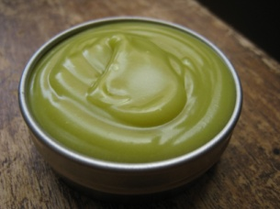 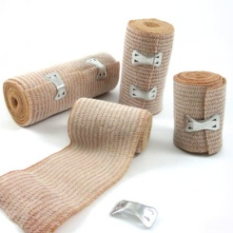 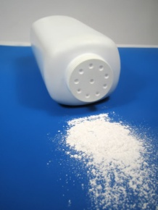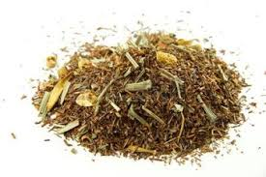 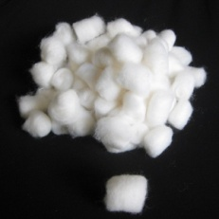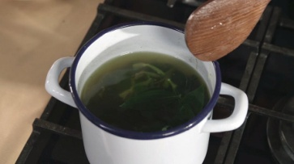 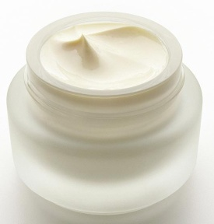 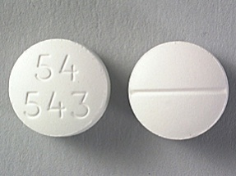 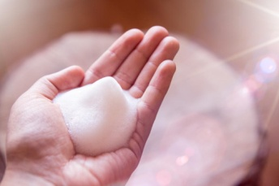 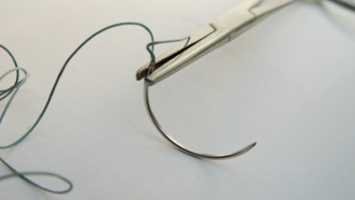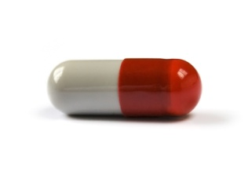 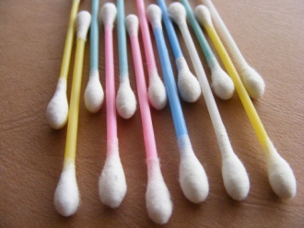 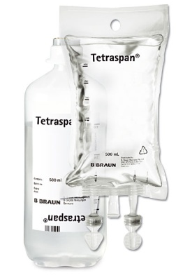 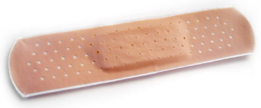 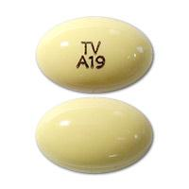 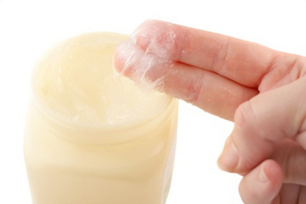 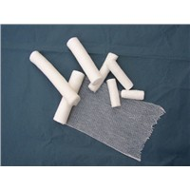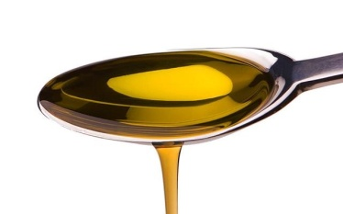 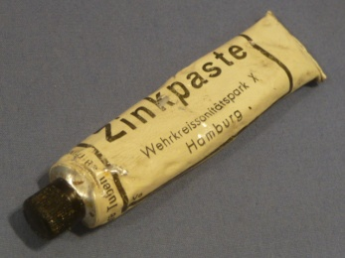 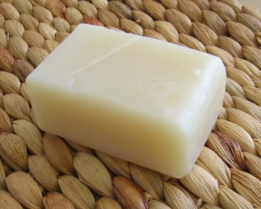 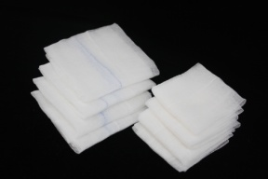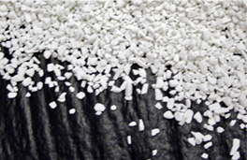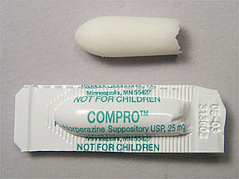 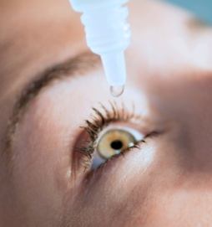 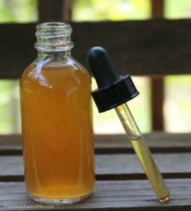

**5. Interpret the samples of medical prescriptions and explain what they are used for/against:**

ANALGETICUM + ANTIPYRETICUM

*Rp.*

*Acidi acetylsalicylici*

*Paracetamoli aa 0,3*

*Codeinii dihydrogenphosphorici 0,02*

*Coffeini cum natrio benzoico 0,1*

*Magnesii oxydati 0,05*

*M. f. pulv.*

*D. t. d. No. XX (viginti) ad caps.*

*S. 3krát denně 1 prášek.*

ANTACIDUM

*Rp.*

*Extracti belladonnae sicci 0,4*

*Papaverinii chlorati 1,0*

*Magnesii oxydati 20,0*

*M. f. pulv.*

*Div. in dos. aeq. No. XX (viginti) ad caps.*

*D. S. 3krát denně 1 prášek mezi dvěma jídly.*

UROLOGICUM

*Rp.*

*Herbae equiseti*

*Folii uvae ursi aa 15,0*

*Herbae herniariae*

*Radicis levistici aa 20,0*

*Folii betulae 30,0*

*M. f. spec.*

*D. S. 1 lžíce na šálek nálevu. Denně vypít 3 – 4 šálky.*

GYNAECOLOGICUM

*Rp.*

*Acidi borici pulv. 100,0*

*D. ad scat.*

*S. Jednu lžíci na litr teplé vody k výplachům.*

MYORELAXANS

*Rp.*

*Mydocalm 150 mg tbl. p. o. 30 x 150 mg*

*Exp. orig. No. III (tres)*

*D. S. 3krát 1 tableta denně.*

ANTIDEPRESSIVUM

*Rp.*

*Asentra 50 tbl. p. o. 28 x 50 mg*

*Exp. orig. No. IV (quattuor)*

*D. S. 2 tablety denně.*

HYPNOTICUM

*Rp.*

*Amobarbitali 0,15*

*Codeinii dihydrogenphosphorici 0,03*

*Aminophenazoni 0,25*

*Olei cacao q. s. ut f. supp.*

*D. t. dos. No VI (sex)*

*S. Na noc zavést 1 čípek.*

IMMUNOSTIMULANS

*Rp.*

*Imunor p. o. 4 x 10 mg*

*Exp. orig. No. I (unam)*

*D. S. Dle rozpisu.*

ANTIBIOTICUM

*Rp.*

*Framykoin plv. ads. 1 x 20 gm*

*Exp. orig.**No. II (duas)*

*D. S. Aplikovat 2krát denně na postižená místa po dobu 10 dnů.*

ANTIDOTUM

*Rp.*

*Ureae 40,0*

*Acidi lactici 1,0*

*Ung. lanalcoli 20,0*

*Cerae albae 5,0*

*Vaselini albi ad 100,0*

*M. f. ung. Týden používat v okluzním obvazu na nehty před aplikací antimykotik.*

*Rp.*

*Carbonis adsorbentis 30,0*

*Magnesii sulfurici*

*(seu Natrii sulfurici) 15,0*

*Aquae purificatae ad 300,0*

*M. f. susp.*

*D. S. Cum formula. Pro medico. Po ukončení výplachu vstříknout do žaludku.*

ANTIMYCOTICUM

DIURETICUM

*Rp.*

*Aminophyllini 1,8*

*Olei cacao q. s. ut f. supp.*

*D. t. d. No. VI (sex)*

*S. 2krát denně zavést 1 čípek do konečníku.*

PARASYMPATOLYTICUM

*Rp.*

*Atropini sulphatis 0,1*

*Aquae pro iniectione ad 10,0*

*M. f. oculoguttae*

*D. ad vitrum guttatorium fuscum*

*S. s. s. v. Denně jednu kapku do každého oka.*

DERMATOLOGICUM

*Rp.*

*Acidi salicylici 7,0*

*Triamcinolon E ung., tub. orig. No. II. (duas)*

*Vaselini flavi ad 100,0*

*M. f. ung.*

*D.S. 1x denně mast na ruce. Repetatur 2x (bis).*

ANALGETICUM

*Rp.*

*Ergotamini tartratis 0,001*

*Diazepami 0,005*

*Phenobarbitali 0,020*

*Coffeini 0,100*

*Paracetamoli 0,200*

*Lactosi ad 0,5*

*M.f. plv.*

*D. t. d. No. L (quinquaginta)*

*D. ad caps. gelat.*

*D.S. 1 tobolku při potížích, max. 2x denně. S. s. v.*