Task 1: Write down the stem and guess the paradigm word

1. os, ossis, n. __________________ __________________
2. cutis, is, f. __________________ __________________
3. mors, tis, f. __________________ __________________
4. pulmo, onis, f. __________________ __________________
5. trauma, atis, n. __________________ __________________
6. dens, dentis, m. __________________ __________________
7. animal, alis, n. __________________ __________________
8. latus, eris, n. __________________ __________________
9. cochlear, aris, n. __________________ __________________
10. pubes, is, f. __________________ __________________

Task 2: Change into nominative plural:

1. Femur ____________________________________
2. Mater ____________________________________
3. Flos ____________________________________
4. Foramen ____________________________________
5. Oedema ____________________________________
6. Apex ____________________________________
7. Caput ____________________________________
8. Melanoma ____________________________________
9. Cartilago ____________________________________
10. Injectio ____________________________________

Task 3: Form phrases:

1. Cortex + ren, lien, cerebellum, ovarium

________________________________________________________________________

1. Carcinoma + ureter, uterus, urethra, tuba uterina, vesica urinaria

________________________________________________________________________

1. Fractura + occiput, femur dextrum, caput femoris, thorax, costae verae

________________________________________________________________________

1. Apex + cor, pulmo, prostata, vesica urinaria, lingua

________________________________________________________________________

1. Basis + cor, pulmo dexter, cranium, phalanges digitorum

________________________________________________________________________

1. Caput + femur sinistrum, costa spuria, humerus, pancreas, fibula dextra, os metacarpi

________________________________________________________________________

Task 4: Find correct form of adjective. Change phrases into plural:

1. margo (dexter, a, um) ____________________________________
2. pars (uterinus, a, um) ____________________________________
3. femur (sinister, a, um) ____________________________________
4. regio (thoracicus, a, um) ____________________________________
5. os (longus, a, um) ____________________________________
6. cirrhosis (chronicus, a, um) ____________________________________
7. pelvis (masculinus, a, um) ____________________________________
8. canalis (nutricius, a, um) ____________________________________
9. rete (venosus, a, um) ____________________________________

Task 5: Match and form phrases: 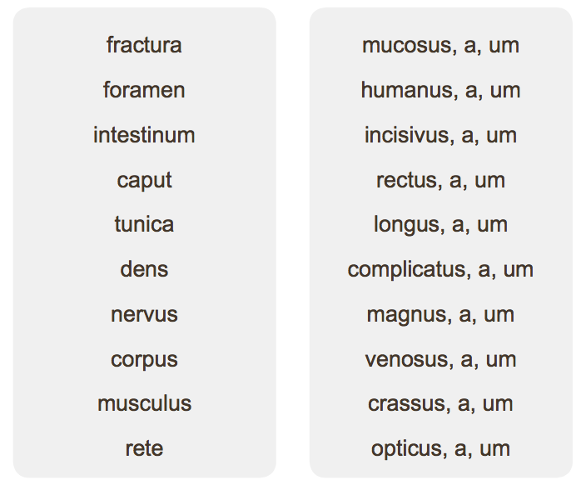

Task 6: Form phrases with different types of injuries:

1. Vulnus + sclopetarius, a, um + dorsum

________________________________________________________________________

1. Sutura + vulnus + lacer, a, um + caput

________________________________________________________________________

1. Oedema + propter + vulnus + contusus, a, um + femur

________________________________________________________________________

1. Infectio + in + vulnus + scissus, a, um + digitus + II

________________________________________________________________________

1. Vulnus (pl.) + sectus, a, um + antebrachium

________________________________________________________________________

1. Sepsis + post + vulnus (pl.) + morsus, a, um + caput

________________________________________________________________________

1. Corpus (pl.) + alienus, a, um + in + vulnus (pl.) + punctus, a, um + abdomen

________________________________________________________________________

Task 7: Translate:

Death on the operating table ____________________________________

Deep part of the parotid gland ____________________________________

Internal ear ____________________________________

Network of carpus ____________________________________

Canine teeth ____________________________________

Venous network of the eyeball ____________________________________

Symptoms of inflammation of liver ____________________________________