

***Additional notes on the published presentation.***

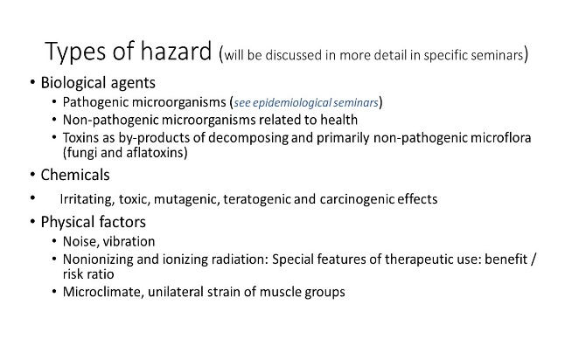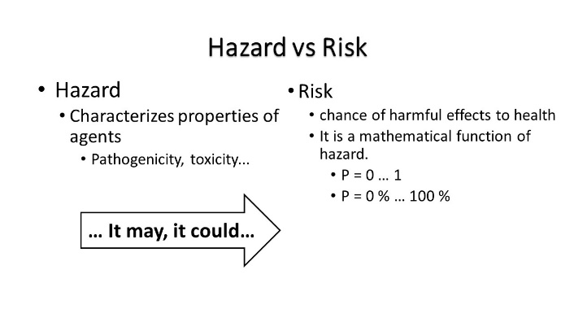Speculating about prevention we suppose that a risk factor contributes to the development of disease. We can derive our knowledge from epidemiological studies: the cohort studies allow us to express results in the form of the relative risk. However, the concept of risk can also be seen in a more general level.

The risk is in general **the probability.** It expresses the chance of a biological, chemical or physical agent to cause an adverse change in health.

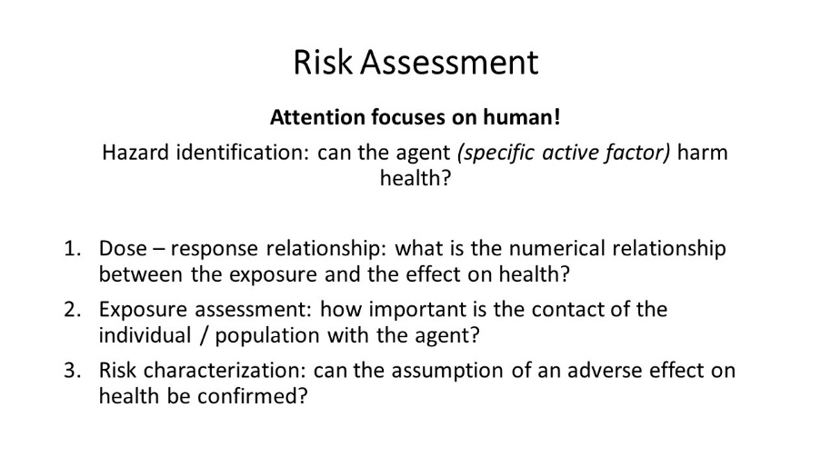Health risk has both an objective and a subjective aspect: despite all objective results and observations, each risk can affect specific people in an emotional way. **The emotional component of health risk** is often greatly underestimatedand, which, as a result, leads to a disruption of communication and mutual trust. In his practice, the doctor encounters this phenomenon in the interpretation of the side effects of drugs, antivaccination campaigns, etc..

The labelling procedure known as a **health risk assessment** is a sequence of steps to be followed: the first step is determination of health or social importance of risk factor. It should be 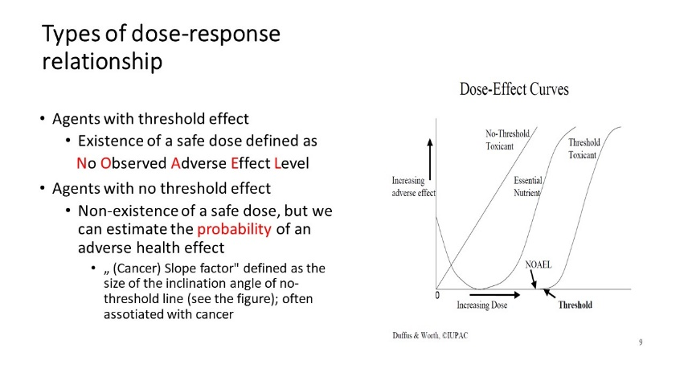replaced later by an effort to express the "strength of harmfulness" of the factor, more precisely the **dose-response relationship**. In many cases, a detectable harmful effect can only happen when the effective (threshold) dose is exceeded. We also know the stochastic effects of an agent, but even here, when the dose is decreasing, the probability of the disease is 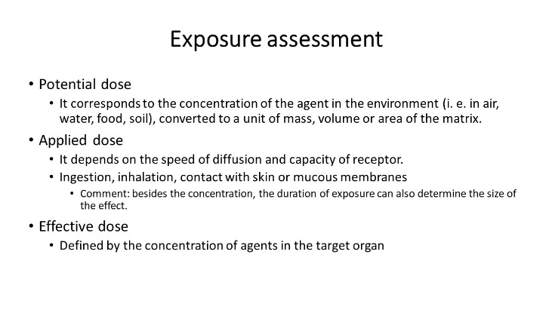reduced up to a certain basal value given genetically.

**Exposure assessment** is the most difficult part of the process: We have to determine an effective dose, which is expected as harmful. The size of effective doses in the target organs is estimated by indirect and by direct methods.

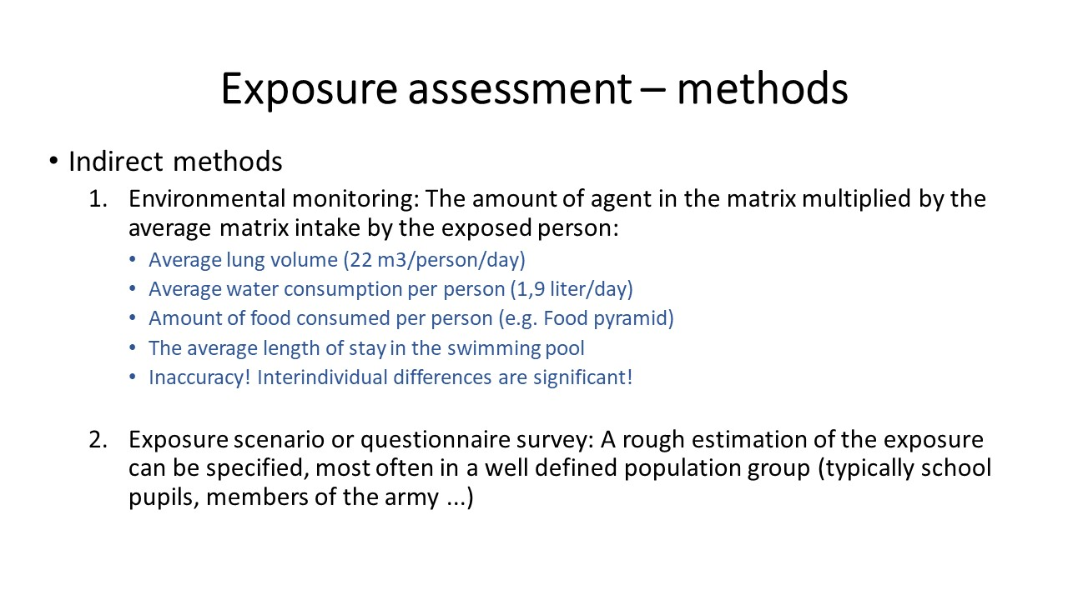

**Indirect methods** are easierbut less accurate: if we know theamount of hazardous substance in food or water and if we can estimate the amount of food or water that is consumed, using simply multiplying the both values, we get a probabilistic estimate of exposure.

To distinguish the subtle differences in exposures, direct methods of estimating exposure based on individual measurements, polling and tests have been developed. However, individual measurement is always time-consuming and financially demanding.

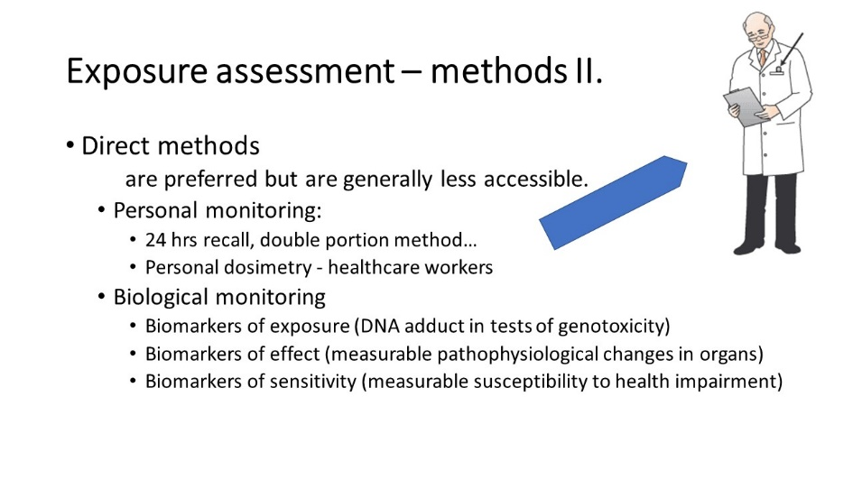

Only when we gather information on harmfulness and quantitative exposure we can conclude an overall impact on health (**characterize the risk**). The whole procedure can also be expressed graphically as the risk matrix: the health impact in relation to the likelihood that we will encounter a risk factor to a sufficient extent.

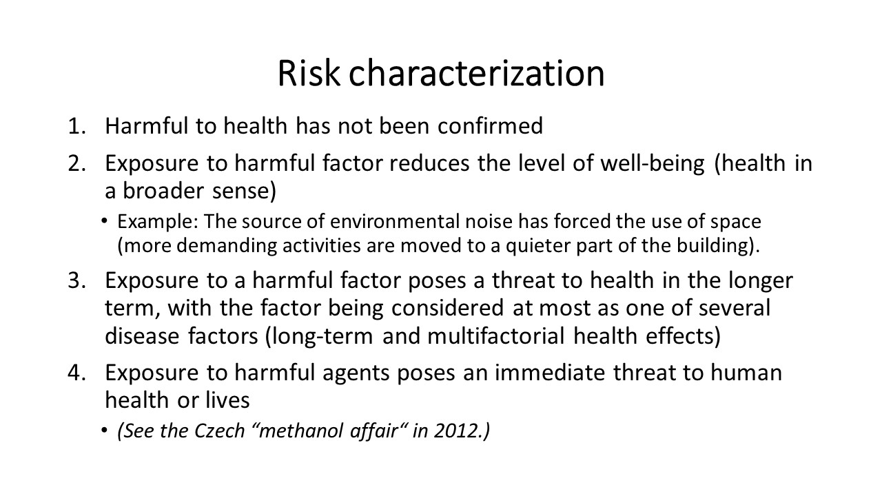

Honesty of any scientific work, incl. health risk assessment cannot be done without a discussion of **uncertainties.** When using indirect methods of exposure assessment, we work with an "average individual". Nevertheless, individual measurements can be affected by random fluctuations, the body's response to the attack is also strictly individual. Epidemiological methodology brings further inspiration to work, from a scientific point of view, with uncertainties in health risk assessment.

A pioneer in this area was british epidemiologist *Austin Bradford Hill*, who has expressed several postulates, suitable for discussing our conclusions about the size of the risk.

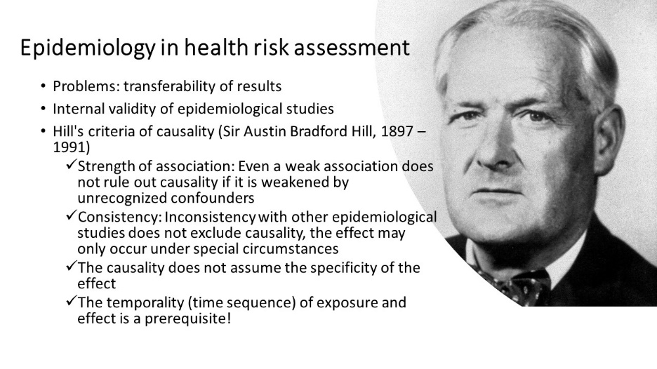Some of Hill's causality criteria have been partially exceeded, others revised. Perhaps the most important thing is the postulate of the **effect temporality**: only such a consequence, which had been proven to occur after known exposure only, it could be responsible for an adverse change in health!

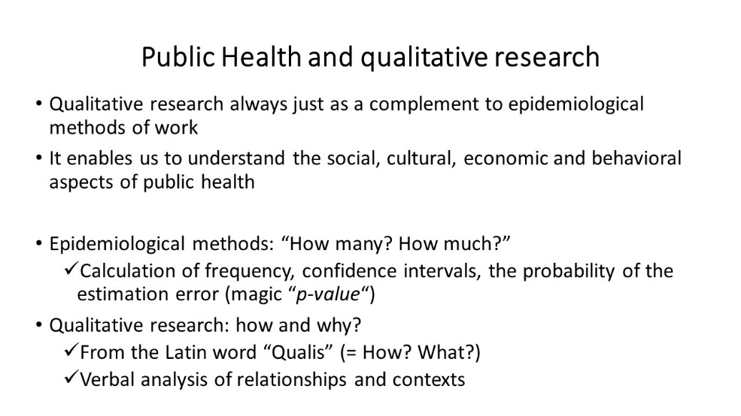In recent years, some elements of the **qualitative research** have penetrated the field of the health risk assessment. Quantitative research and qualitative research should form indivisible unity. The complex of health and risk factors that threaten health cannot be summarised in the result formally expressed as "*p<0.05".* Questioning public attitudes and including public attitudes in objective decision-making of authorities should gradually become a matter of course in the protection of public health.