Unit 5 Revision – Food and Nutrition

1 Underline the odd one out in each group.

1 **carbohydrates:** honey chocolate chips ~~banana~~

2 **fats:** cheese ~~pasta~~ milk oil

3 **proteins:** egg chicken ~~bread~~ tofu

4 **vegetables:** potato ~~banana~~ tomato carrot

5 **fruit:** pineapple ~~tomato~~ papaya apple

6 **minerals:** zinc calcium iron ~~rice~~

2 Choose the correct words in *italics*.

7 I sometimes add *a little* / *a lot* / *any* chilli powder to our dishes as my children love spicy food.

8 ‘Do you eat soya products?’ ‘No, not *a little* / *much* / *many*.

9 Please have *a* / *some* / *any* cheese – it’s come all the way from France.

10 Do they have *a* / *some* / *any* butter? We need some to make the cookies.

11 There isn’t *some* / *much* / *many* salt in this dish, is there?

12 You seem to eat *a little* / *a lot* / *some* of tropical fruit.

13 That’s too sweet for me – there’s too *lot* / *much* / *many* honey.

14 I try not to eat *a little* / *much* / *any* dairy products – I’m allergic to them.

**37/4**



3 Read this food journal and complete the sentences with the words in the box.

balanced calorie intake fibre portion skips snacks

|  |  |  |
| --- | --- | --- |
| **Food Journal:** Kevin Baker | | |
| **Tuesday** | **Time** | **Typical food intake** |
| Breakfast | 7:30 | nothing |
| Mid morning | 11:00 | large milky coffee, 2 chocolate muffins, banana |
| Lunch | 13:30 | steak, chips, cake, large coke, 2 cups of strong coffee |
| Mid afternoon | 15:00 | 2 cups of coffee, chocolate bar |
| Dinner | 21:00 | pasta and meat sauce, white bread roll and butter, ice cream, fizzy drink |
| Evening | 23:30 | 1 cup of coffee, ½ packet of biscuits |

15 The patient’s diet is not very *balanced*.

16 His *calorie intake* is very high and most of the calories come from fat and sugar sources.

17 He only eats one *portion* of fruit a day and no vegetables (except potatoes).

18 The patient often *snacks* on foods that are high in fat.

19 He *skips* the most important meal of the day – breakfast.

20 The patient should eat more *fibre* and include five portions of fruit and vegetables in his diet. He should also reduce the amount of coffee he drinks.

4 Complete these sentences with the words in the box. You do not need all the words.

adverse antibodies harmful immune reactions skin

21 An allergy is a(n) *adverse* reaction to a food.

22 Children often experience strong allergic *reactions* to peanuts.

23 A food allergy occurs when your body thinks that a food is *harmful*.

24 Your *immune* system helps protect the body against disease.

25 Vitamins are necessary for your bones, teeth and *skin*.

5 Rewrite these suggestions. Use the words and phrases in brackets.

26 You should give up smoking if you are pregnant, according to government advice.

It is advisable to give up smoking if you are … (advisable)

27 You should drink lots of water. (important)

It is important to drink lots of water.

28 If you don’t like meat, you should eat fish to increase your protein intake. (why don’t you)

If you don’t like meat, why don’t you eat fish to increase …

29 You shouldn’t include so many high-calorie snacks in your diet. (advisable)

It is not advisable to include …

30 You should join the local gym with a friend. (can I suggest)

Can I suggest you join the local gym …

**Healthy diet and lifestyle – oral exam topics**

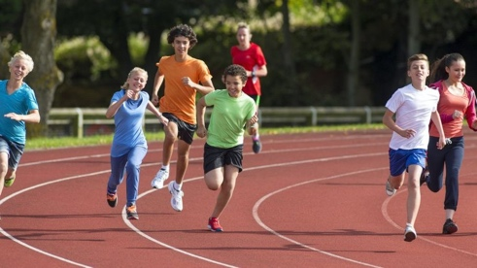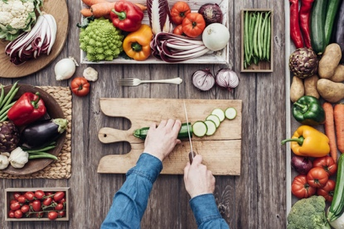

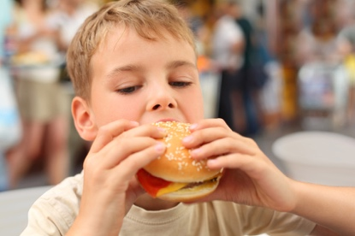

pyramid for a healthy diet

food groups – why important, where found

balanced diet

weight, BMI

food allergies

glucose levels and diabetes

exercise vs. sedentary lifestyle

what exercise you do, with whom etc.

**Unit 6 Revision – Personal care**

1. Write the words in the box in the correct group.

bed pan deodorant hairbrush mirror pyjamas shaving cream

shower chair toothpaste urinal bottle washcloth

**Washing:** (1) shower chair (2) washcloth

**Grooming:** (3) deodorant (4) hairbrush (5) mirror (6) shaving cream

**Oral hygiene:** (7) toothpaste

**Dressing:** (8) pyjamas

**Toileting:** (9) urinal bottle (10) bed pan

2 Choose the correct words in *italics*.

**Nurse:** Do you need help (11) *going to get* / *getting* ready today, David?

**David:** Thank you, Nurse Carter. Could you give me a hand shaving, please? I can’t hold the razor without (12) *going to shake* / *shaking*. It’s very difficult.

**Nurse:** No problem. I (13) *am going to get* / *getting* a washbowl and shaving cream and we   
 can start.

**David:** Before that, can you help me to the toilet, please? I hate (14) *used* / *using* the urinal bottle.

**Nurse:** Yes, of course.

**David:** Thank you. I’m so (15) *embarrassed* / *embarrassing*!

**Nurse:** There is no need to feel (16) *ashame* / *ashamed*,David. Most patients find the   
 situation difficult.

**David:** I (17) *am going to find* / *finding* my stick. OK, here it is.

**Nurse:** Do you need any help (18) *going to get* / *getting* onto the toilet seat?

**-ing/-ed adjectives**

I went to the cinema last night.

The film was boring. I was bored.

The film was depressing. I was depressed.

The film was interesting. I was interested (in…).

The film was amusing. I was amused.

49/7

3 Match sentences 19–24 to language functions a–f.

19 I’ll pull the curtain round your bed. c

20 What do you need help with this morning, Peter? e

21 P: Thanks but I want to try and do everything by myself today. f

22 Don’t be embarrassed, Mr Lorenz – it can happen to anyone. b

23 I can see it’s difficult for you. a

24 P: I need help getting to the toilet, please. d

a showing empathy

b reassuring the patient

c respecting the patient’s privacy

d making a request for help

e offering assistance/help

f refusing help

4 Choose the correct answer, A, B or C.

25 First, I prepare my equipment: I wash my hands and then I put on _____ .

A antibiotics B dressing C disposable gloves

26 Next, I remove the old _____ from the wound and dispose of it immediately in the bin.

A tape B dressing C sutures

27 After that, I check the wound carefully for any _____ or a bad odour, changes in colour, redness or swelling.

A pus B wound C dressing

28 If the wound looks clean and healthy and the _____ are beginning to join up, I know that it

is healing.

A wounds B sutures C edges

29 I can then clean it with _____ and use a piece of cotton wool to dry the wound.

A saline solution B antibiotics C dressing

30 Finally, I put a new dressing on the wound and secure it with _____ .

A sutures B tape C cotton wool

**Personal Care – Oral exam topic**

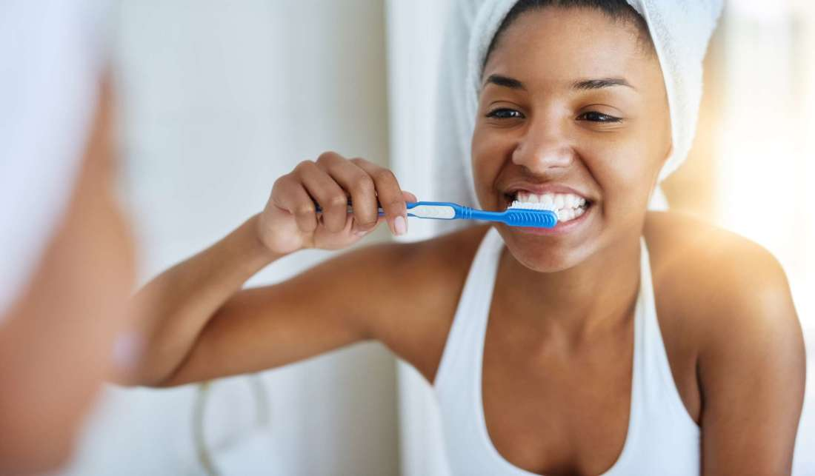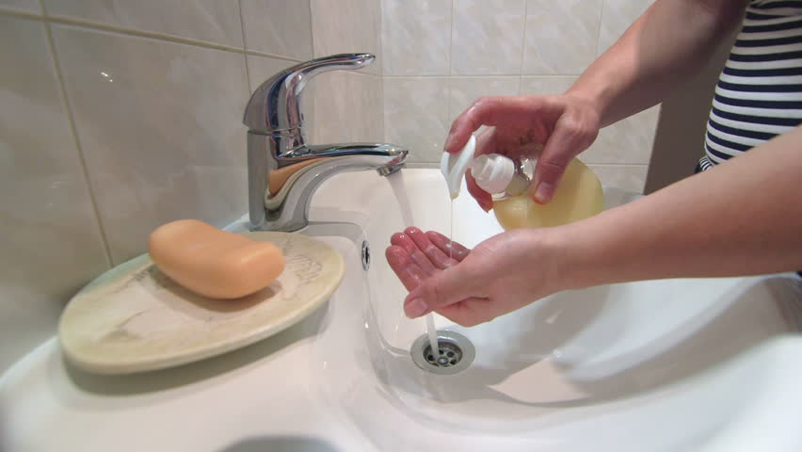

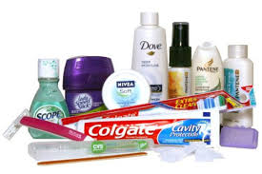

hygiene, toiletries

patients – independent, need help *doing* something

activities of daily living (ADLs)

(bathing, showering, dressing, grooming, oral hygiene, toileting)

**Homework for May 21**

**Prepare a 2-minute talk on the following oral exam topics. You will find the pictures in Study Materials in the IS (Oral Exam Part 2).**

Pain – headache, chest pain

Taking vital signs

Alternative treatment