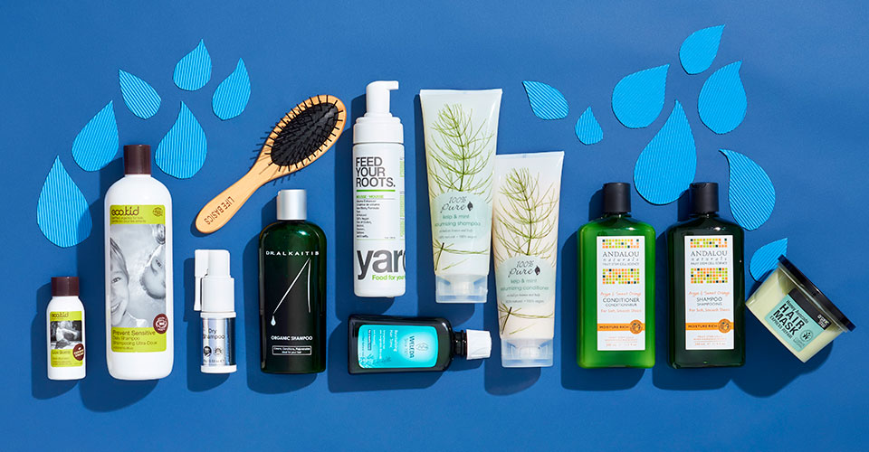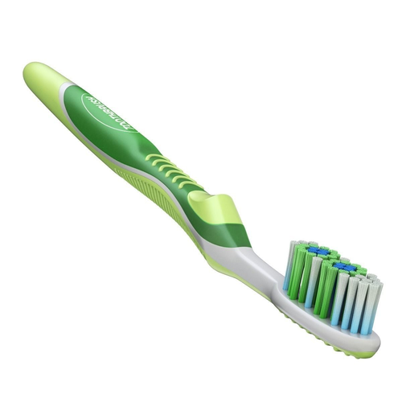

**PERSONAL CARE**

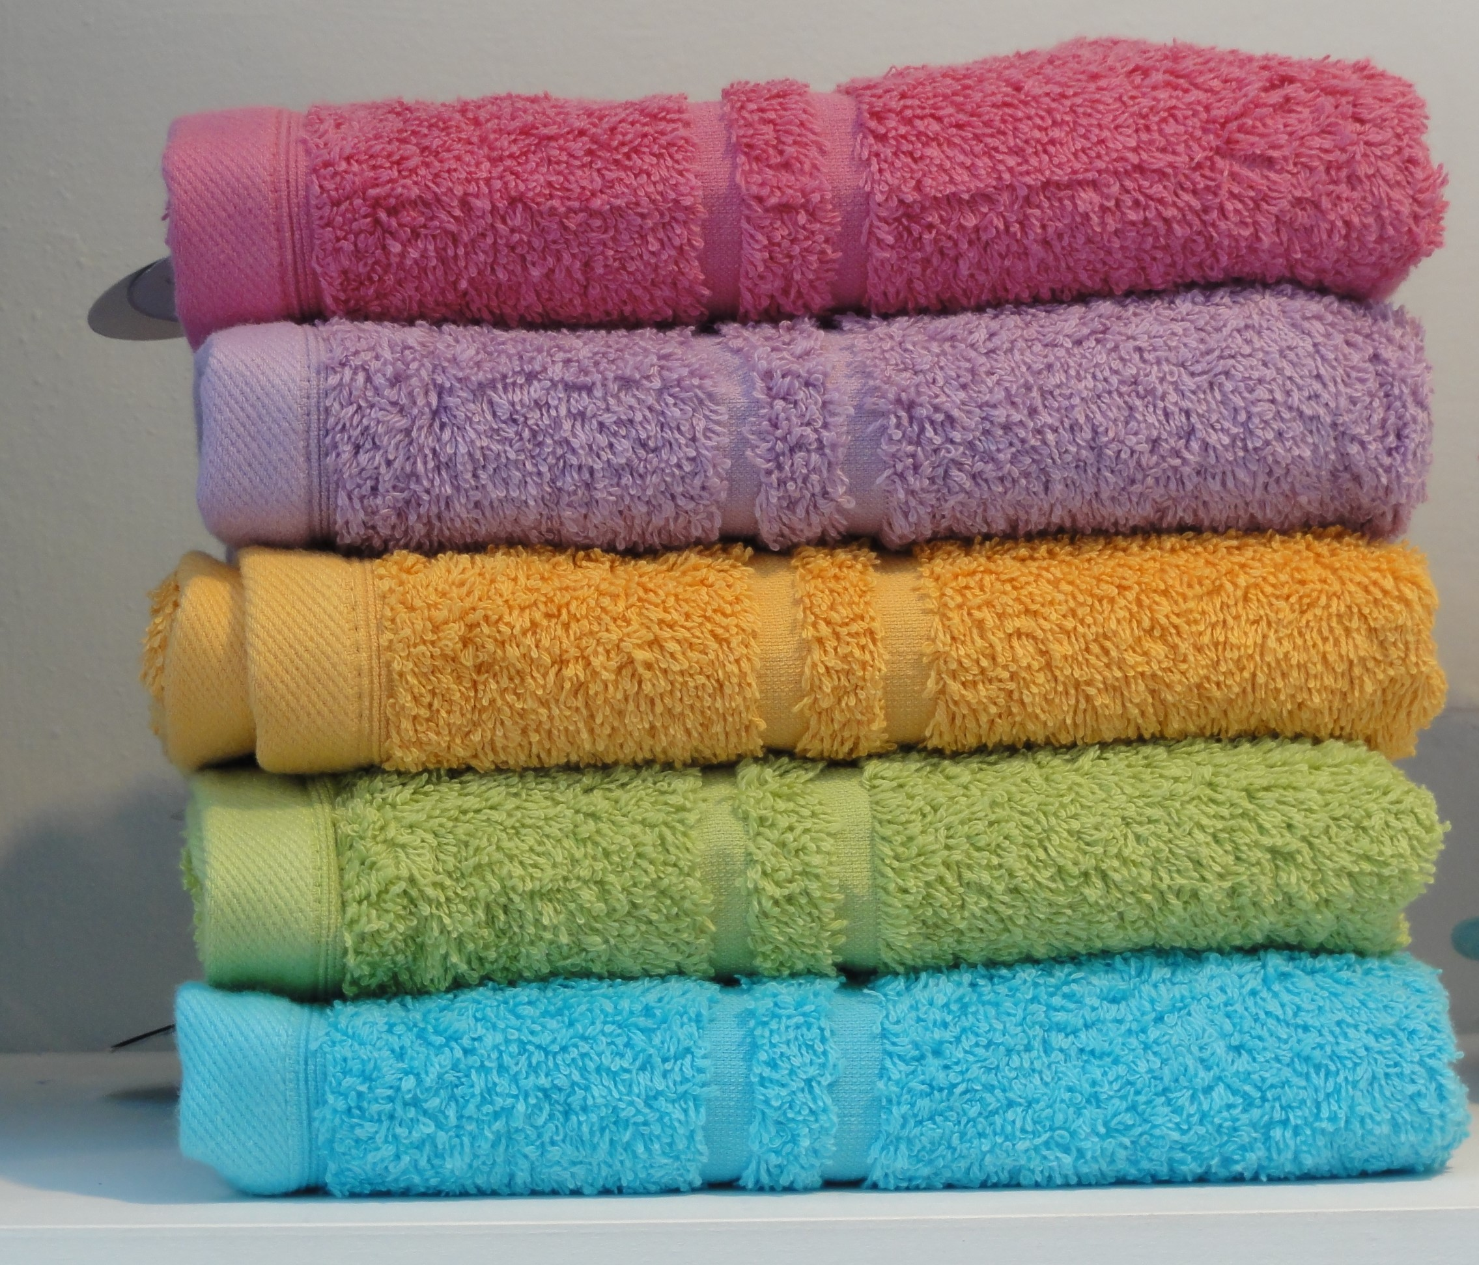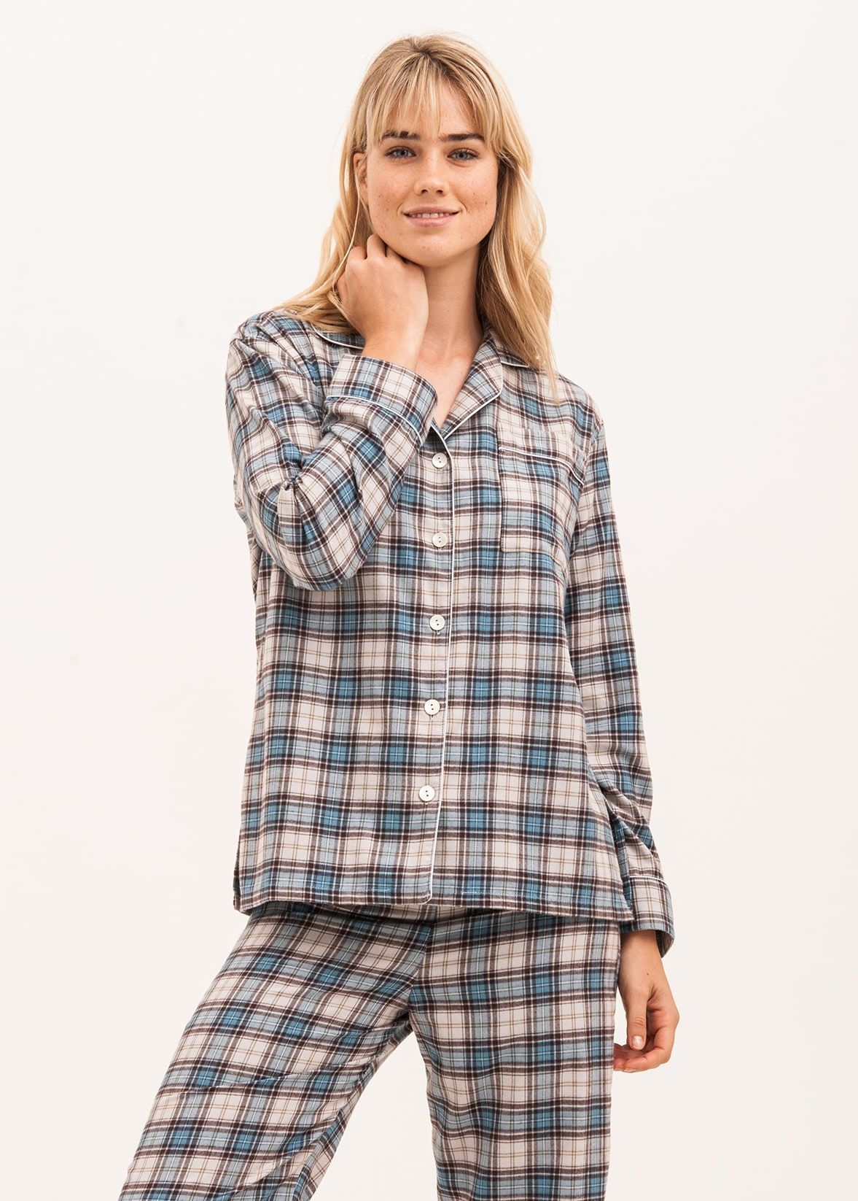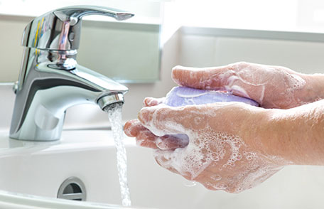

|  |  |  |  |  |  |
| --- | --- | --- | --- | --- | --- |
|  | |  | |  | |
| **FIGHTING HEADACHES** | | | | | |
|  | |  | |  | |
|  | |  | |  | |
| **LOSING WEIGHT** | | | | | |
|  | |  | |  | |

|  |  |  |
| --- | --- | --- |
|  |  |  |
| **SKIN CANCER PREVENTION** | | |
| Tanning Bed Ban Ontario |  | [File:Melanoma.jpg](https://upload.wikimedia.org/wikipedia/commons/6/6c/Melanoma.jpg) |