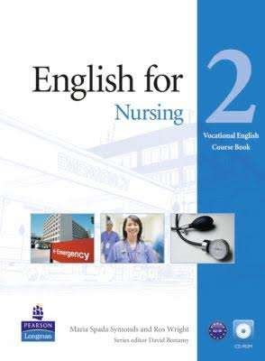**Course organization**

Chapter 5: Food and nutrition

Chapter 6: Personal care

Chapter 7: Elimination

Chapter 8: Patient discharge

The last session: Revision and test

**Grammar**: countable and uncountable nouns, be going to for the future, present perfect, zero conditional and first conditional

**Exam**:

**Written test (70%)** – similar to the winter semester, exercises based on the vocabulary and grammar from our textbook

**Writing (10%)** – you will get a card with information about a patient and you need to create a short story – write a few sentences concerning the patient

**Oral exam (20%)** – done in pairs, 12 to 15 mins, three parts

You must score at least 60% from each part of the exam

**The final grade:**

100-90 points A

89-82 points B

81-74 points C

73-66 points D

65-60 points E

59 – fewer points F