**Oral exam**

**Part 1 (3 mins) Answering personal questions:**

How do you spend your free time?

What are your hobbies?

What would you like to do in the summer?

Where are you from?

What is your favourite place in Brno?

Do you have any pets at home?

Do you listen to music?

Do you go to the cinema?

What is your favourite food?

Do you do sports?

What did you do yesterday?

Did you travel anywhere last year?

Did you take any exams last week?

What will you do in the summer?

**Part 2 (4 mins) Describing photos:**

In the second part of the exam, you will look at two pictures. I would like you to describe your pictures.

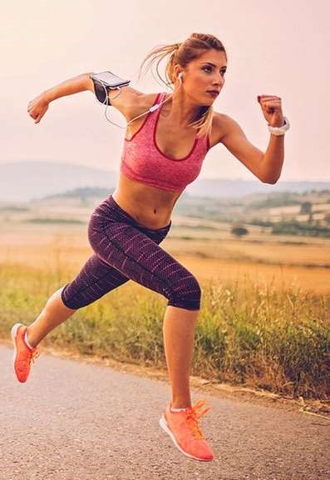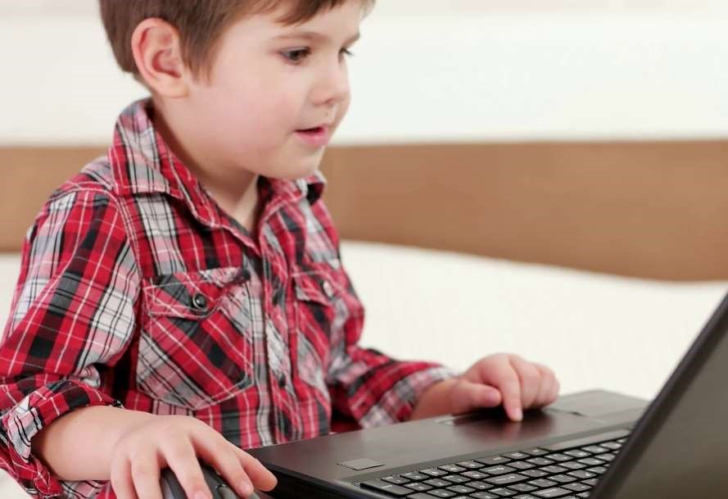

**Part 3 (5 mins) Discussion with your partner**

Imagine that you and your partner are treating a middle-aged woman who is considerably obese. Please consider the ways that can be used for reducing weight.

Here are some pictures to help you decide on what could help the patient.

