PROTOCOL–TELENCEPHALON

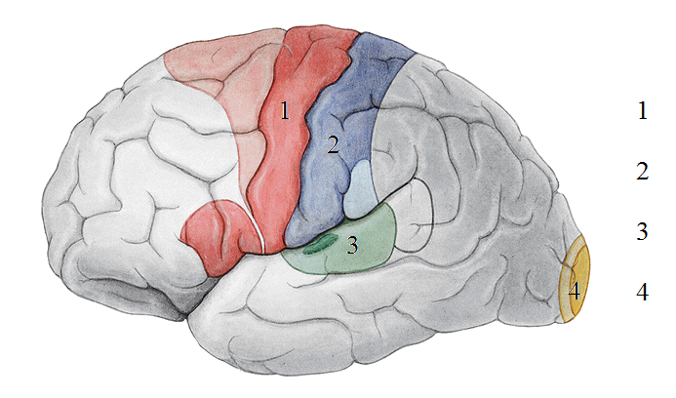1) Describe the functional cortical areas:

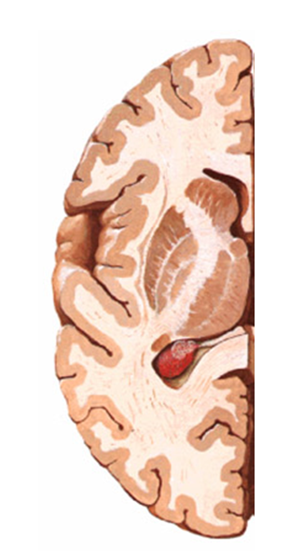2) Mark capsula interna in the picture:

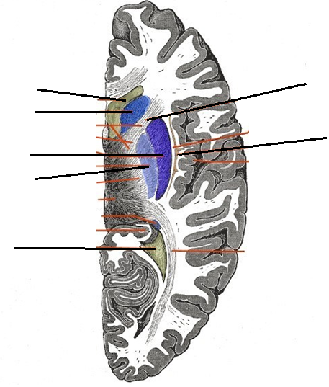3) Describe the picture:

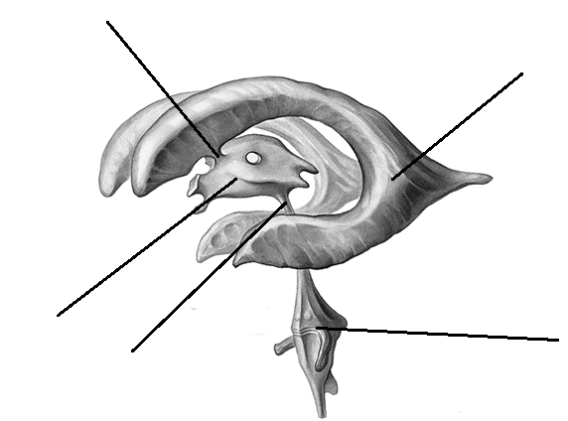4) Describe the picture:

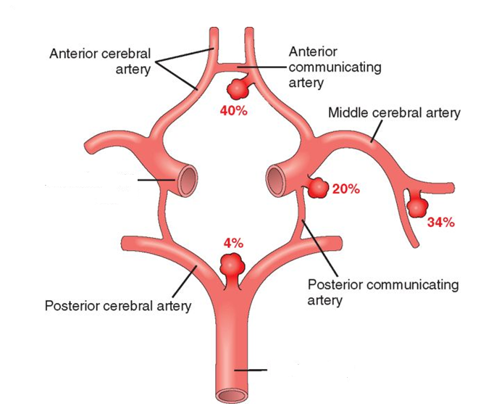5) What is the name of this structure? Complete the description:

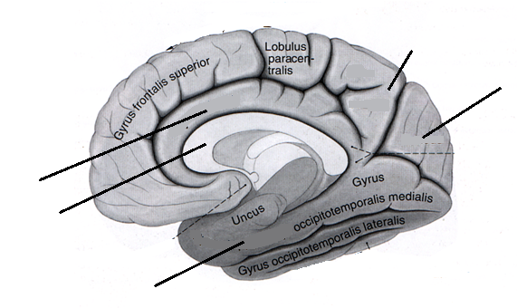6) Describe the picture:

7) Describe the parts of the limbic system:

