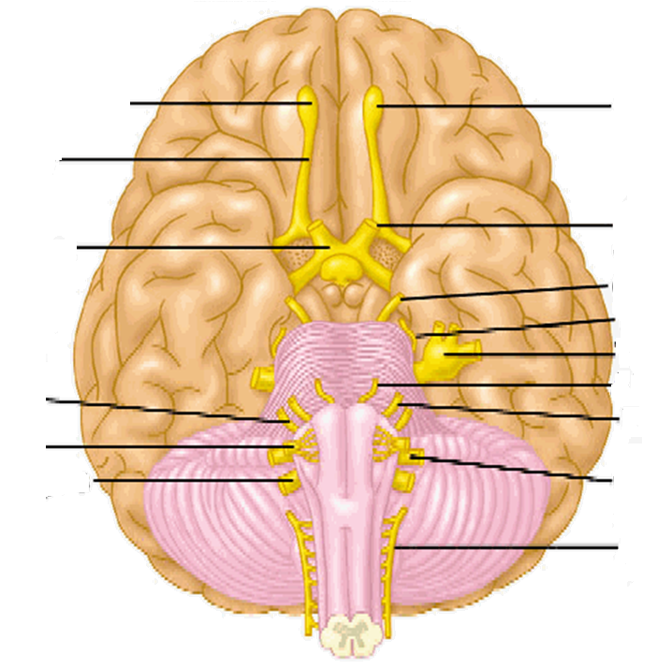PROTOCOL – CRANIAL NERVES

1) Describe the picture

2) Which structures belong to each other?

|  |  |
| --- | --- |
| 1 nervus lingualis | A nervus laryngeus recurrens |
| 2 nervus vagus | B nervus facialis |
| 3 nervus oculomotorius | C musclus trapezius |
| 4 nervus petrosus major | D nervus mylohyoideus |
| 5 nervus glossopharyngeus | E nervus zygomaticus |
| 6 nervus accessorius | F chorda tympani |
| 7 nervus maxillaris | G ganglion oticum |
| 8 nervus alveolaris inferior | H musculus sphincter pupillae |

|  |  |  |  |  |  |  |  |
| --- | --- | --- | --- | --- | --- | --- | --- |
| 1 | 2 | 3 | 4 | 5 | 6 | 7 | 8 |

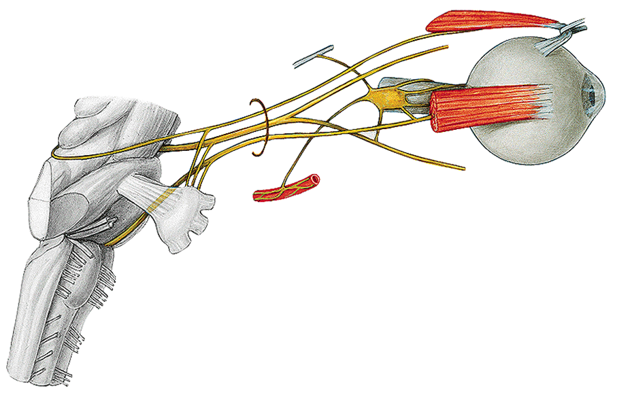3) Mark these structures in the picture: 1) n. oculomotorius, 2) n. trochlearis, 3) nervus abducens, 4) ganglion ciliare

4) Which nerve is in the picture? Find and name three main branches.

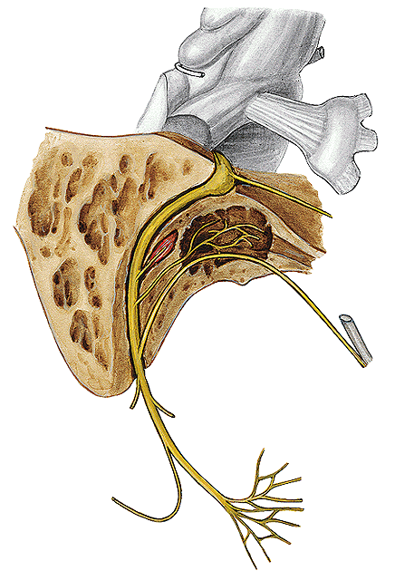

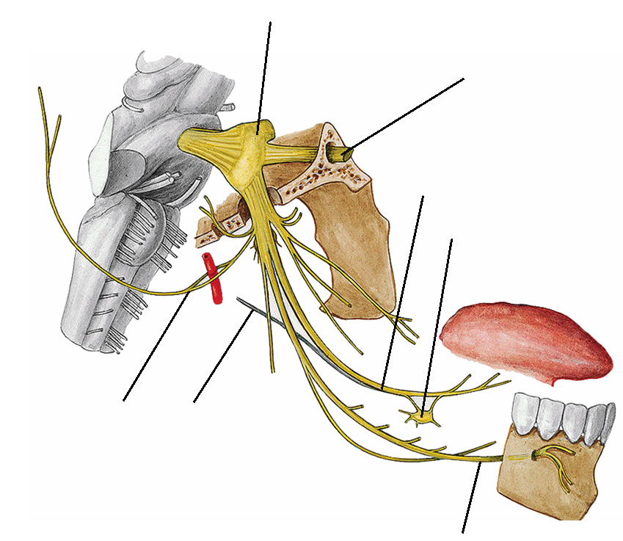5) Describe the picture:

6) Complete the text:

The hypoglossal nerve as the name indicates can be found below the

________________. It is a ________tomotor nerve that innervates all the intrinsic and all but one of the

extrinsic ____________of the tongue. The neuronal cell bodies that originate the

hypoglossal nerve are found in the dorsal medulla of the brain stem in the

hypoglossal nucleus. This nucleus gives rise to axons that exit as rootlets that

emerge in the ventrolateral sulcus of the _______________ between the olive and

________________. The rootlets come together to form the hypoglossal nerve and exit the cranium via the ________________ __________.