**PROTOCOL-ANS**

1. Describe the picture

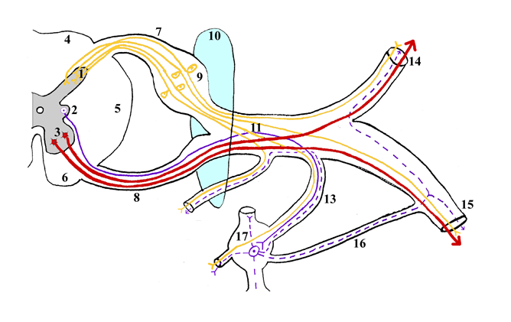

1. Which ganglion is sympathetic and which parasympathetic?

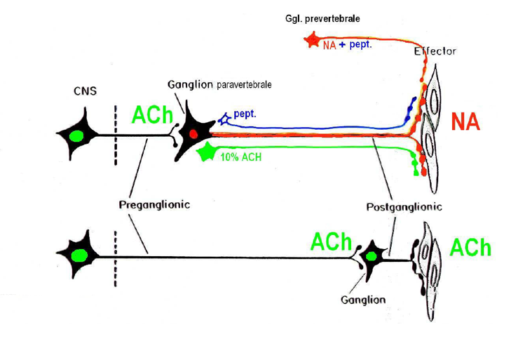

1. Parasympathetic information for which gland are transfered through this ganglion? And whats tne name of this ganglion?

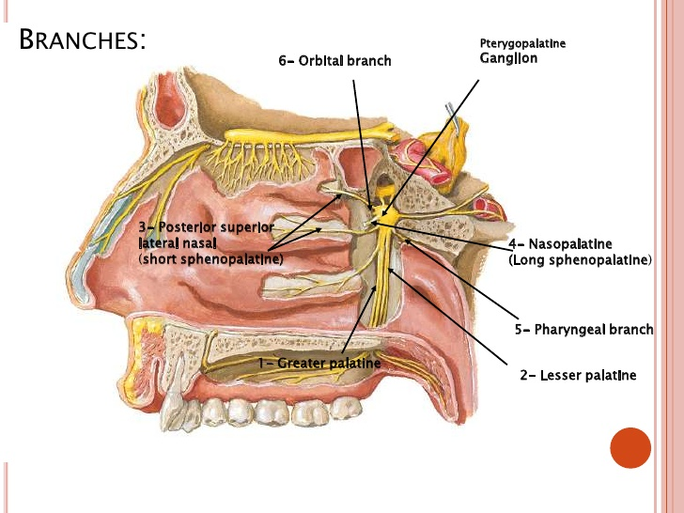

1. What is the name of this structure and where (in which space) we can find it?

