**The regional anatomy**

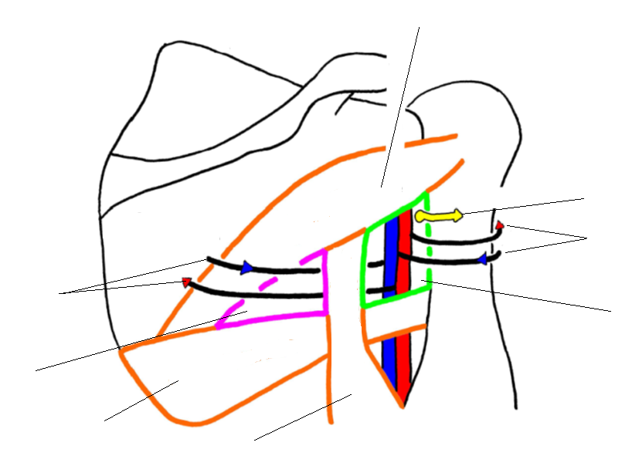1) Describe this picture:

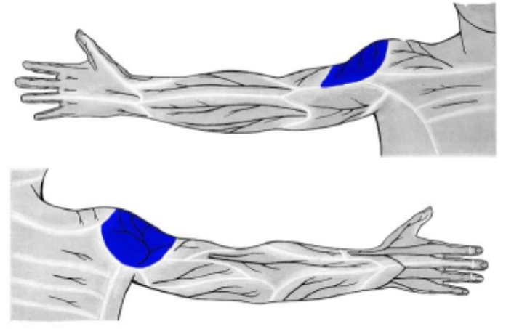2) Which nerve innervates skin of marked area?

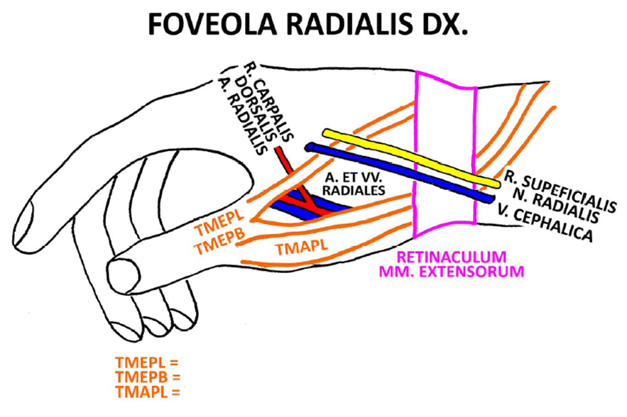3) Explain the abbreviations:

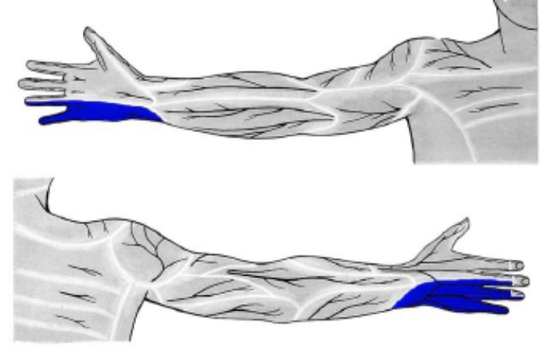4) Which nerve innervates skin of the marked area?

5) Describe the picture:

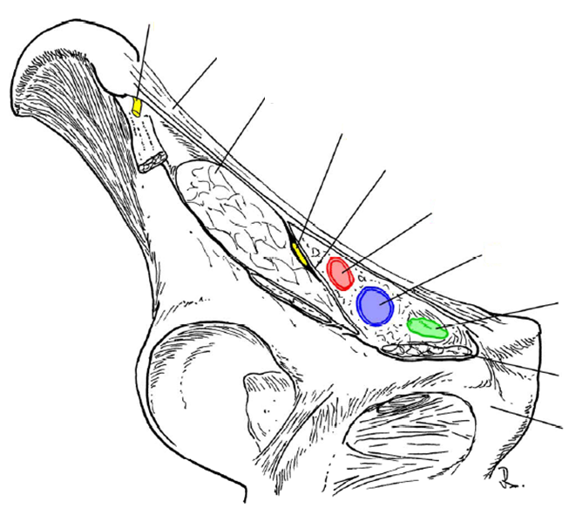

6) Which nerves innervate skin of marked areas of the thigh?

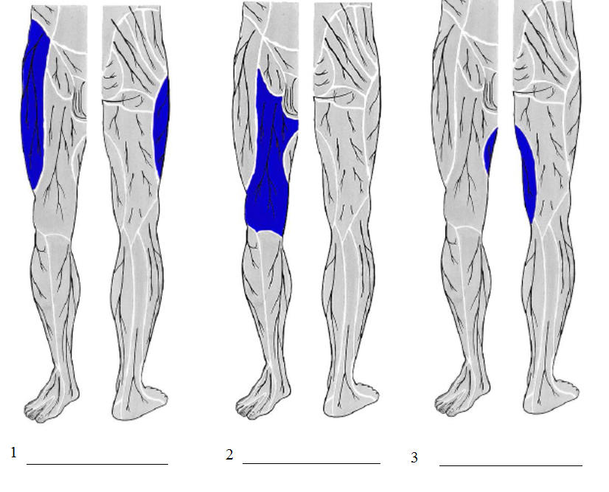

7) Describe the picture:

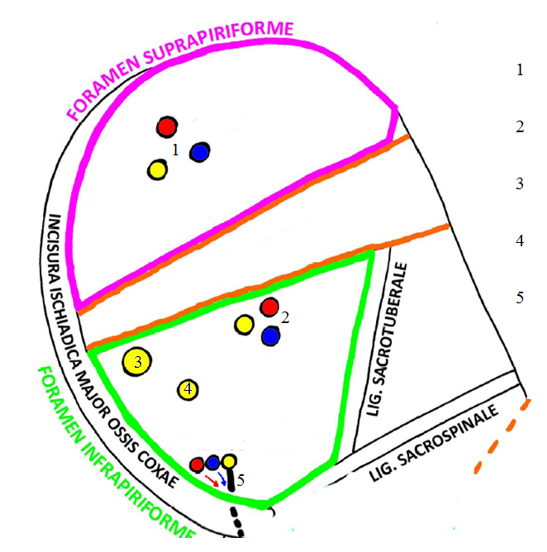

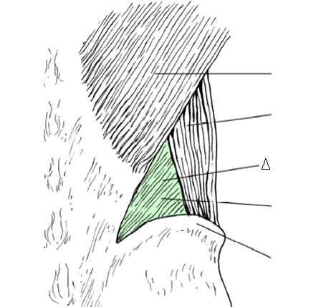8) Describe the picture: