**PLEXUS SACRALIS ET PLEXUS LUMBALIS**

1**)** Plexus lumbalis is distrubuted around m. _______________________________.

2) Describe the picture:

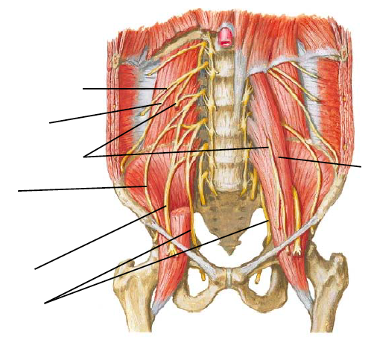

3) Does n. ilioinguinalis pass through the inguinal canal? ____________

4) N. cutaneus femoris lateralis is purely __________________ nerve and it passes through _______________________________ and innervates skin of ________________________

______________________________________.

5) Which is the longest branch of n. femoralis? ______________________________

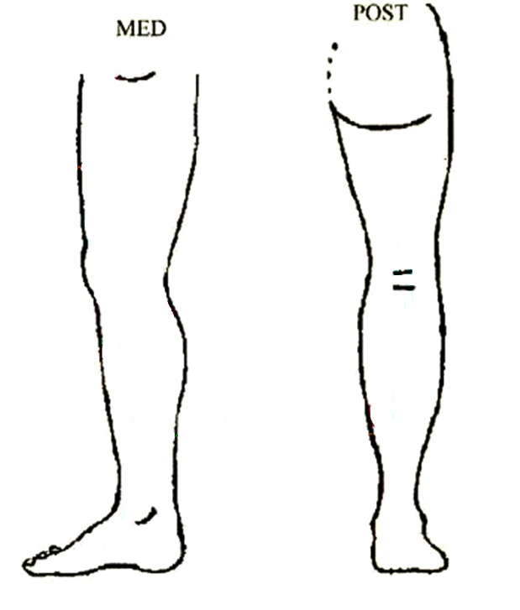 Please draw its course.

6) Write all muscles (6), which are innervated by nervus obturatorius:

_________________________________________________________________________________________________________________________________________________________________________________________________________________________________

7) Which nerves (of sacral plexus) are passing through foramen suprapiriforme?

__________________________________________________________________________

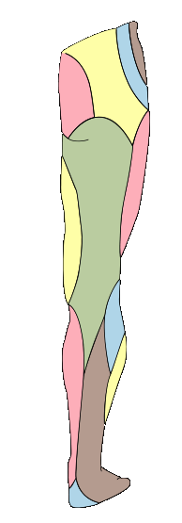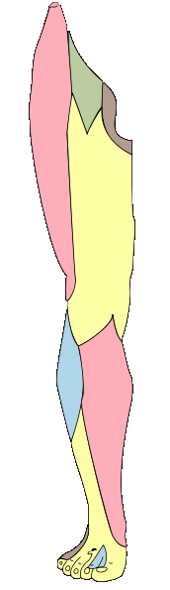8) Which area is innervated by n. cutaneus femoris posterior and which one by n. cutaneus femoris lateralis?

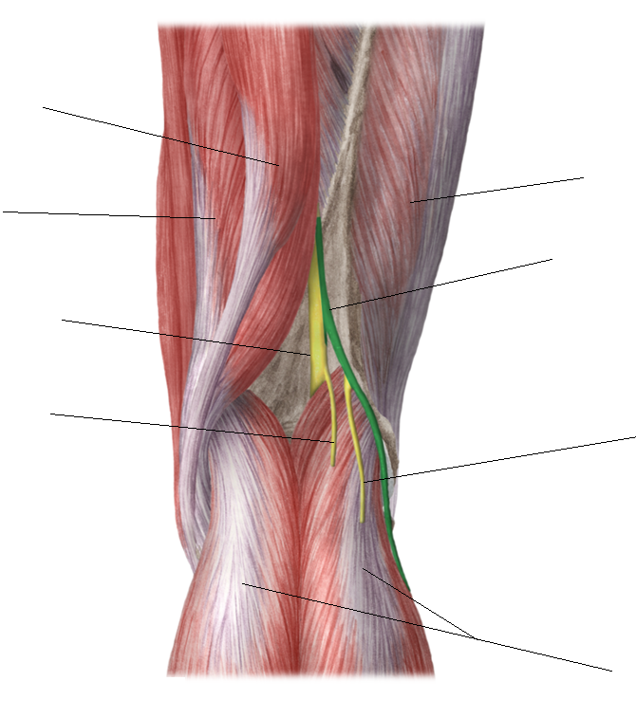9) Describe the picture.

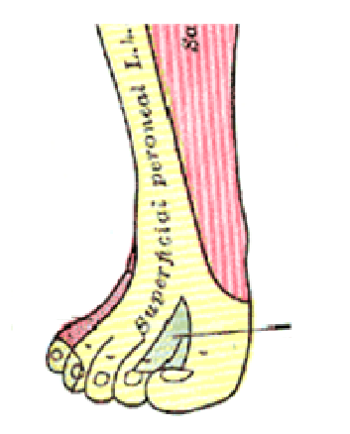10) Which nerve is the marked area innervated by: