**THE BRACHIAL PLEXUS**

1) Musculus brachialis is innervated by n. _____________________________, which pierces through m. ________________________________.

2) The above mentioned nerve continues onto the forearm as n. _________________________, which is purely __________________.

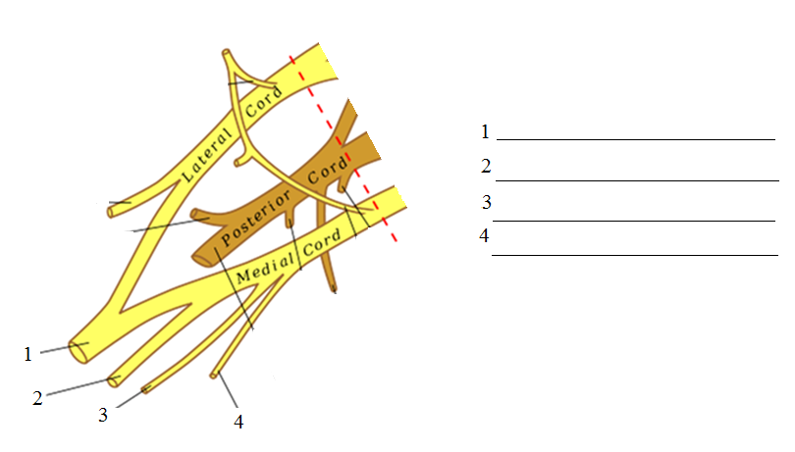3) Describe the scheme of fasciculus medialis:

4) Write at least three nerves, which arise from pars supraclavicularis plexus brachialis.

_______________________________________

_______________________________________

_______________________________________

_______________________________________

_______________________________________

_______________________________________

5) Draw schematically the sensory innervation of the palm and dorsum manus:

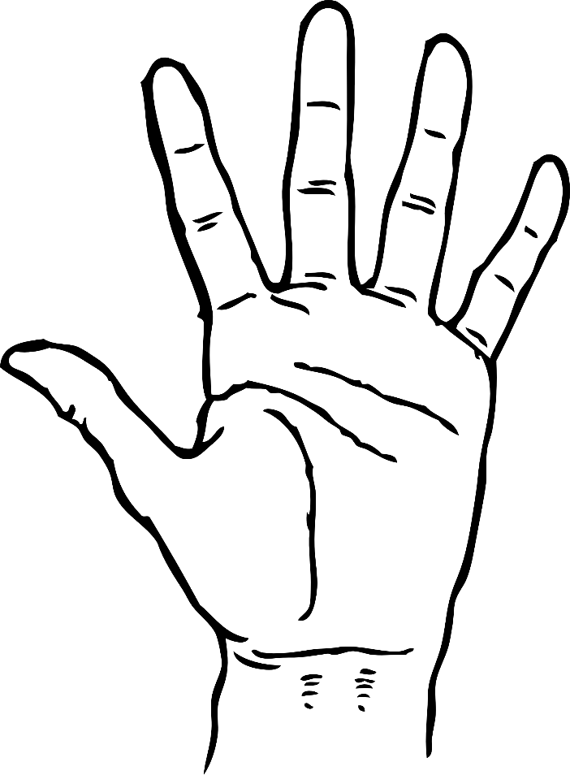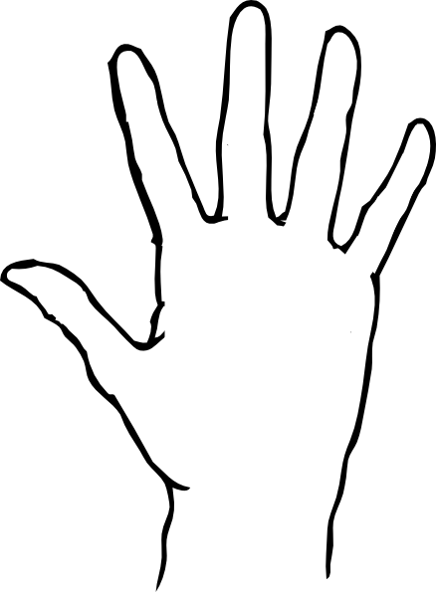

5) Which are the terminal branches of nervus radialis?

__________________________________

__________________________________

6) Mark nervus axillaris.

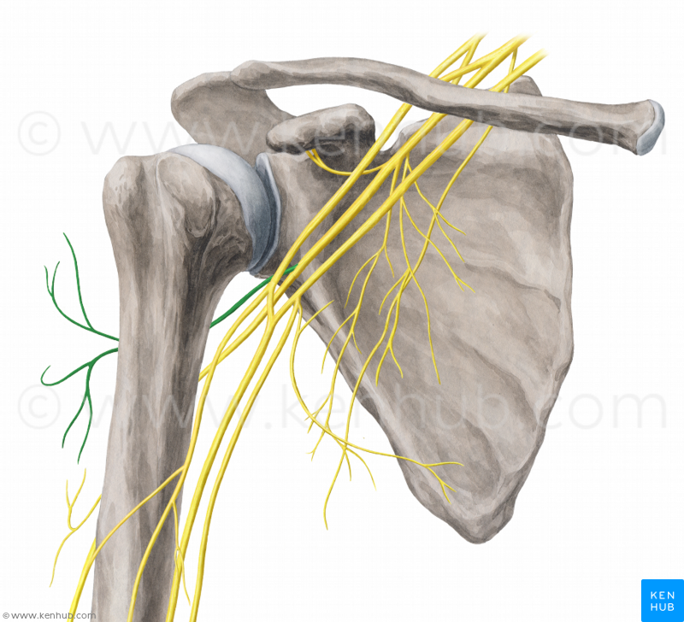

7) Musculus adductor pollicis is innervated by __________________________________.

Musculus abductor pollicis brevis is innervated by ________________________________.

Musculi interossei palmares are innervated by _________________________________.

Musculi interossei dorsales are innervated by _________________________________.