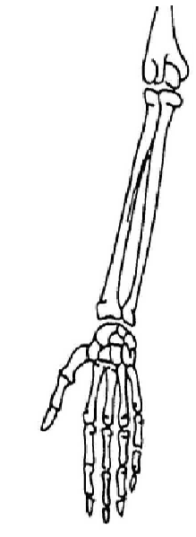**VARIANT A**

**1) Choose the correct statement:**

a) n. axillaris passes through foramen omotricipitale

b) n. radialis arises from fasciculus medialis

c) n. musculocutaneus pierces through m. coracobrachialis

d) n. medianus arises from fasciculus posterior

e) all statements are correct

**2) Nervus ulnaris innervates:**

a) m. flexor carpi radialis

b) m. flexor carpi ulnaris

c) m. supinator

d) m. flexor digitorum superficialis

e) all above mentioned muscles

**3) Draw schematically m. flexor pollicis longus.**

**Write innervation and main function.**

**VARIANT B**

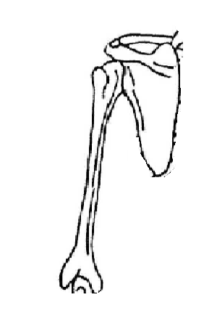**1) Choose a nerve, which is not a branch of plexus brachialis:**

a) n. subclavius

b) n. suprascapularis

c) n. supraclavicularis

d) n. thoracicus longus

e) n. pectoralis major

**2) Choose the correct statement:**

a) palsy of n. medianus is called hand of benediction

b) n. medianus innervates m. triceps brachii

c) n. medianus gets into the palm above retinaculum flexorum

d) n. medianus innervates m. flexor carpi ulnaris

e) all statement are correct

**3)** **Draw schematically m. teres major.**

**Write innervation and main function.**