**FACILITATION, STIMULATION, FACILITATING ELEMENTS AND METHODS**

**Facilitation** = make easier, usually exercise or activity (this is improving the conditions for performing motion)

**Stimulation** = activity that promotes or encourages a reaction by stimuli (activity is induced, the movement is executed, the muscle contracts)

The activation of motor effectors is going through the reflex arc on the basis of facilitation and stimulation of the afferent systems (the sensory receptors, the visceroreceptors, the exteroreceptors in the skin reacting for the pain, touch, pressure, heat and cold, the proprioceptors in the muscles, tendons and articular capsule responsive to the change of the muscle’s length, to the change of the tension in the muscle).

**The reflex arc** consists of sensors (receptors), the centripetal (afferent) pathways, the center, the centrifugal (efferent) pathways and the executing body (effector).

**Monosynaptic reflex**

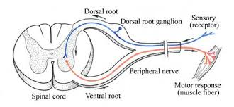The simplest kind of reflex consists only of two nerve cells (neurons). The afferent (sensory, centripetal) neuron leads an impulse through single synapse onto the efferent (motor, centrifugal) neuron.

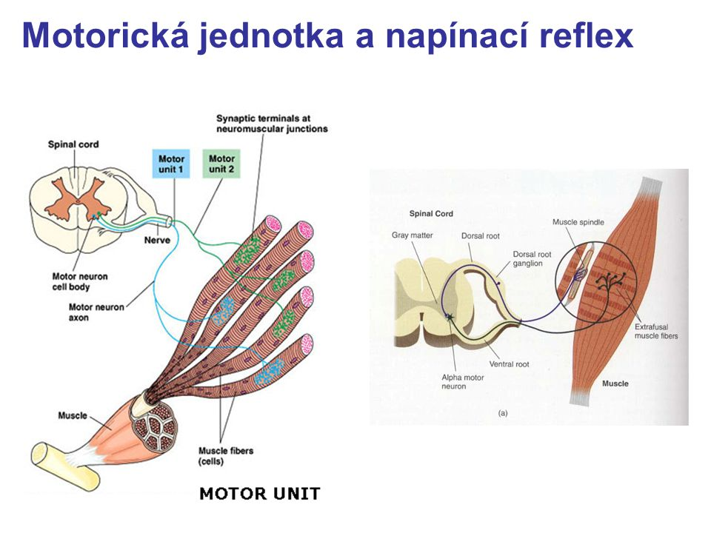 **The stretch reflex** is the only type of the monosynaptic reflex in the true sense in the body. The function of this reflex is a protective reaction to the sudden unwanted muscle elongation. Very simple terms: When a muscle is stretched by rapid passive motion thus it contracts. This avoids the rupture.

The muscle spindle is the receptor of the stretch reflex. It is formed an intrafusal fibers, which are disposed in parallel with an extrafusal fibers (muscle fibers) and they react to the stretching of the muscle. The afferent pathway ends on the excitatory synapse of the alpha motor neuron in the front horn of the spinal cord. The efferent pathway ends on the motor junction of the extrafusal fibers of the same muscle.

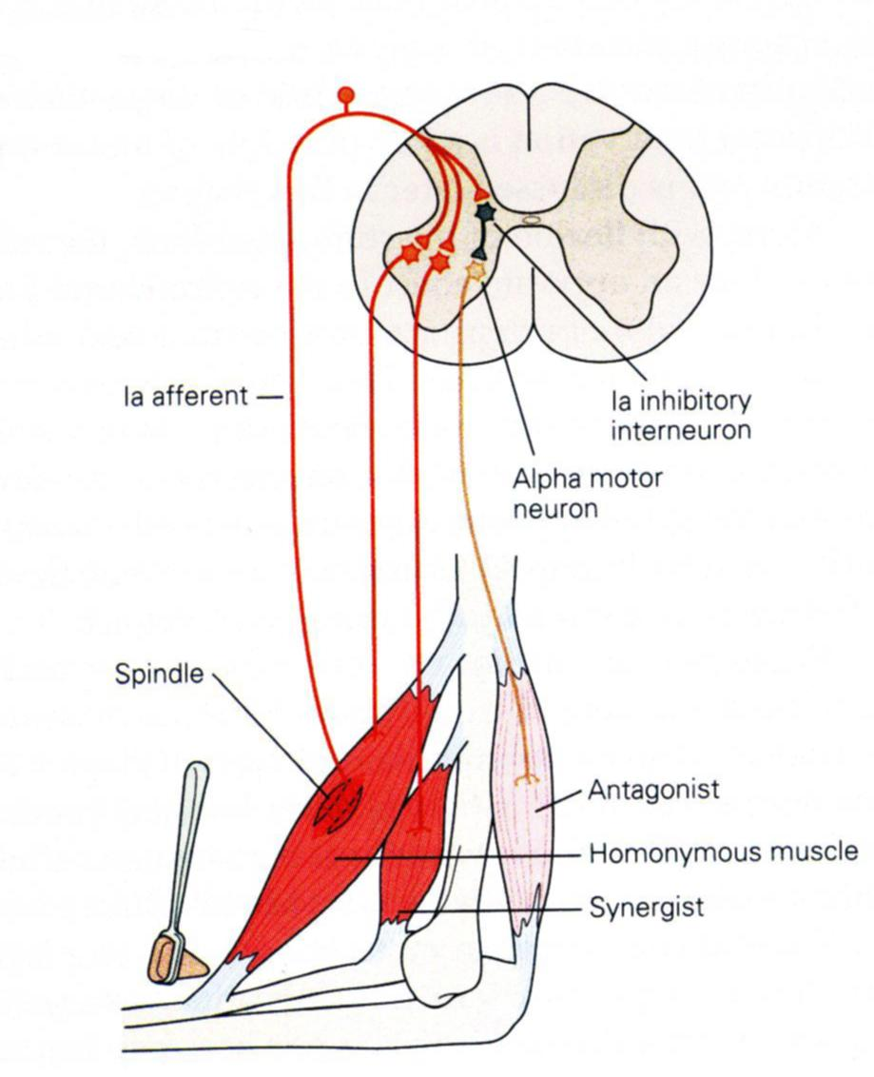Because in the dorsal spinal horn the divergence occurs, the further motor neurons of agonistic muscle groups (synergists) are activated during the stretch reflex and the contraction is amplified.

**Polysynaptic reflex**

**Bisynaptic reflex**

One interneuron (2 synapses) is inserted into the course of the reflex arc.

**Reciprocal innervation:** In order to be implemented the movement, the interplay between agonists and antagonists must operate. It means that relaxation of antagonists is necessary when activating agonists. This condition occurs on the basis of the reciprocal innervation. Part of the branches of afferent pathways creates synapses on Ia inhibitory interneuron through the divergence, they are linked to the alpha motor neurons of antagonists, and thereby their activity is inhibited.

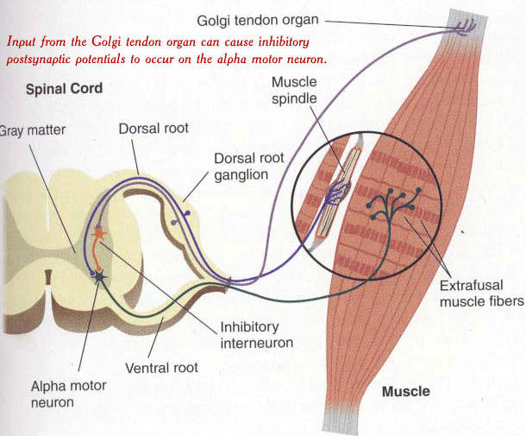**Tendon reflex:** The receptor - Golgi organ is located in the muscle tendon. Its fibers are stored into the muscle-tendon transition in a series to the muscle fibers and they react to the muscle stretching and above all on increasing the muscle tension. The afferent fiber Ib via the inhibitory interneuron is transferred to an alpha motor neurons of the same muscle, and thereby allow it to relax agonists. The Golgi organ builds on the activation of the muscle spindle and cooperates with it. The Golgi tendon organ prevents overloading of the muscle and tendon.

**Polysynaptic reflex:** A greater number of interneurons are inserted into the reflex arch. Examples the tonic stretch reflex (monosegment), the tonic neck reflex (polysegments) and the crossed extensor reflex.

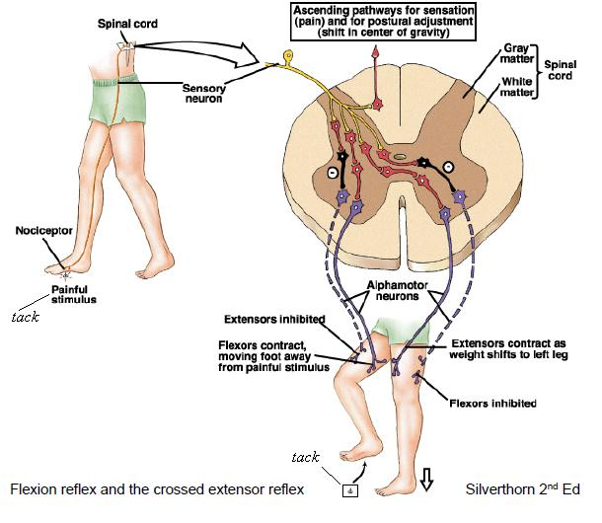

**Facilitating elements**

1. **Breathing:**

The inspiration – activation of the trunk extensors

The expiration - activation of the trunk flexors

General: the movements towards out the body with inspiration, the movements towards in the body with expiration

1. **Vision:**

Monitoring and checking of movements

view up - to activate extensors of the head and the neck

view down – to activate flexors of the head and the neck

1. **Hearing**

I as a physiotherapist say what the patient is doing.

1. **Stimulation of the heat sensors**

Heat decreases muscle tone.

Coldness increases muscle tone.

1. **Stimulation of the skin exeteroceptors for pressure and touch**

Stroking, brushing, pinching, scratching

1. **Stimulation of the proprioceptors**

Fast passive stretching of the muscle

Vibrations

To evoke reflexes