**Czech for Foreigners II – Final Exam (Oral Part)**

**Pass Mark: 70%**

* the oral part will be taken through **MS Teams application**
* camera, microphone and solid internet connection are necessary
  + *if you don’t have it, you can sit the exam at the faculty where necessary equipment will be provided*
* informational tutorial will take place before the exam (date will be released soon): it is fully recommended to try it – to see whether everything works fine on your device/computer (seeing pictures in good resolution)

**Part 1: Human Body**

Your task will be to translate **10 expression into Czech** (TM 1). You need to translate the whole expression, e.g. *adenoid=nosní mandle*, *large intestine=tlusté střevo* (only *střevo* is not a sufficient answer and will not be recognized).

**Part 2: Picture Description**

**·**  You will get a picture, corresponding with the topics of units 1–9 in the book. Your task will be to describe the picture in detail, using full sentences.

· The examiner will then ask you 5 follow-up questions related to the topic in the picture.

**Czech II – Final Oral Exam Worksheet_EXAMPLE**

**Part 1**

**Translate. (10 points)**

|  |  |
| --- | --- |
| navel | joint |
| cranium | aorta |
| cervix uteri | forearm |
| vertebra | adenoid |
| pharynx | thoracic cavity |

**Part 2**

**Describe the picture in 5 sentences. (5 points)**

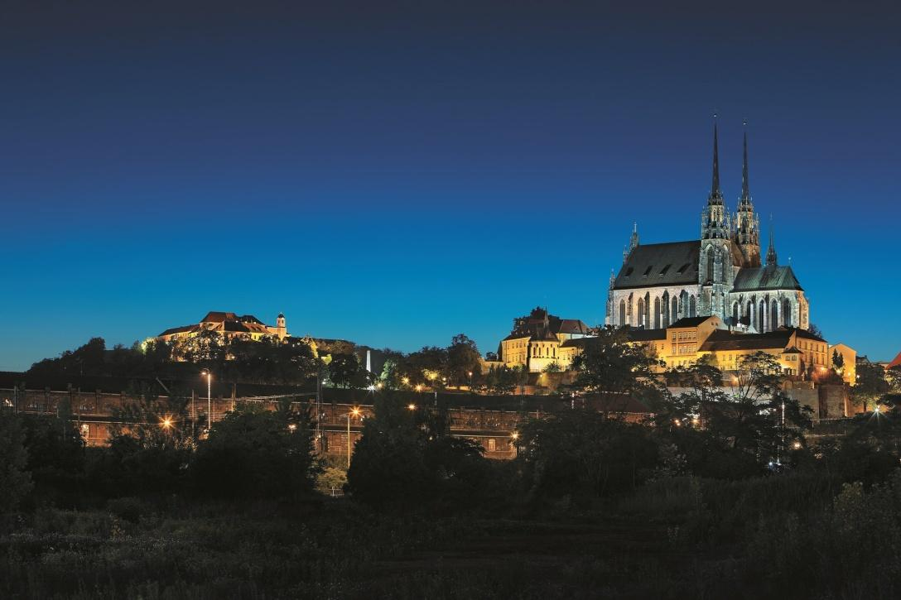

**Part 3**

**Answer the teacher´s 5 questions (10 points).**