**Microscopic slides for practical part of Pathology Exam**

**with audio and pointer English comment (by Filip Sokol, MD):**

<https://atlaspatologie.med.muni.cz/>

Please click on the second right on “Zkouškové preparáty pro studenty LF“

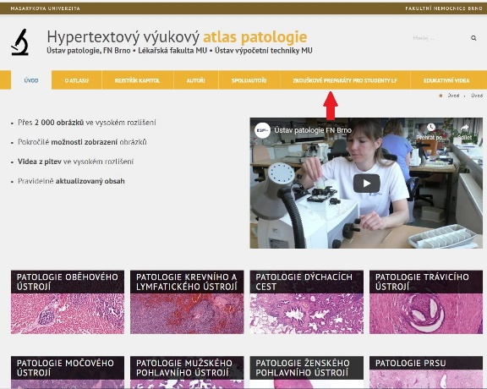

Then click down to “Preparáty k praktické zkoušce“

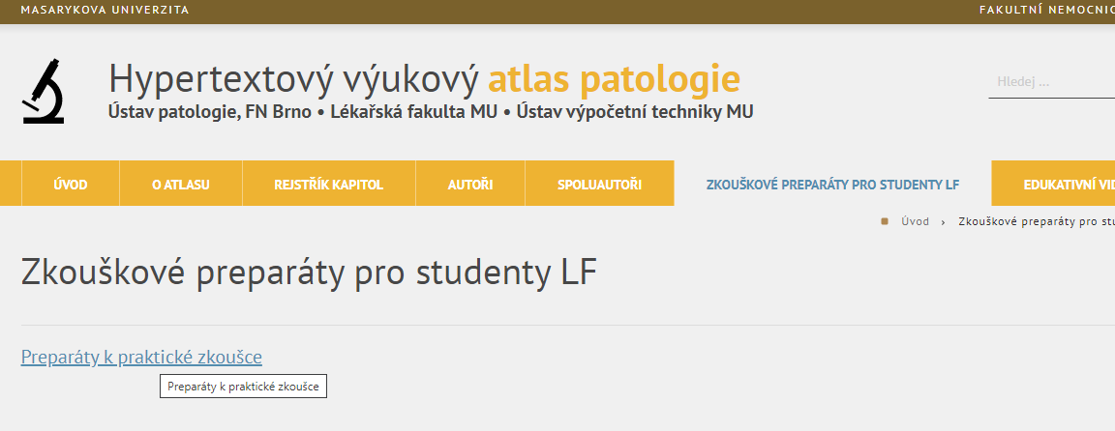

Then please log in:

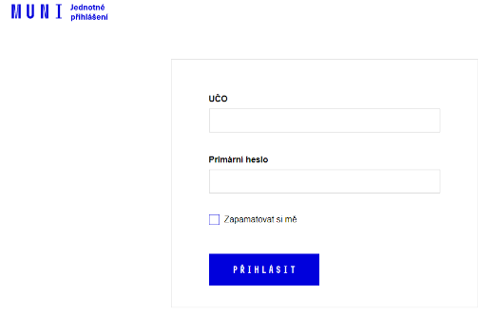

**Here you can slides with links on Youtube with audio comments**

