**Tutorial II – E-learning task**

**1. During examination of the respiratory system in practice, we perform a functional test with holding the breath during inhale. How can we enlarge the apneic pause during inhale?**

**…**

**2. Complete the partial pressure values of oxygen (pO2) and carbon dioxide (pCO2) in atmospheric air (box 1), alveoli (box 2), arterial blood (red box), venous blood (blue box) and exhaled air (box) 3).**

Box 3: pO2………….

pCO2 ………..

Box 1: pO2 ……….

pCO2 ……..

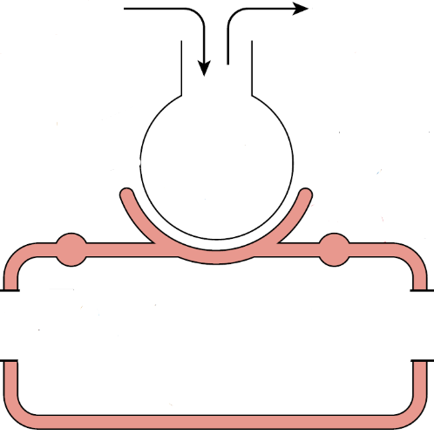

pO2 ………….

pCO2 ………..

pO2 ………….

pCO2 ………..

Box 2. pO2 ………….

pCO2 ………..

**3. In the following flow/volume loop find parameters that are given below:**

- Inhale …

- Exhale …

- Tidal volume …

- Inspiratory reserve volume …

- Expiratory reserve volume …

- Residual volume …

- Peek expiratory flow …

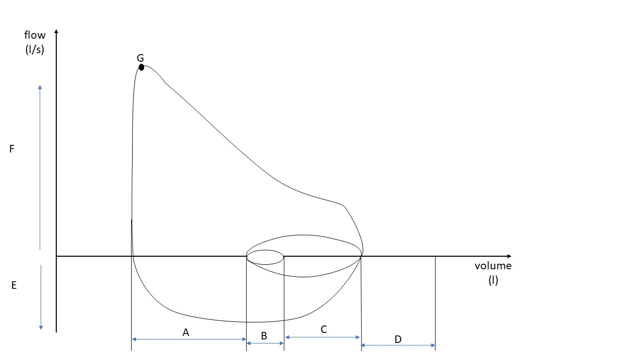

**4. In a measurement of residual capacity by helium dilution, the original and final helium concentration were 10% and 6%, and the spirometer volume was kept at 5 liters. What was the volume of the residual capacity in liters?**

…

**5. Herring-Breuer reflexes are:** …

a. Reflective changes of breathing triggered by receptors in the sinus caroticus

b. Reflective changes of breathing triggered by CO2 changes near chemoreceptors

c. Reflective changes of breathing triggered by pulmonary receptors via n. vagus

d. Reflective changes of heart frequency during the inspiration and expiration

**6.**

**The following diagram shows the depth of respiration of a 45-year-old man who suffered a head injury in an automobile accident.** 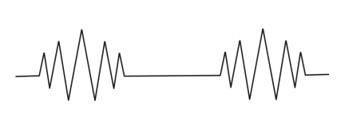

This “crescendo-decrescendo” pattern of breathing is called: **…**

a. Apnea

b. Biot breathing

c. Cheyne-Stokes breathing

d. Hyperpnoea

e. Tachypnoea

Expected level of lesion is: **…**

**7.** **A preterm infant has a surfactant deficiency. Without surfactant, many of the alveoli collapse at the end of each exhale, which in turn leads to pulmonary failure.**

**a.** How the following parameters changed in the preterm infant, compared to a normal infant?

Alveolar surface tension **…**

Pulmonary compliance **…**

**b.** Which of the following parameters we have to change to setting the assisted ventilation in preterm infant?

Tidal volume **…**

Frequency of breathing **…**

Pressure at the end of the breathing cycle (vacuum/overpressure) **…**

**8. An anesthetized male is breathing with no assistance. He is then artificially ventilated for 10 min at his normal tidal volume but at twice his normal frequency. He is ventilated with a gas mixture of 60% O2 and 40% N2. The artificial ventilation is stopped and he fails to breathe for several minutes. This apneic episode is due to which of the following?**

a. High arterial pO2 suppressing the activity of the peripheral chemoreceptors

b. Decrease in arterial pH suppressing the activity of the peripheral chemoreceptors

c. Low arterial pCO2 indirectly suppressing the activity of the central chemoreceptors

d. High arterial pCO2 indirectly suppressing the activity of the central chemoreceptors

Your answer: **…**