**Seminar 17**

**DNA, RNA. Enzymes. Vitamins**

* **DNA, RNA**

1. Give examples of nucleic acids.
2. Structurally, nucleic acids are poly _ _ _ _ _ _ _ _ _ _ _
3. What are the four bases in DNA and RNA?
4. What are structural differences between DNA and RNA?
5. Give the names of nucleosides present in the following RNA sequence:

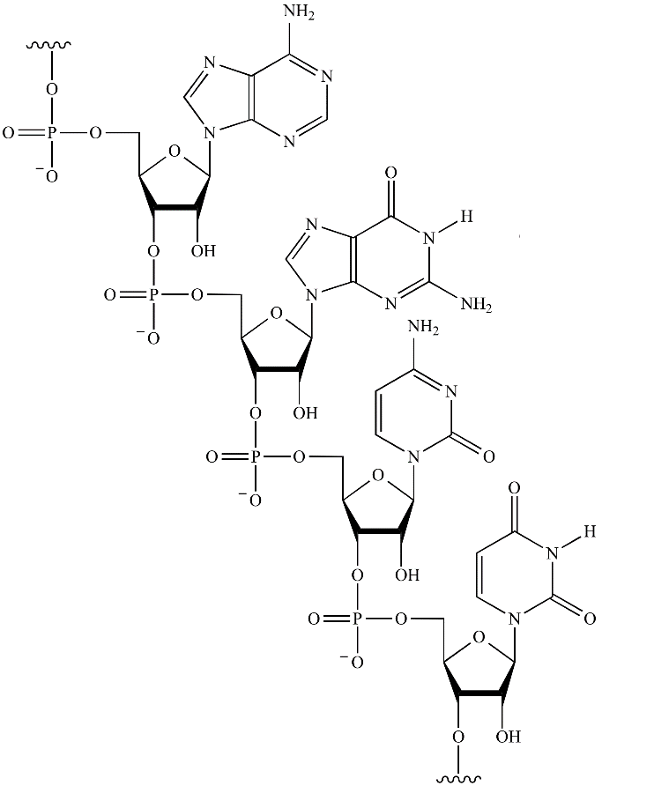

1. The unique sequence of bases is known as _ _ _ _ _ _ _ structure.
2. Characterize the general structure of nucleic acids:

Nucleotides are linked by 3´, 5´-……………………………….. bonds, i. e. the 5´-phosphate group in one nucleotide is attached to the _ - _ _ group of the following nucleotide. As many nucleotides are added using …………………………. bonds, a backbone forms, consisting of alternating ………………… and …………….. groups. The bases are attached to each ………………….. and extend from the backbone.

Polynucleotide chain has a chain polarity 5´→ 3´. Mark the 5´- and 3´-end in the RNA sequence above (task 5).

1. Characterize the secondary structure of DNA.

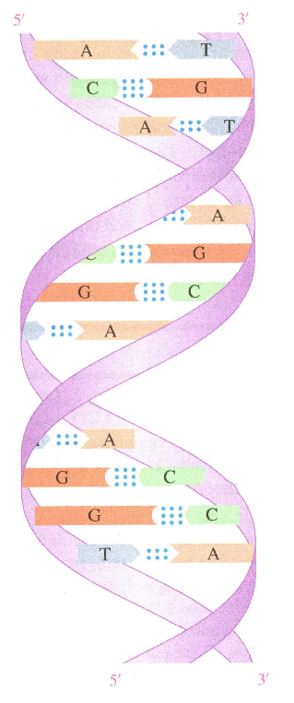

1. The ………… strands of DNA run in the same/opposite direction, i. e. they are parallel/antiparallel. (circle the correct option)
2. What kind of chemical bonds between bases holds together opposite nucleotides in DNA (makes the secondary structure)?

a) hydrophobic interactions b) hydrogen bonds c) covalent bonds

d) electrostatic interactions

11. How many H-bonds are formed between:

a) adenine – thymine

b) cytosine – guanine?

Plot to the schemes:

 

1. Write the complementary base sequence for the following DNA segment:

3´- A C A G T G C C T – 5´

1. A sample of dsDNA contains 10 % of G. What is the % of C and T?
2. Complete the table:

|  |  |  |
| --- | --- | --- |
|  | DNA | RNA |
| Function |  |  |
| Cellular localization |  |  |
| Bases present |  |  |
| Pentose |  |  |
| Number of strands |  |  |

1. Define the base pairs for DNA and for RNA.
2. Describe the structure of DNA molecule.
3. DNA contains the same number of thymine and ……………… molecules and the same number of cytosine and ……………… molecules.
4. Why are GC base pairs more stable than AT base pairs?
5. Draw the structural formula for the dinucleotide AT in a DNA molecule.
6. What is the general function of DNA? In which cellular compartments can it be found?
7. Give the three different types of RNA and describe their function.
8. All types of RNA are needed for synthesis of ……………………. .
9. What is the structure of mRNA?
10. Complete the base sequence in the coding strand of DNA and the base sequence in the mRNA produced by the transcription of this DNA if the sequence of bases in the DNA template strand is:

3’- ATGATCGGATCGATCCAT-5’

1. 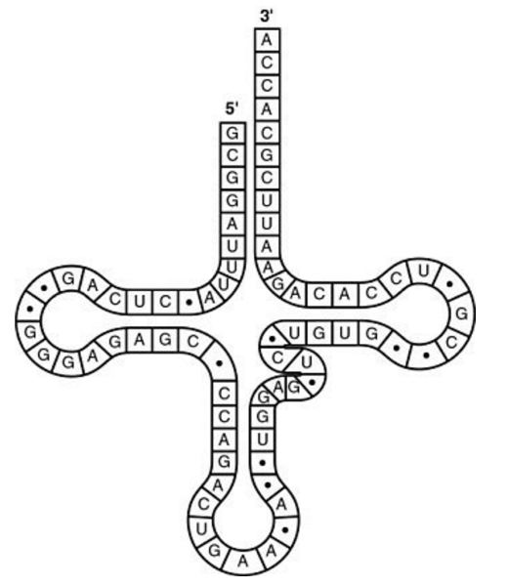In the following tRNA molecule, identify the site for amino acid attachment and the anticodon.
2. What type of bonding is responsible for maintaining the specific shape of a tRNA molecule?
3. Why are there at least 20 different tRNAs?

* **Enzymes, cofactors, vitamins**

1. What is the chemical composition of an enzyme?
2. Why are enzymes needed for chemical reactions in the body?
3. Match the class of enzymes with the reaction that the enzymes catalyze:

|  |  |
| --- | --- |
| **Transferases** | Lysis of a molecule using water |
| **Oxidoreductases** | Making bonds between molecules |
| **Ligases** | Movement of ions or molecules across membranes |
| **Hydrolases** | Rearrangement of atoms in a molecule |
| **Lyases** | Transfer of electrons |
| **Isomerases** | Cleavage of bonds |
| **Translocases** | Transfer of a group between two compounds |

1. Characterize reactions catalyzed by the following enzymes and identify the class of the enzyme:
2. Glucokinase
3. Lactate dehydrogenase
4. Amylase
5. Phospholipase A
6. Aminoacyl tRNA synthetase
7. Alkaline phosphatase
8. Trypsin
9. DNA polymerase
10. Alanine transaminase
11. Why does an enzyme catalyze a reaction of only certain substrates?
12. What type of forces hold a substrate in the active site of an enzyme?
13. Why do denatured enzymes no longer function properly?
14. What effect will each of the following conditions have on the rate of an enzymatic reaction:
15. Addition of a strong acid
16. Depletion of the substrate
17. Removal of the cofactor
18. Cooling down the reaction mixture
19. Addition of the enzyme
20. Explain why an increase in pH above the optimum will lead to decrease of enzymatic activity.
21. Evaluate the specificity of alcohol dehydrogenase.
22. What is an apoenzyme?
23. What is the role of a cofactor?
24. What is the difference between a coenzyme and a prosthetic group?
25. What are the following cofactors derived from?
26. NAD+
27. PLP
28. FAD
29. TDP
30. Coenzyme A
31. Which cofactors (vitamins) are required for the following reactions:

|  |  |
| --- | --- |
| Reaction | Cofactor (vitamin) |
| Transamination of aspartate |  |
| Blood coagulation |  |
| Acyl group transfer |  |
| Oxidation of ethanol by ADH |  |
| Decarboxylation of tryptophan |  |
| Conversion of succinate to fumarate |  |
| Hydroxylation of proline residues in collagen |  |
| Reduction of pyruvate to lactate |  |

1. 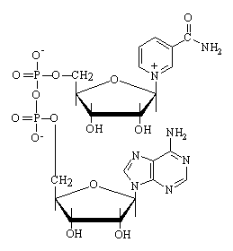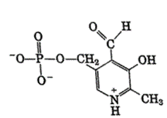Match each formula with the name of cofactor:

pyridoxal phosphate

Biotin

NAD+

Folic acid

Vitamin C

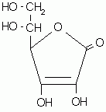

1. Why does a noncompetitive inhibitor prevent binding of the substrate to the active site of an enzyme?
2. Which from the following compounds can act as competitive inhibitor of the enzyme succinate dehydrogenase, which catalyzes the oxidation of succinate?
3. Malonate
4. Ethylene glycol
5. FAD
6. ATP
7. Explain why ions of heavy metals, e.g. lead or mercury cations, are very toxic?