**1.** **PROGRESS TEST 2**

**2. READING**

* Read Eva’s email: Textbook - page 67.

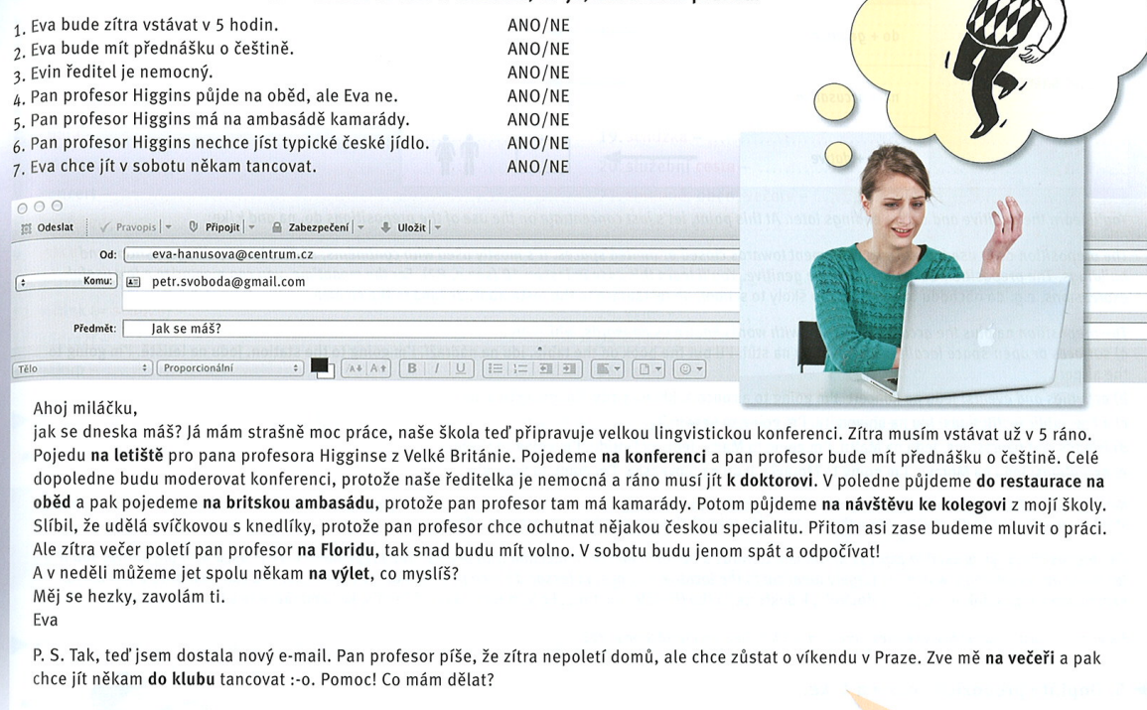



Miláček = honey (beloved person, not food); miláčku = honey!

Dělat = to do/to make; udělat

Dělám kávu = I am making coffee (now, i tis not over yet) × udělám kávu = I will make coffee

* Complete the exercises 1 + 3.

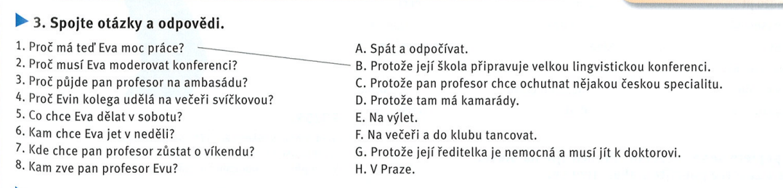



* Observe the future tense + prepositions DO/NA/K.

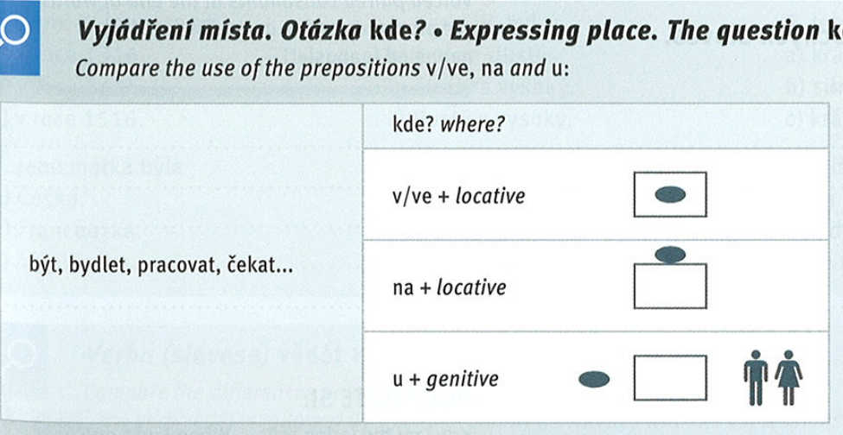



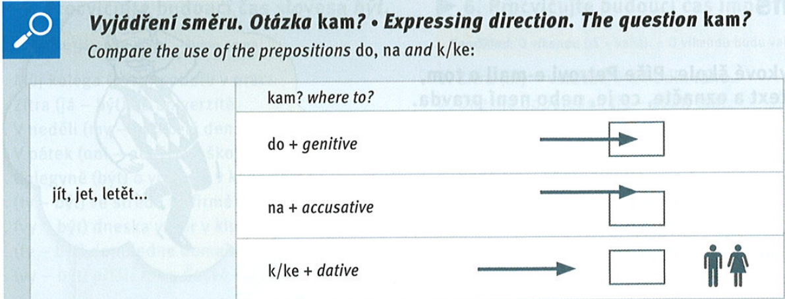



Jedu do Brna = to visit

Jedu na Brno = to invade

Jdu ke kamarádovi = to see my friend

~~Jdu do kamaráda = intends to f**k him~~

**3. GRAMMAR: expressing directions, the question KAM?**

[KDE x KAM](https://is.muni.cz/auth/el/med/jaro2022/aVLCJ0282/110611535/KDE_x_KAM_azincakn.pdf?predmet=1414979)

* Study the grey box in Textbook page 68 + document above.
* Complete the exercises: Textbook page 68/ex. 5 + 6.

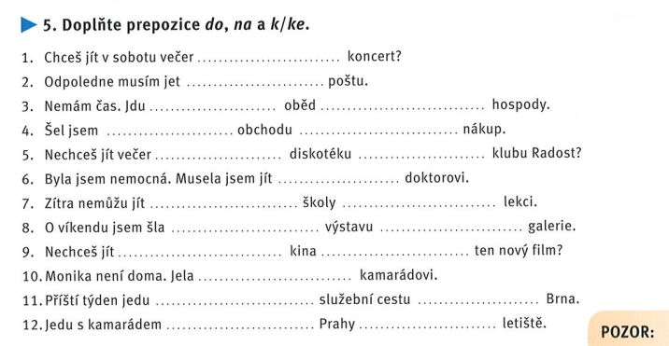



* Learn NA-places: Textbook page 69/ex. 7.



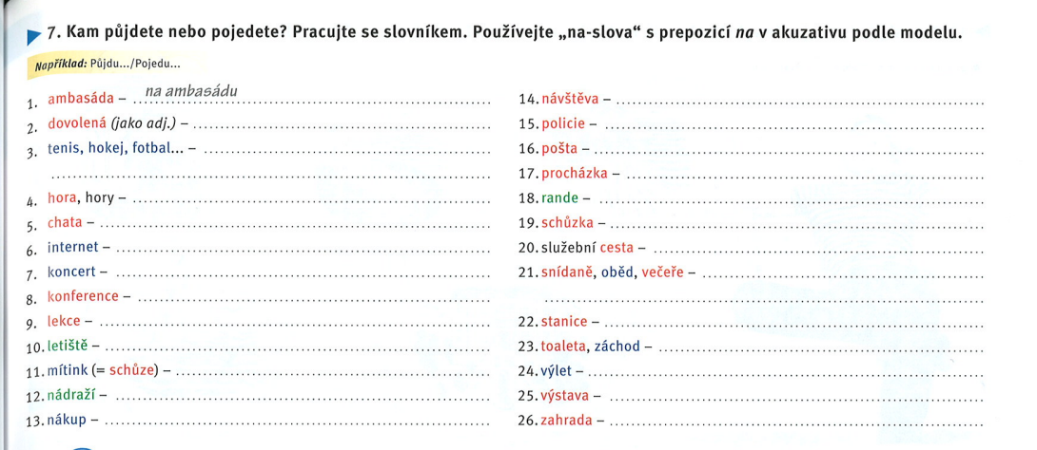



Hospoda = Hospodin (God) + hospital/ity

* Online practice (self-study): [LINK](https://learningapps.org/watch?v=ptuspmm3n20)

**4. LISTENING + SPEAKING: Můj víkend**

* Listen to the text in Textbook - page 71/ex. 4: [AUDIO LINK](https://www.czechstepbystep.cz/coLm4dEPxQE9/uploads/2018/06/CD1_track_74.mp3)
* Work in groups and speak about your weekend: *Co rád/ráda nebo nerad/nerada děláš o víkendu?* Use also the past tense and the future tense: *Co jsi dělal/a minulý víkend? Co budeš dělat příští víkend?*

**5. SUMMARY: UNIT 8**

* Play kahoot: [LINK](https://create.kahoot.it/details/8b061ba3-ea9d-460f-aabc-c2f359e1142c) (self-study: [LINK](https://kahoot.it/challenge/53de2841-453c-4956-bb19-6c56f5ca5278_1618297332455))
* Online revision (self-study): [LINK](https://learningapps.org/watch?v=pgur327qa20)
* Revise with the Workbook - page 98/ex. 48.

**HOMEWORK**

**MEDICAL CZECH III: Internal and genital organs**

* Learn new vocabulary - medical Czech III: Internal and genital organs (table below)
* Online practice (self-study): [Link](https://quizlet.com/584415268/vnitrni-a-pohlavni-organyinternal-and-genital-organs-flash-cards/)
* Online learning (self-study): [Link](https://quizlet.com/584415268/learn)