**Introduction:**Simulation of aortic function is based on a simple “Windkessel” model.

**Digital Model of Aortic Function**

**Equipment:**

PC with simulation programme **Aortic_Model 2018**

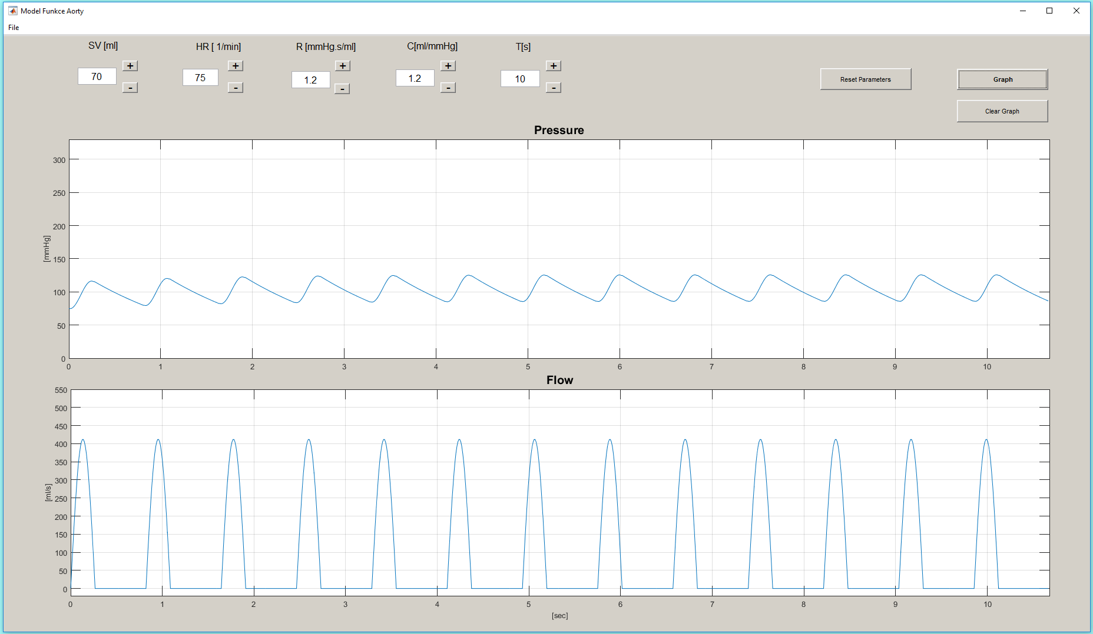

**Procedure:**

1. Start the program **Aortic_Model 2018** by double-clicking the icon.
2. New window opens; maximize it in order to reveal the buttons legend.
   * in the upper part of the screen you can see the buttons + a –; use this buttons to increase or decrease the value of parameters described bellow
   * you will work with four parameters: stroke volume (SV, preset 70 ml), heart rate (HR, preset 75/min), peripheral resistance (R, preset 1.0 mmHg∙s/ml) a compliance (C, preset 1.2 ml/mmHg). Do not change the pre-set value of time (10 seconds) during the whole exercise.
   * There are three buttons in the upper right corner: *Graph*, Clear graph and *Reset* *parameters*. By clicking *Graph* the graphs modelling changes of blood pressure in the aorta and changes of blood flow across the aortic valve will be created. Using *Clear graph* will delete this graph *Reset parameters* is used to return values of abovementioned parameters to pre-set values.
   * window in the middle part of the screen represents the changes of blood pressure in the aorta according to set parameters; axis x represents time and axis y blood pressure in mmHg
   * window in the bottom part of the screen represents the changes of blood flow across the aortic valve; axis x represents time and axis y represents flow in mL/s.