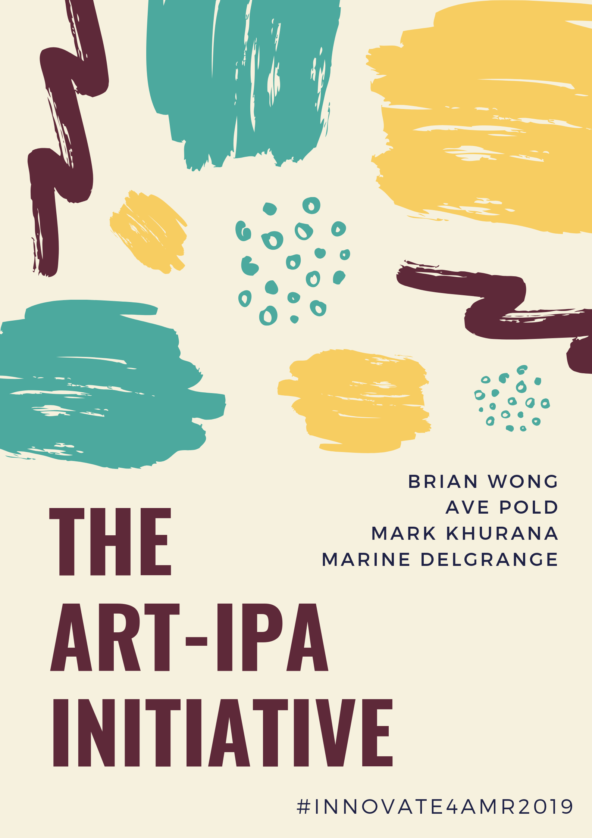

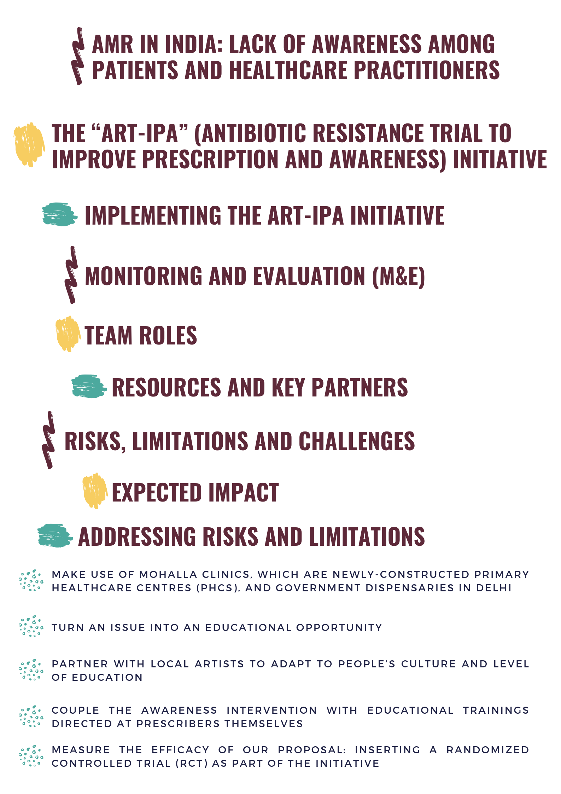

The global burden of antimicrobial resistance (AMR) is undoubtedly on the rise and disproportionately affects LMICs, particularly those with less-developed health systems. In this respect, India is a relevant context given its AMR burden and population size; in fact, India was the world’s largest antibiotics consumer [1]. Numerous factors drive India’s uphill battle in the fight against AMR, from human consumption to inadequate environmental regulations. We will focus on two specific AMR-related issues in India:

1. **Human Consumption:**
   1. Broad-spectrum and last-resort antibiotics use, particularly between 2000-2015, has increased rapidly; whereas, narrow-spectrum antibiotic usage decreased in the same period[1]
   2. Availability issues of narrow-spectrum antibiotics, i.e. penicillin, contributed to increased usage of broader antibiotic classes
   3. Fixed-dose combinations of antibiotics have increased in popularity, even if they fail to prove superiority over single-compound prescriptions[1]
2. **Social Factors:**
   1. Access to antibiotics without prescriptions, lack of knowledge regarding antibiotic usage and use of informal healthcare providers drive up usage[1]
   2. In public healthcare settings, reasons for increased antibiotic prescription include high patient loads, lack of medical education and pressure to prescribe antibiotics[1] based on qualitative studies with doctors

**The problem**

Inappropriate antibiotic prescriptions and lack of knowledge among providers (doctors) and patients regarding AMR contributes to an increased AMR burden in the country[2,3]. Previous studies in Indian primary healthcare centres (PHCs) demonstrate reduced prescription rates for antibiotics through doctor-specific awareness initiatives and training[2]. Additionally, previous studies show that patient expectations regarding medications can drive up prescription rates, and that patient education can subsequently reduce them[4-6].

In 2017, India launched their first ever National Action Plan for containing AMR[7], with six main strategic areas for action. One of the main drivers in antibiotic consumption occurs in the primary sector, where patients presenting with fevers, colds and coughs are often incorrectly treated with antibiotics. Focusing on human consumption patterns as well as social factors in the primary sector has enormous potential. Worldwide, Universal Healthcare Coverage (UHC) is being promoted as an effective solution to increasing access to healthcare and improved healthcare outcomes. Additionally, India has recently launched Ayushman Bharat, an initiative aiming to augment access to healthcare coverage by building and improving 150,000 PHCs to become “Health and Wellness Centres”. As such, identifying areas for improvement in the primary sector is both scalable and effective - and has the capacity to greatly reduce inappropriate antibiotic prescriptions.

We are choosing to focus on antibiotic prescription in PHCs due to the increased demand for primary healthcare coverage (particularly in India), the volume of antibiotics prescribed in the primary sector and the lack of effective solutions to reduce prescription by doctors and increase awareness of AMR among patients. To our knowledge, effective solutions tackling AMR in PHCs in LMICs are lacking in comparison to HICs. The aim is to reduce inappropriate antimicrobial prescriptions while increasing awareness among doctors and patients regarding AMR and optimal practices. While we focus on the Indian context, lessons learned from our solution are highly applicable in other LMICs, given the importance of expanding UHC and PHCs in these contexts.



Our proposed solution comprises a multi-pronged, community-based approach which would start at the grassroots level, be low-cost and would make use of existing infrastructure. This would include the education of patients through an arts initiative and the training of doctors in optimal AMR practices. To determine the most effective strategies, the proposed ART-IPA initiative would also comprise a randomized controlled trial (RCT).

We propose to:

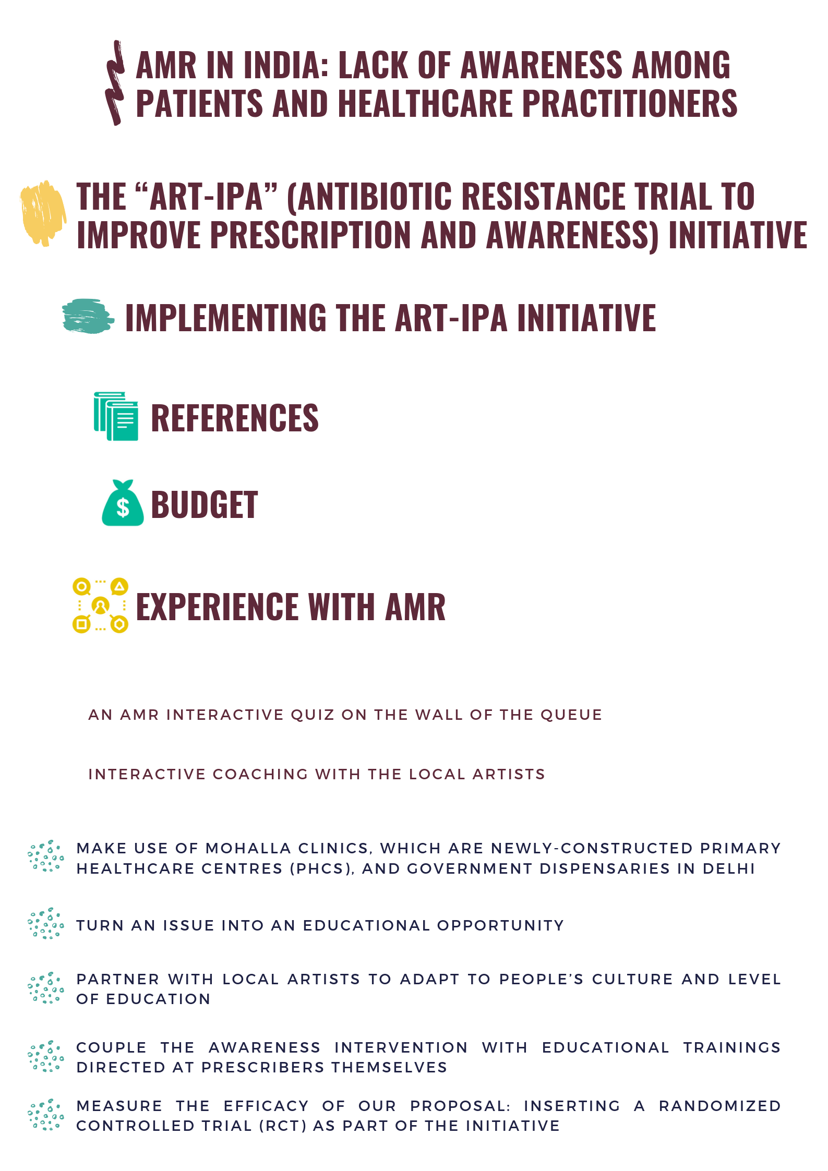

One major issue faced when setting up public health (PH) awareness projects is ensuring that initiatives reach their target populations. Our proposal takes advantage of both Delhi Government dispensaries and the newly-built PHCs – or “Mohalla Clinics” (Hindi for “neighbourhood” or “community”) in Delhi. There are currently about 300 Delhi Government dispensaries and 200 Mohalla clinics in Delhi. The Indian government has set a goal of constructing 1,000 Mohalla clinics by the end of 2019 and is confident to achieve it; completion of these clinics would aid in ensuring this project’s feasibility and scalability. Furthermore, given these clinics receive 94 patients/day on average[8], this project can be expected to reach a large number of its target population.

Due to their location – which has been found to considerably reduce patient commute times[9] – and absence of cost (since visits/medicines are free), both these clinics serve as a first point of contact for the population and reduce the loads of referrals to secondary and tertiary health facilities, to private clinics and unregulated vendors, which has long been – and still is – a key problem in the Indian healthcare systems. Clinics are generally staffed with a doctor, a pharmacist (only in dispensaries) and a midwife.

PHCs play a pivotal role in increasing awareness surrounding PH issues. Furthermore, the absence of cost ensures diversity amongst the target population, as it allows low-income families – who often have a low awareness of good practices to avoid AMR – to access health services,



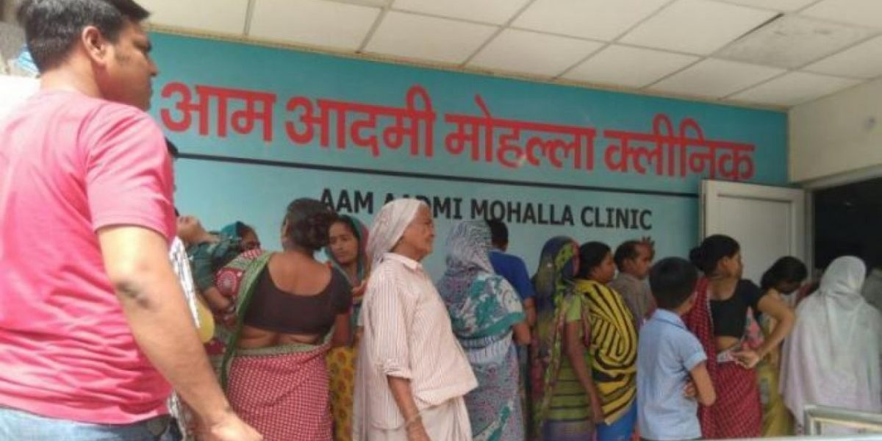

Source: <https://thewire.in/health/are-mohalla-clinics-making-the-aam-aadmi-healthy-in-delhi>

Because of their absence of cost, patients of these clinics often face long waiting times. Following a long wait, they meet the doctor for a short appointment and are in most cases unable to ask about preventive care, especially considering that doctors in Mohalla Clinics are paid on a per patient basis. According to the evidence base, lack of time is seen as one of the largest barriers to patient-doctor consultation and ultimately to evidence-based practice in primary care[10].

We propose to turn this wait into an educational opportunity where patients can already receive information about proper antibiotic administration and AMR in the queue. Additionally, this would give doctors more time to consult patients on other healthcare topics.



Our project involves setting up an interactive educational game on a wall in the patient waiting area and collaborating with Indian artists to facilitate this arts & health initiative.



Several questions about antibiotic usage and AMR will be written on the wall to address common misconceptions; patients will have the opportunity to answer them and will be provided with the correct answer.

* Questions will be chosen after consulting Indian PH experts, to ensure they adequately address common misconceptions. (i.e. *What is an antibiotic?* *Can I get antibiotics without a prescription? Where can I get antibiotics? Is it dangerous to take too many antibiotics?*)
* Local artist partners will be responsible for translating the questions in the local dialect and through illustrations to make them easily understandable
* Upon arrival at the clinic, patients will receive coloured stickers from a vending machine to respond to questions (similar to the method in which they receive tokens to identify their number in the queue)
* Each question will have 2-3 possible answers, with a colour attributed to each. Patients will place the sticker corresponding to what they think is the right answer on the wall.
* A QR code will be located at the bottom of each question[11], linking to the correct answer with detailed explanations and illustrations. In this way, patients will have access to complete, correct and detailed information. For those who may not have a smartphone, a paper booklet with the same information will be available at the end of the queue



Several successful art coaching initiatives have been implemented in India which we intend to collaborate with for our project (i.e. the Pomegranate Workshop, a venture set up to deliver experiential learning in children and adults[12])

* An artist would be present once a week in each participating clinic for the project duration
* After scanning the QR code and obtaining the correct answer in pictures and writing, patients would move to paint a mural about antibiotics and AMR together with visual artists in the clinic waiting area
* During the painting process, visual artists will provide knowledge to patients on the topic. The mural will decorate the waiting area after the interaction is finished. The artist would be at the clinic on a rolling basis at certain hours to facilitate this aspect of the project, while the mural with the quiz would be self-explanatory such that the patients can use it independently while waiting



Many Indian doctors lack adequate training in infectious diseases and AMR, exacerbating the instance of unnecessary antibiotic prescription[13]. As such, training would be facilitated to doctors over the project duration, given as a 1-hour workshop one day/week in each clinic. Doctors would be reimbursed for their time attending the workshops, corresponding to the typical fee-per-patient charged (30 rupees) and adjusted to the number of patients they would have been able to see in this time period. Additionally, workshops would not overlap with peak times for seeing patients.



A recent article in BMJ Global Health shows that evaluation of the impact of antibiotic awareness campaigns remains sub-optimal[14]. Given the need for reliable extensive data and monitoring of PH initiatives, we ensured the outcome of our proposal was easily measurable.

We propose to set up a randomized controlled trial of three arms:

1. “Placebo clinics”, where neither the mural nor educational booklets would be set up nor would there be trainings organised (5 clinics)
2. Clinics in which only workshops for doctors about antibiotic prescription would be organized (5 clinics)
3. “Test clinics”, where the ART-IPA initiative would be set up in its entirety (patients quiz & coaching + doctors’ training) (5 clinics)

The primary outcome examined is the number of prescribed antibiotics (DDD), which would be measured and collected from public registers.

This RCT’s primary benefit lies in measuring the added value of an awareness-raising initiative among patients such as this and determine overall which method is most effective. The ultimate goal of this initiative is to reduce antibiotic prescriptions in an LMIC context. Setting up an RCT as part of our initiative has several advantages. First, the context in which the initiative would be set up (government clinics) would facilitate the easy gathering and analysis of data. Second, as these clinics provide free consultations, it incentivizes more patients to come as awareness about the initiative is spread through word-of-mouth. As free medication is provided, testing prescription would be representative of what patients are receiving.

***

The ART-IPA initiative will be split into three phases. Phase 1 will occur in the time leading up to the intervention, Phase 2 will be the 4-month period of the intervention itself, and Phase 3 will occur after the intervention has taken place to monitor and evaluate its effectiveness. Throughout the initiative, we will be partnering with the local government actors, healthcare workers and artists to engage patients from the local population.

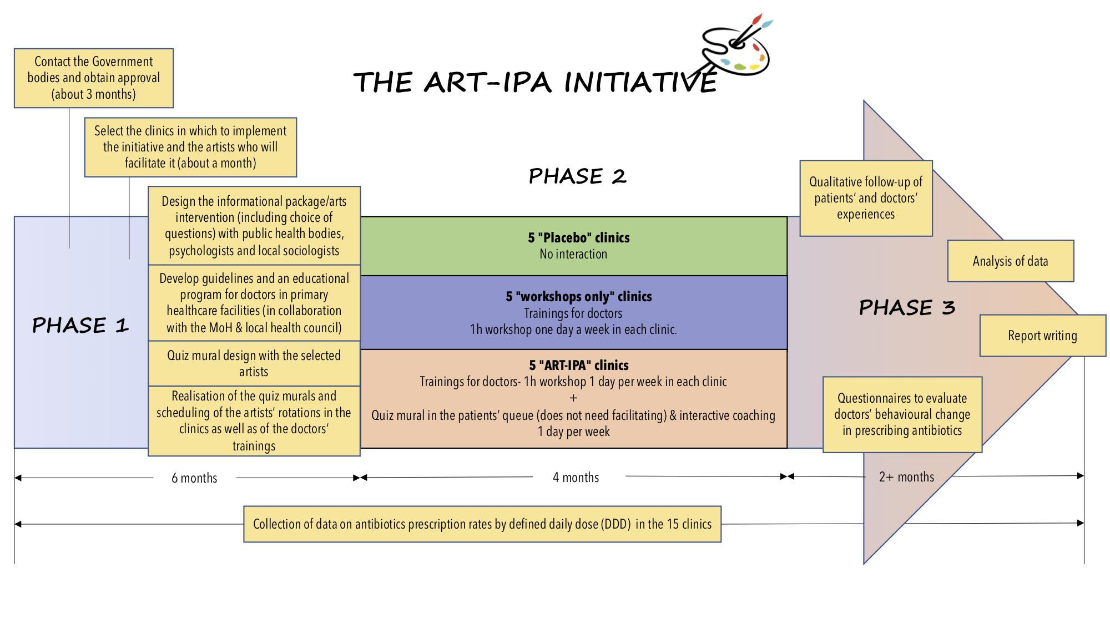



***Short-Term (2 months post-intervention)***

With help from the Indian Ministry of Health (MoH), there are both quantitative and qualitative aspects of the project that can be measured. We propose to evaluate the number of antibiotics prescriptions by DDD, given that it will be difficult to evaluate how much patients have learned after the intervention as we will not necessarily have the same patients returning to the clinics. A baseline study will be conducted prior to the start of the initiative in order to measure the improvement - which must also take seasonal variations in prescription rates into account. This will then be compared with DDD values during and after the intervention. A qualitative follow-up study of patients’ and doctors’ experiences will also be carried out two months after finishing the workshops. Doctors will be handed questionnaires to evaluate behavioural change in prescribing antibiotics. These results will be written up and summarized into an evaluative report on the effectiveness of the initiative and will be used to inform future plans.

***Long-Term (1 year post-intervention)***

After finalizing this pilot project and analysing the 3 models and their impact on prescription rates, the most effective model would be implemented gradually in all of the Mohalla clinics as well as other PHCs outside Delhi. Future plans would also include the conducting of pre- and post-initiative questionnaires to assess patient knowledge about AMR in relation to the effectiveness of the training provided.



Each team member will be responsible for a different aspect of the implementation process. With his prior global health policy and advocacy experience, Brian will act as a liaison between the team and the Indian MoH; and given his background in epidemiology and data analysis, he will also be involved in the analysis of the data collected. Given Mark’s background in medicine and medical education, he (alongside local PH bodies) will develop educational guidelines and the curriculum for doctors and healthcare professionals working in PHCs. With her experience working in the area of health workforce, Ave will be the recruitment lead, recruiting local healthcare workers and artists for the initiative. Finally, Marine will act as creative director, working on designing the initiative’s artistic components as well as liaising with local artists involved.



The main resources needed for this initiative can be grouped into the following categories: financial support and human resources for developing ART-IPA. Human resources for art constitute local artists from the Pomegranate workshop with whom we work, and if needed, other local artists’ networks. Additionally, working with staff in each clinic is necessary (by providing training, incentives) in order to ensure that the process runs smoothly and consistently across clinics. Funding would be managed by the Delhi government, given they run the Mohalla clinics, as well as the MoH & Family Welfare (under the Indian Government), as they have developed the national strategy for AMR. The latter will also be able to help with expansion in due course. It would also be feasible to partner with the Public Health Foundation of India.

**

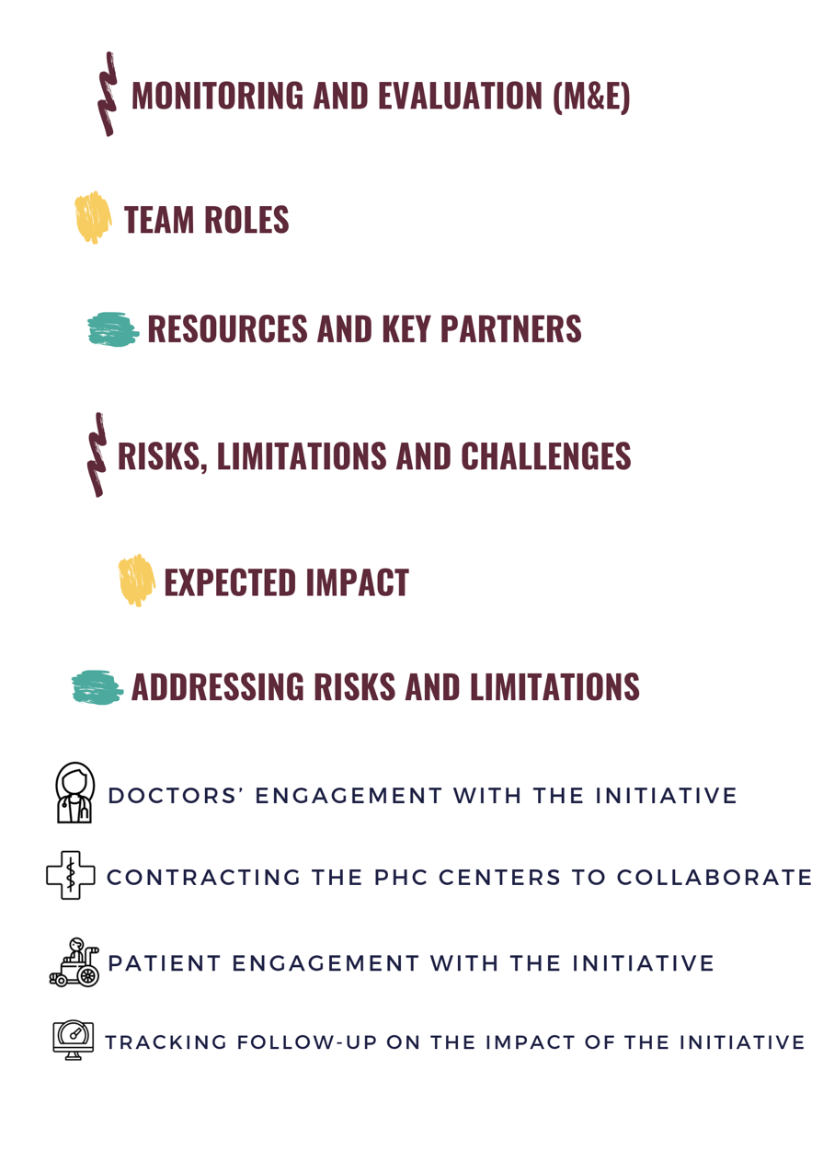

Doctors need to be motivated to want to learn more and change their prescribing habits. Even if we guarantee a high attendance rate, the doctors might still face barriers in implementing what they have learned- either personal difficulties in changing habits, lack of time to learn and implement, lack of incentives to make doctors seek new information throughout their professional careers.

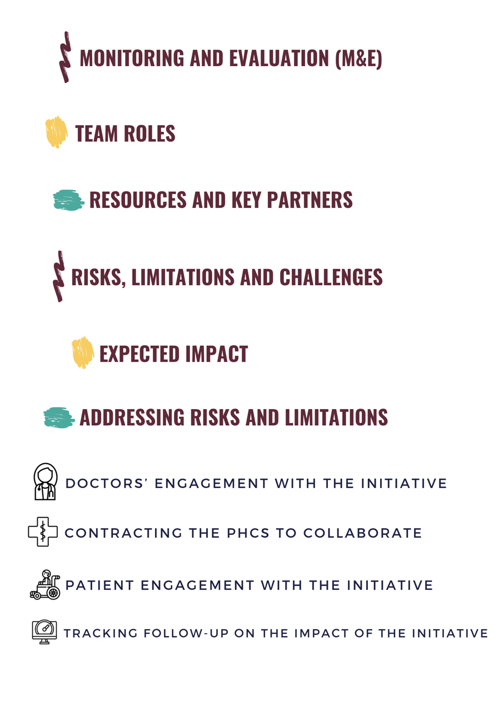

The network of PHCs in India is constantly growing and more clinics also might pose more risks to big projects being agreed upon: the process of implementing new initiatives takes more time, resources and bureaucracy. Getting a representative and statistically significant number (necessary for statistical power) will be a challenge.

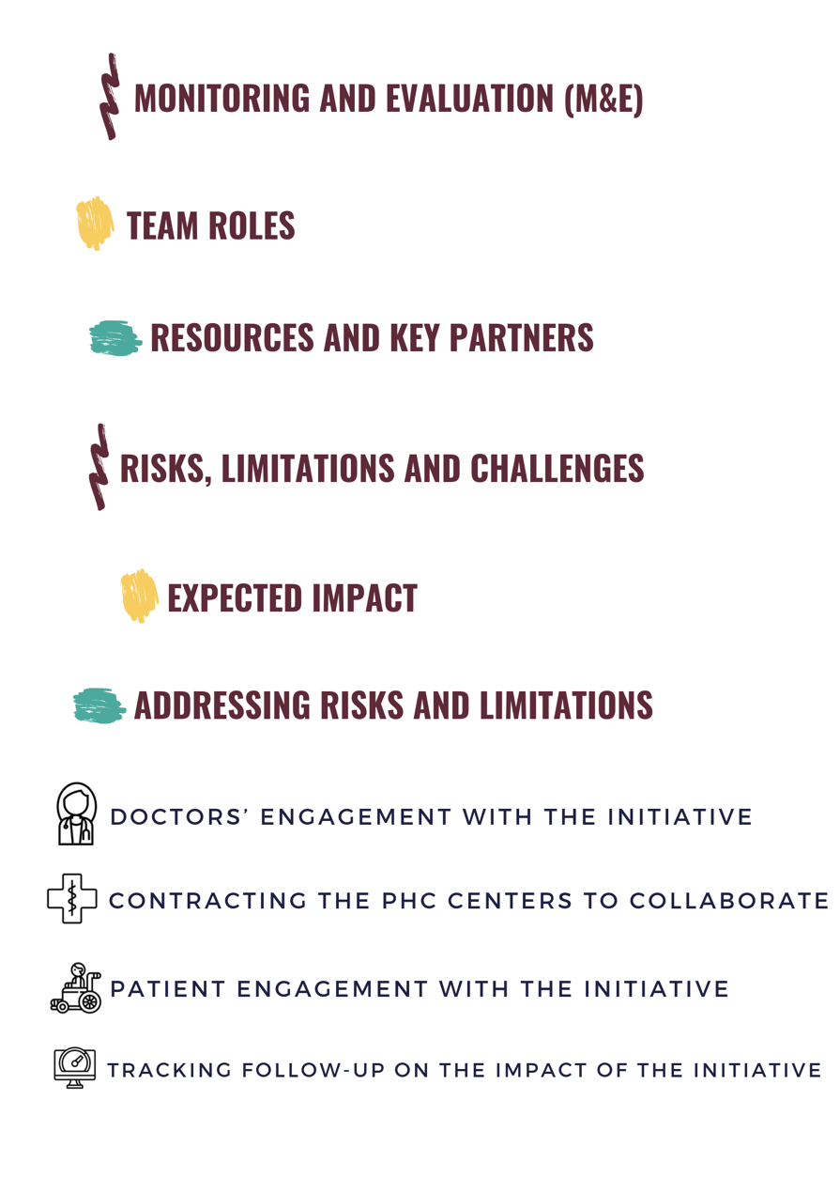

We are basing our patient-oriented initiative on the premise that there are queues in the centres, which presents an untapped time resource to provide patients with healthcare knowledge. Patients waiting in queues for a doctor’s appointment are often anxious, not in a good mood or good physical state to want to engage with questionnaires and art projects. With ill individuals and elderly people there might be extensive limitations to being able to ask them to fill in a questionnaire.

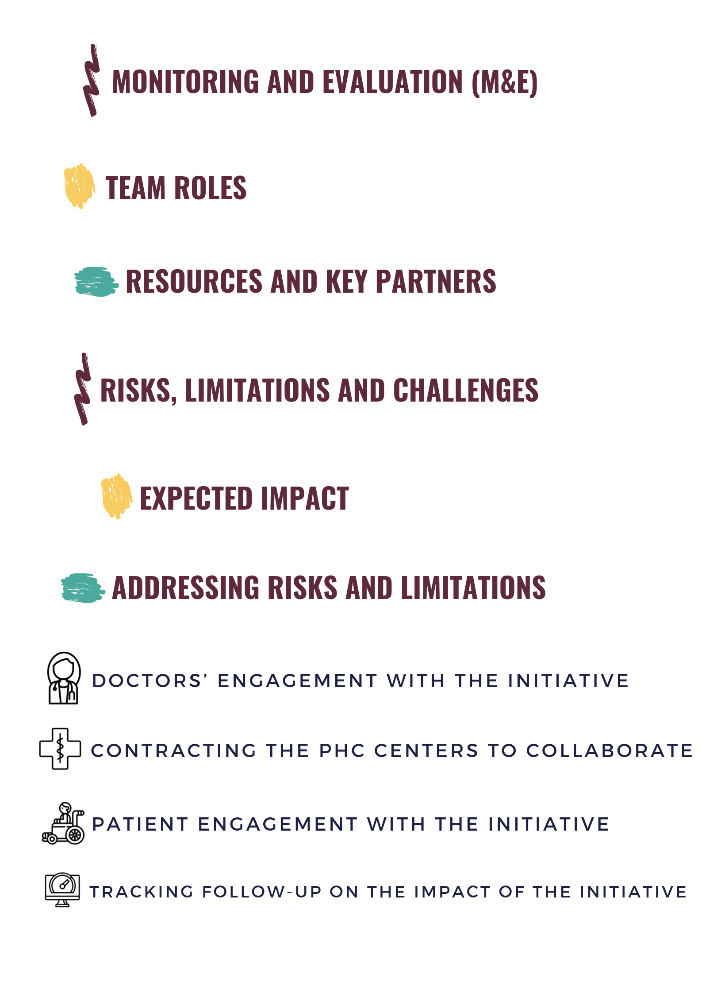

An essential element in this project is related to gathering follow-up data after the local work has been finalized. This is needed in order to validate whether doctors’ habits in prescribing antibiotics has changed, whether patients’ behaviours when handling antibiotics and disposing them has changed and whether this information is being transferred among doctors and patient groups.

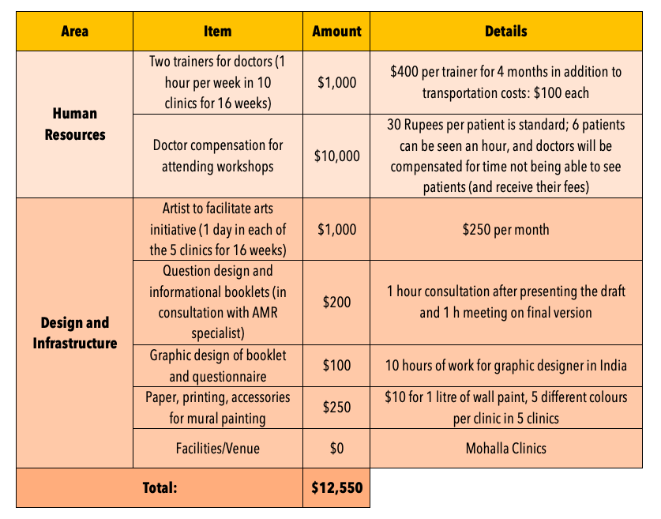

# 

***

With an expected duration of four months for the actual trial, assuming 15 clinics participate, with an average of 90 patients/clinic/day and with approximately 63 working days in 4 months, an estimated 85,000 interactions will take place between the patients and doctors. Given the frequency of antibiotic prescription, there is huge potential for reducing inappropriate prescriptions and increasing awareness. Once the trial has been completed and evaluated, we aim for this program to be rolled out across Delhi, and thereafter in PHCs state-by-state in India, tailoring approaches to local contexts and lessons learned from the trial, if successful. We hope that the general population will become more aware of the risks associated with misuse of antibiotics, and doctors will be more aware of their prescription patterns, which would ultimately result in lower rates of AMR.

***



Doctors will be reimbursed for their time attending the workshops, corresponding to the typical fee-per-patient charged (30 rupees) and adjusted to the number of patients they would have been able to see in this time period. Additionally, workshops would not overlap with peak times for seeing patients.



These Mohalla clinics are set up and run by the local Delhi government. The key is to establish a rapport with the government and present the merits of such an initiative, of which there are many. Additionally, designing the initiative in a way that does not disrupt their normal workflow is imperative to guaranteeing their cooperation.



The initiative needs to be designed not to feel like a burden for patients but should be optimized for the user experience to guarantee participation. Working with clinic staff is essential for motivating patients to participate.



To address this issue, our aim is to collect objective data that can be compared over time. This would be the DDD prescribed at the clinic pharmacy; this can be tracked over time and is reliable. Additionally, the qualitative surveys for the doctors will be designed to understand their potential behaviour changes and allow us to reflect on high-impact vs. low-impact parts of the initiative, as it relates to their prescription patterns.



**Ave Põld:** Masters student in International Health at the Berlin Charité university, DDS in dentistry; has worked on AMR campaigns done by the World Health Students’ Alliance as a representative of the International Association of Dental Students. Has attended an AMR workshop during the preWHA organized by IFMSA and some AMR sessions during the WHA.

**Mark Khurana:** 4th year medical student at the University of Copenhagen, former member of the European Public Health Alliance AMR Working Group and researcher at the Centre of Excellence for Health, Immunity and Infections.

**Brian Wong:** PhD candidate in Cardiovascular Science at UCL; Completed an MSc in Epidemiology at the London School of Hygiene and Tropical Medicine, during which he learned extensively about AMR. Participated in various AMR case competitions and attended conferences/workshops focused on AMR, including the 71st World Health Assembly, as part of the IFMSA delegation.

**Marine Delgrange:** Master's student in Population Health at UCL; completed a dual Bachelor's in Political Science (SciencesPo Paris) and Biology (Sorbonne University Paris); has worked for the French Senate, French Ministry of Health and completed an European Commission Blue Book Traineeship with the Pesticides & Food Safety Unit in DG Santé, where she worked on related projects and had her interest in AMR piqued.



1. Gandra S, Joshi J, Trett A, Lamkang AS, Laxminarayan R. Scoping report on antimicrobial resistance in India. Center for Disease Dynamics, Economics & Policy, Washington, DC. 2017.
2. Lunn AD. Reducing inappropriate antibiotic prescribing in upper respiratory tract infection in a primary care setting in Kolkata, India. BMJ Open Qual. 2018 Nov 1;7(4):e000217.
3. Farooqui HH, Selvaraj S, Mehta A, Heymann DL. Community level antibiotic utilization in India and its comparison vis-à-vis European countries: Evidence from pharmaceutical sales data. PloS one. 2018 Oct 17;13(10):e0204805.
4. Cockburn J, Pit S. Prescribing behaviour in clinical practice: patients' expectations and doctors' perceptions of patients' expectations—a questionnaire study. Bmj. 1997 Aug 30;315(7107):520-3.
5. Al-Homaidan HT, Barrimah IE. Physicians’ knowledge, expectations, and practice regarding antibiotic use in primary health care. International journal of health sciences. 2018 May;12(3):18.
6. Currie J, Lin W, Zhang W. Patient knowledge and antibiotic abuse: Evidence from an audit study in China. Journal of health economics. 2011 Sep 1;30(5):933-49.
7. Ranjalkar J, Chandy SJ. India's National Action Plan for antimicrobial resistance–An overview of the context, status, and way ahead. Journal of Family Medicine and Primary Care. 2019 Jun 1;8(6):1828.
8. India Today (2019). PM Modi pays emotional tribute to Arun Jaitley. [online] Available at: https://www.indiatoday.in/india/story/-pm-modi-pays-emotional-tribute-to-arun-jaitley-1597732-2019-09-10?utm_source=rss [Accessed 15 Sep. 2019].
9. Sah, T., Bailwal, N. and Kaushik, R. (2019). Are Mohalla Clinics Making the Aam Aadmi Healthy in Delhi?. *The Wire*. [online] Available at: https://thewire.in/health/are-mohalla-clinics-making-the-aam-aadmi-healthy-in-delhi [Accessed 15 Sep. 2019].
10. Sherwin HN, McKeown M, Evans MF, Bhattacharyya OK. The waiting room “wait”: From annoyance to opportunity. Canadian Family Physician. 2013 May 1;59(5):479-81.
11. The Economic Times. Internet users in India to rise by 40%, smartphones to double by 2023: McKinsey. [Internet]. 2019 [cited 15 September 2019];. Available from: https://economictimes.indiatimes.com/tech/internet/internet-users-in-india-to-rise-by-40-smartphones-to-double-by-2023-mckinsey/articleshow/69040395.cms?from=mdr
12. Clift S, Camic PM, editors. Oxford textbook of creative arts, health, and wellbeing: International perspectives on practice, policy and research. Oxford University Press, USA; 2016.
13. Dixit A, Kumar N, Kumar S, Trigun V. Antimicrobial resistance: Progress in the decade since emergence of New Delhi metallo-β-lactamase in India. Indian journal of community medicine: official publication of Indian Association of Preventive & Social Medicine. 2019 Jan;44(1):4.
14. Huttner B, Saam M, Moja L, Mah K, Sprenger M, Harbarth S, Magrini N. How to improve antibiotic awareness campaigns: findings of a WHO global survey. BMJ global health. 2019 May 1;4(3):e001239.